FINAL PROJECT SUBSTANTIVE AND FINANCIAL REPORT

This report is to be submitted to the Fund Manager at unodc-victimsfund@un.org by the time stipulated in the grant agreement. It should cover the entire implementation period of the project.

Please complete ALL sections below.

If you have any questions regarding the funded project, kindly please directly write emails to the Trust Fund rather than only noting them in the report.

Grant holder

Name of NGO | WOMEN, INFANTS AND CHILDREN CARE INITIATIVE (WICCI)
Postal Address | 4, Ogunbayode Street, Off Abiola Way, Oke-Abetu, Abeokuta, Ogun State.
Telephone | +2349038939338
Project Director/Manager (name and contact information) | Doyinsola Adebayo  Email: doyinadebayo2003@yahoo.com  Tel: +2348034753222
Primary Contact Person (name, job title and contact information) | Doyinsola Adebayo  Project Manager  Email: doyinadebayo2003@yahoo.com  Tel: +2348034753222
Head of Organization (authorizing officer) | Doyinsola A. Adebayo

Project information
(It should be in line with Annex A of the Grant Agreement)

Project Title | Provision of sustainable reintegration assistance and protection to vulnerable victims of trafficking in Ogun State, Nigeria
Location of Project | Ogun State, Nigeria
Start Date | 01.12.2022
End Date (when project was completed. It should NOT be later than the expiration date of the grant agreement) | 30.11.2024
Project Objective | 1. To screen and identify 115 vulnerable victims of trafficking (sexual exploitation, forced labour and forced begging) aged 10-35 years old and increase awareness on human trafficking in Ogun States by November, 2024.  2. To improve the mental and social health needs and well-being of 115 vulnerable victims of trafficking (sexual exploitation, forced labour, forced begging) aged 10-35 years old in Ogun and Lagos States (externally, most victims are received at destination countries in Lagos) by November 2024.  3. To facilitate social reintegration and prevent re-trafficking of 115 VoT aged 10-35 years old in Ogun State through economic rehabilitation i.e. business management skill training and business establishment by November, 2024.

Assessment of implementation of the project activities

3.1. Reporting period (covering the entire implementation period)
(It should be in line with reporting period stipulated in Article VIII and IX)
From 01.12.2022 (the start date of the project) to 30.11.2024(not late than the expiration date of the agreement)
3.2 Project Context
(Please provide a short description of any chance in context during the reporting period, specifically linked to the project)

Not Applicable

3.3 Activities carried out in the project
(Please describe all activities which have taken place in the project as listed in the Annex A of the Grant Agreement)

1a. Advocacy visits to Stakeholders (1st Quarter): WICCI project staff conducted advocacy visits to some identified key stakeholders in the State as part of measures in the prevention of sexual exploitation, forced labour and other slavery-like exploitations which are as a result of Human Trafficking.
During the reporting period, WICCI conducted an advocacy visit to Nigeria Security and Civil Defence Corps (NSCDC) and Beninese Stakeholders Forum in Ipokia Local Government, Ogun State. The leaders of the association were advised to hand over known traffickers to the Nigeria Police Force or NSCDC, join hands with WICCI to combat trafficking and other trans-organized crime in their communities and refer survivors for medical or humanitarian assistance or family reunification.
They were also sensitized with some IEC materials (posters and postcards condemning Human Trafficking). Some VoT in the community were later introduced to the Project Manager who advised them to come for screening at the office which they did.

b. In the 2nd quarter, advocacy visits were conducted to Egun (Beninese) community in Ifo local government area of Ogun State. They were sensitized on the dangers of irregular migration and human trafficking; it was emphasized that it is imperative for them to kick against stigmatization of survivors of human trafficking in their various communities and to refer all cases of TiP to WICCI or our collaborator, JESA Future Foundation.

c. In the 3rd quarter, which is the reporting month, advocacy visits were conducted to Ogun State Task Force on Human Trafficking and Nigeria Immigration Service (NIS), Ogun State. The Advocacy Team, WICCI project staff and our Partners – JESA Future Foundation and Life Agenda Initiatives visited the members of the Ogun State Task Force on the 5th July, 2023; same visit was conducted by the Team to NIS on the 2nd of August, 2023. The two activities were successful.
The two government agencies – NIS and the Task Force on TiP pledged their support and cooperation to WICCI; promised to refer victims of TiP for assistance as well as involve WICCI in their programmes/activities on Human Trafficking especially the 2023 World Day against TiP which the Agency earlier planned to mark on the 9th of August 2023 but was later cancelled due to lack of fund.

During the advocacy visit to the Coordinator, Ogun State Task Force on Human Trafficking – Mr. Akolawole Shoremi, the Project Manager – Doyinsola Adebayo informed our host and his Team about all the assistance and support available for 115 victims of trafficking in the State – food and materials assistance, medical tests, psychosocial support, legal assistance, provision of shelter, family reunion, counselling and micro-business empowerment. She added that the Agency should liaise with NAPTIP and NCFRMI to quicken the process of developing the National Referral Form for referral of victims for assistance. Mr, Akolawole Shoremi in his response appreciated WICCI and UNODC for the initiative and assistance for the VoT. He admitted that the development of Referral Form is necessary for effective provision of assistance to VoT, he however suggested to WICCI to inform her Funders to consider providing vocational skill training and micro-business empowerment for all the survivors in subsequent projects.

2023 World Day Against Trafficking in Persons
a. WICCI marked this year’s World Day against TiP on Monday 31st July 2023 with the Nigeria Immigration Service (NIS). The 2 in 1 programme organized by NIS (2023 World Day against TiP and 60 years anniversary of the Nigeria Immigration Service) was titled - Enhancing Seamless Regular Migration. It was packed with activities such as:
* Media chat
* Road Walk / Seamless Regular Migration
* Sensitization and Enlightenment to passport applicants on immigration services
* Showing of clips on TiP, SoM
* Hosting of stakeholders and sister agencies in an interactive session
* Showcasing of immigration activities

The State Comptroller of Immigration, Mrs. Bosede Olufunmilayo Olayemisi expressed her delight in having CSOs, including WICCI around to celebrate and collaborate together to fight irregular migration and TiP.

b. Donation of mattresses and food stuff to NCFRMI for the IDPs
As part of the activities to mark 2023 World Day against TiP, WICCI visited the Ijebu-Ode, Ogun State Office of the National Commission for Refugees and Internally Displaced Persons (NCFRMI) on the 28th July 2023 to donate five (5) mattresses and some food stuff – rice, beans, noodles, vegetable oil, salt and tomato paste. These materials were meant to be shared among twenty-eight (28) VoT residing among Internally Displaced Persons (IDPs) community since IDP camp situated at Oru Ijebu-Ode has been closed. The items were later shared among the identified VoT by the staff of the Commission on 11th August 2023 (photos attached). The Head of Operations, during our discussion with him in order to assess the needs of the IDPs, informed WICCI that food stuffs would be preferred by the survivors instead of plastic chairs as there was serious hunger in the community. That was the reason for donating the food stuffs to the VoT instead of plastic chairs as proposed).

c. Production of jingles and radio news announcement
WICCI produced some jingles on dangers of TiP, how victims were trafficked and contacts of organizations and government agency to call for enquiries and notification of cases of TiP, in three (3) different languages – English and two (2) other local languages – Yoruba and Egun.
The jingles were shared on the WhatsApp platforms of Civil Society Coalition on SDG (CSCSDG), Ogun State Child Protection Network (CPN), CSO Network on Migration and Development (CSONetMADE), and both Southwest and Ogun State Network Against Child Trafficking, Abuse and Labour (NACTAL). The members were encouraged to share the jingles, among their contacts. As a result of this, WICCI received some referrals who were identified and supported with reintegration assistance.
Radio news announcement was made in a local language on FM 106.5 on August 1, 2023 to sensitize the general population on different methods of recruitment by traffickers in order not to fall victim, the need to report pimp or trafficker to the law enforcement agencies and telephone numbers of WICCI and other CBOs working on Human Trafficking were rolled out for provision of protection, psychosocial support and material assistance to VoT.

d. In the 4th quarter, advocacy visit was scheduled to be conducted on October 10, 2023 to the Commander, National Agency for the Prohibition of Trafficking in Persons and other related offences (NAPTIP) who was recently posted to the State. She apologized that she has a busy schedule at that moment, setting up her newly assigned office and some official duties she has to attend to. However, she promised to meet with the Project Team as soon as she settles down in the assigned temporary office.

e. In the 5th to 6th quarters, no advocacy visit was conducted.

f. In the 7th Quarter - Advocacy visit was conducted to the State Commander, National Agency for the Prohibition of Trafficking in Persons (NAPTIP) on the 11th July 2024. At the meeting, it was agreed that NAPTIP would be referring victims of trafficking to WICCI for social reintegration.
The Project Director Presented some IEC material to the Commander and assured her of a long-time collaboration with the Agency.

g. 2024 World Day Against Trafficking in Persons – WICCI commemorates the Day with NAPTIP Benue State Command (pictures attached). WICCI joined other CSOs to mark the Day with a WALK round the metropolitan city of Makurdi; distributing handbills on dangers of TiP to the general populace.

h. Stakeholders’ Consultative Forum - STAKE HOLDERS CONSULTATIVE FORUM TO END HUMAN TRAFFICKING IN OGUN STATE, NIGERIA HELD ON THURSDAY, 25th JULY, 2024.

'THEME' Human Trafficking: OGUN STATE POSITION AND STAKEHOLDERS IMPACT

Participants at the event were:
- The State Commander, NAPTIP
- Nigeria Immigration Service (NIS)
- Migration Desk officer, Ogun State Ministry of Women Affairs and Social Development (OGMoWA)
- Media - Ogun State Broadcasting Corporation
- Women leader, Abeokuta North Local Government Area
- Religion leaders - Christian Association of Nigeria (CAN)
- Deputy Chairman, National Association of School Principals in Nigeria
- Network Against Child Trafficking and Labour (NACTAL) and other CSOs -Civil Society Network on Migration and Development (CSONetMADE) atc.
- Zonal Coordinator, National Commission for Refugees, Migrants and IDPs (NCFRMI)
- Chairman, Community Development Associations in Ogun State
- Traditional Rulers
- Survivors of TiP and their guardians

The Executive Director of WICCI in her welcome remark beseeched all the stakeholders to work hand in hand to eradicate Human Trafficking in Ogun State.

History about NAPTIP was read by Ogun State NAPTIP commander (Mrs Jimoh Abosede) who stated that the agency was established in the State on the 14th of July, 2023 by the Trafficking in Persons Prohibition Enforcement & Administration Act 2003. She added that it is a fulfillment of the country's International Obligation to prevent, suppress and punish traffickers.

Mrs. Jimoh listed part of the agency’s functions as follows:

- Investigate all cases of TIP including forced labour, Organ harvesting, slavery like activities and forced prostitution.

- Enforce and administer the provisions of this Act.

- Co-ordinate and enforce all other laws of TIP & related offenses.

- Establish co-ordinate preventive regulatory and investigatory machinery geared towards the eradication of TIP.

There was a brief contribution by each of the stakeholders; stating their commitment in ending HUMAN TRAFFICKING in their localities.

WHAT CAN BE DONE TO END HUMAN TRAFFICKING?

*NIS - Mr. Ogunmakinwa said that Immigration Officers work at the borders and other strategic places in the country to arrest traffickers and report to NAPTIP.

*Religion leader -Mr. Folorunsho Samson advised that parents should give birth to the number of children they could cater for.

*Traditional Ruler - Baale Waheed appreciated WICCI and gave illustration of issues they had being having lately at Sagamu between 10/11pm at express junction. He concluded that from interrogation,
some parents are the major source of recruiters for both National and International trafficking.

*OGMoWA - Mr. Fashina in his speech thanked everyone for their contributions. He assured other stakeholders that the government and the Task Force on TiP have put various activities in place to prosecute the offenders.

*CSONetMADE - Mr. Similoluwa Adedayo educated the attendees about some signs and symptoms of traffickers in our locality. For example,
a. From research, traffickers settle for less than a year in an area.
b. They forcefully associate with people to know their weakness.
c. Avoid strangers who cannot describe their origin or identity.

There was a group work plan on way forward to end TIP.

Empowerment program was conducted for Nine VOT according to their vocations.
The program came to a close with group pictures with the VoT and the stakeholders.

2a. Screening and Identification of victims (1st- 8th Quarters) – The profiling of VoT was conducted by IOM and NAPTIP. Some VoT that were Ogun State indigenes were referred to our organization for reintegration assistance by these agencies as well as by the Beninese Association in Ogun State. The victims were screened in order to be sure that they were truly victims of trafficking. Those who were on voluntary return from Libya brought copy of Emergency Travel Document given to them by IOM which have been kept in their files.
There was a pre-interview Assessment using indicators such as: age, sex, nationality/ethnicity, last location, documentation, signs of abuse and assessment of the referring agency. The survivors were interviewed, after emergency assistance has been provided, using prepared questions that focus on the recruitment, transportation and exploitation phases; using the Screening Interview Form. The victims’ case files were handled with care and confidentiality. Final decisions were made based on the evaluation of the pre-interview assessment indicators and answers provided by the victims during the screening interview. The most vulnerable victims were given priority while those who were found ineligible are being considered for support under our other project. Those who needed vocational training were able to identify suitable ones (considering the distance of the vocational centers to their home).
Also, the victims were fully informed about the kind of assistance we were providing and where and how they could report any criminal cases against them and what sort of legal assistance or protection are available for them in the Shelter.

The total number of survivors that were screened and identified for assistance till date are one hundred and fifteen (115) VoT: Male: 30 Female: 85

Referral and Reintegration assistance (1st - 8th Quarters): All the referred victims from government agencies – NSCDC, NAPTIP, Ogun State Ministry of Women Affairs and Social Development, Association of Beninois (citizens of Republic of Benin in Ogun State) were prepared for reintegration assistance – (a) Medical Care (b) Accommodation/housing, Rehabilitation and Material Assistance (c) Psychosocial support and counselling (d) Economic empowerment.

All the one hundred and fifteen (115) VoT were provided with reintegration assistance in order to provide a safe, dignified and sustainable return back to the family, and community and to live a normal life.
- Medical tests – The blood samples of all the one-hundred and fifteen (115) VoT who were interviewed by the caseworkers were tested for HIV and STD. The result of the medical laboratory tests conducted on each of the survivors showed that only three (3) VoT have tested positive to HIV/STD so far; two of them have HIV while the third person has STD (all the beneficiaries are females). They have been referred to an appropriate hospital for care and support.

- Humanitarian Assistance – One-hundred and fifteen (115) VoT were selected out of the one-hundred and twenty-six (126) VoT interviewed and these were the ones certified as returnees and subsequently given humanitarian aid such as: rice, bean, cassava flour (gaari), spaghetti, noodles (for their children), detergent, sanitary towel, tomato paste, salt, vegetable oil, palm oil; clothing material and shoes.

- Psychosocial support: The caseworkers interacted with all the 115 beneficiaries individually: they share their experiences and the challenges they have overcome and the ones they were facing. Some of them cried in our office while narrating their experiences in the destination countries e.g. Libya, Saudi-Arabia, Ivory Coast, Togo and Benin Republic. They were all counselled, convinced to get therapy and the coping strategies suitable for living a dignified life were discussed together.

- Legal assistance - None of the survivors were interested in establishing a case against their traffickers or agents who recruited them. During the screening exercise, quite a number of the survivors revealed that they were recruited through someone close to their family such as a relative, friend, neighbor, family friend. They got to know their traffickers in Lagos State at a point when they were told that they would be travelling to Abuja from where they would be taken to Libya by airplane. They were given food which contained sleeping drugs while in the bus and when they woke up they were in Kano State on their way to the desert. At this point, they had no information about the traffickers or their exact whereabouts; when they contacted the agent who recruited them, the recruiter either apologized or claimed that he/she did not know that the victim would be trafficked.
During the Needs Assessment, the victims were asked if they would like to prosecute their trafficker, the common response was that they could not trace them to a particular place. When asked if they would like to pursue legal action against their recruiter, their answer would either be ‘No’ or ‘Not interested’.

According to ten of the survivors, they were introduced to the idea of migrating abroad by their country brothers who introduced a networking business to them which turned out to be a worthless and slavery venture. They were put in small rooms (about fifty people), given food only once a day, their movement were restricted and were deprived their rights of communication with loved ones at home (Nigeria). When asked if they would like to charge their traffickers to court, they individually answered that the main agent/recruiter was also trafficked as he was also deceived! The payment made was to someone communicating to the agent/recruiter from Ivory Coast (Cote D’Ivoire) and when the issue was reported the Nigerian Police arrested and jailed the agents.

Eleven (11) male survivors out of the returnees have acquired vocational skills before they were trafficked so, they sold all their working tools to pay their traffickers in order to travel for better job opportunities, according to what they were told. So, eight out of these eleven male survivors were among the thirty empowered beneficiaries of income-generating vocations/businesses.

PRESENTATION OF START-UP TOOLS, SHOP AND ACCOMMODATION TO THIRTY (30) BENEFICIARIES
In an event organized by our organization on the 14th September, 2023, a total of eighteen (18) VoT – 8 males 10 females (prior to the occasion, 4 VoT and 3 VoT have been supported with micro-business and accommodation/shop respectiviely). were presentated with tools and materials to start their own businesses. They have acquired skills in vocations like: Tailoring, Hairdressing, Aluminium Cutting work, Shoe-making, Bricklaying, Make-up/Make-over Artistry/Pedicure & Manicure, Catering, Soft drink and bottle water sale, POS business, Fabric stoning, Plumbing, and have received Business Management Skills training organized by WICCI.
The remaining five (5) VoT who are qualified for the income-generating tools have been identified and they were equally presented with their start-up tools on the 25th July, 2024.

- Education and Vocational training – Eight of the beneficiaries that were learning vocations such as: hairdressing, facial treatment, vehicle mechanical work, iron bending, tailoring and fabric/dress stoning have graduated; majority of them have skills in different vocations before they were trafficked. Four (4) of these trainees were among the beneficiaries that were economically empowered on September 14, 2023.

- Income generating support and Business Management Skill Acquisition Training – Some of the victims who already have skills in some vocations were advised to go back to learning centers to brush-up/improve their knowledge on the chosen vocation before we could procure the necessary tools and materials for them.

On the 6th July, 2023, WICCI organized a One-Day Business Management Skill Acquisition Training Workshop for 40 identified beneficiaries as at the time but 36 in attendance. The workshop was facilitated by Ms. Chinonye Opara from Mr. Osita Osemene, a Master Trainer by ILO, as he was indisposed during this workshop period. Ms. Opara gave a detailed lecture on:

- Goal orientation
- Making business oriented decision
- Taking risk
- Ability to handle stree
- Financial literacy
- The need for social support
- Differentiating need from want
- Importance of savings

The overall objective of the training was to assist the beneficiaries to understand how to arrange their business plans for progress and success.

Till date, thirty (30) VoT have benefitted so far under the income-generating support
and these are some of the cases that were provided assistance for:

- A female hairdresser (she was employed as a hair stylist few months after she arrived back to Ogun State) whose yearly shop rent was paid with hairdressing equipment and materials like: trolley. Washing basin, hair straightener, spray gel, set of combs, hairdryer and hairdressing materials like shampoo, hair-conditioner etc.
- A female Soft-drinks seller (she was shot in the leg by the border guard when she attempted to cross from Libya to Italy) who sustained leg injury which has restricted her to selling bottled water and soft drinks. So, her fridge and wheelbarrow were repaired by WICCI apart from stocking her shop with goods.
- A female jobless VoT without accommodation was supported financially through payment of a year house in order to prevent her from being homeless. She was registered for dress stoning vocation from where she graduated in April 2023. She was assisted with a Steam Stoning Machine on According to the result of the medical tests conducted on her she was discovered to be HIV+. She confessed to have known her status before then and that she has since been on ARV; she was involved in prostitution while in Libya.
After she was empowered by WICCI, she organized training sessions with young women on fabric stoning (picture attached).
- Two female hairdressers (2) without shops to display their working tools and appropriate place to attend to their customers, were supported by paying a year shop rent for each of them as that would help in having more patronage.
- A female VoT in a six (6) months skill acquisition training on Make-up Art, manicure and pedicure and tying of headgear graduated a week before the presentation of Start-up tools on October 26, 2023.
- A female survivor, an orphan and widow, with three (3) children who lost her husband in Libya and saddled with the care of her children was assisted with an income-generating business of soft drinks/bottle water/juice. She received a freezer and some materials from IOM when she arrived Nigeria in 2022 but the financial constraints that she faced left her with only the freezer and the shop. WICCI, therefore re-equipped her shop and set up a monitoring plan for her.
- A male VoT who has been trained as a shoe-maker with the assistance of the Association of Beninois in Ogun State but needed sewing machine, filing machine and other tools to start his shoe-making business after the training. He was given the necessary start-up tools on September 14, 2023.
- A female VoT who returned from Libya without any skill was trained as a caterer after receiving counselling from her caseworker.
- Two male plumbers who sold all their tools in order to be able to pay six hundred thousand naira (N600,000) each to their traffickers were glad to receive, individually, new sets of equipment worth about four hundred thousand naira (N400,000) from WICCI to continue their plumbing work.

3.4 Results achieved (Describe overall progress towards project goal)
(Please list all the results which were achieved through the activities mentioned above)

1. Increased understanding of dangers of trafficking in Ipokia Local Government Areas and among the Egun Association in Ogun State.
2. Conduct of medical tests have enabled the beneficiaries to know their HIV and health status.
3. We have built confidence and relationship with the survivors during counselling and psychosocial support
4. Food/palliative provided for the VoT, especially at this time of austerity in Nigeria, came at the right time; it was a great relief.
5. WICCI, as part of the experience of the current project by the UNODC, has won another grant award by UNVTF to provide reintegration assistance to 45 victims of trafficking in Makurdi, Benue State, Nigeria.
6. WICCI received a Letter of Appreciation and recognition by the National Commission for Refugees and Internally Displaced Person for her good work in Nigeria.
7. Achieved collaboration with Ogun State Task Force on Human Trafficking to organize School Competetion in secondary schools in Ogun State as a means of sensitizing the students on dangers of irregular migration and human trafficking.
8. WICCI is becoming an authority in Ogun State in the area of fight against human trafficking.
9. We have been able to provide a source of livehood to survivors of human trafficking which has made them to be self-reliant, mentally stable and hopeful of a brighter future.
10. ICMPD-STEAP Project : WICCI was identified by International Centre for Migration Policy and Development through the Network Against Child Trafficking, Abuse and Labour (NACTAL) to conduct advocacy to stakeholders and create awareness against human trafficking among school children in Ogun State (2024-2027).
11. WICCI was nominated to be one of the members of Returnees Reintegration Committee coordinated by the National Commission For Refugees, Migrants and Internally Displaced Persons (NCFRMI).
12. Award by Abeokuta Women
13. Review of National Migration Data Strategy by Joint Fund

3.5 Lessons Learnt
(What are the main lessons learned so far? Please describe what worked well and what did not work well and explain why. Highlight key lessons that can feed into learning and planning of new
projects/initiatives. Please do not hesitate to highlight how mistakes might have led to new approaches, ideas and/or results)

What worked well -
The referral of victims of trafficking in Ogun State was facilitated through IOM Master trainers. That is, we were able to strategically identify VoT who are indigenes of Ogun State through the WhatsApp group of VoT which was created by IOM for the Returnees. Recently, VoT were referred to us for support by National Commission for Refugees, Migrants and Internally Displaced Persons (NCFRMI) through the Ogun State Ministry of Women Affairs and Social Development.

WICCI collaborated with Network Against Child Trafficking, Abuse and Labour (NACTAL) Ogun State Chapter to identify victims of trafficking for possible assistance.

Our collaboration with government agencies, Beninois Association and CBOs working on Migration and Human Trafficking helped in the area of identification of VoT and family reunification.

What did not work well –
Everything is still working as planned.

Key Lessons
- An election took place in Nigeria for a change in power around February – March 2023 whereby activities were suspended during this period because of government policy which causes cash scarcity as a result of change in currency.
WICCI was able to manage the situation by using the period of elections and money scarcity to form a WhatsApp Group for the selected beneficiaries and getting to build the self-esteem of the survivors through phone calls and WhatsApp chats.

- The survivors were not willing to learn trades or engage in vocations; they wanted to engage themselves in buying and selling of goods/services even when most of them had no experience in such field of expertise.
WICCI insisted on the fact that they needed to have skills in whatever they wanted to do for a living. They took WICCI’s advice and most of them are in various vocational centres learning tailoring, hairdressing, face make-up artistry, welding/iron bending and fabric stoning.

- Some of the VoT who visited our office after the presentation of the start-up tools to the identified beneficiaries were there because they saw the start-up tools that have been given to their VoT friends and they would be pleading to be economically empowered too. The most important part of their reintegration process after psychosocial support is economic empowerment of VoT.

- It was quite surprising to hear few of the returnees planning to go back to Libya. Their excuse is that they earned more money for the same vocation while in Libya than in Nigeria.

3.6 Innovative methodologies
Is your project using any new/innovative methodology?

WICCI, through her ambassador, has been able to reach more survivors for the provision of direct assistance.

3.7 Number of vulnerable people/victims of human trafficking assisted by the project
(Please indicate how many vulnerable people/victims your organization has provided substantive assistance in this period by age and gender. Please avoid double counting.)

Direct beneficiaries

- Number of girls (< the age of 18): 8
- Number of boys (< the age of 18): 3
- Number of adult women (≥the age of 18): 77
- Number of adult men (≥the age of 18): 27
- Number of disabled persons (provide gender/age disaggregated information, if possible): 1 (female, aged 20)
- Others (specify): 0

Total number of victims your organization was able to directly assist: 115

Beneficiaries supported by different types of activities

- Emergency assistance: 115
- Legal assistance: 113
- Psychological counselling: 115
- Vocational training and/or access to formal education: 8
- Repatriation and/or reintegration: 115

Only applicable to previous UNVTF grantees: how many beneficiaries (mentioned above) received support through previous UNVTF grants (include breakdown, if possible): 0

Indirect beneficiaries

Total number of indirect beneficiaries (include breakdown, if possible):

Total number of indirect beneficiaries (include breakdown, if possible): 6220
- Advocacy visits to stakeholders with Advocacy kit – 670 people
- Sensitization and Awareness campaign at Ipokia – 300 people
- Social media awareness on TiP – Facebook (Wicci Nigeria), Instagram (Wicci-Nigeria) – 1200 people, FM 106.5 Radio News Announcement - 5000
- Collaboration with Government Agencies and sister organizations/networks – 260
- Attendees from the three local government areas (LGAs) in Abeokuta (Odeda, Abeokuta North and Abeokuta South LGAs) during the presentation of start-up tools to the beneficiaries – 72 attendees.

3.8 Major obstacles encountered, and action taken when implementing the project
(Please describe the key issues and/or challenges that have affected project implementation during the reporting period. For each issue and challenge identified, please provide the action(s)
taken to manage the issues and/or challenges.)

CHALLENGES
- Hike in the cost of food items and transportation due to inflation and recent fuel subsidy removal by the new government May 29th, 2023). Change in government – campaign period (February 25th & March 11th 2023) - Restriction of movement due to scarcity of Naira as a result of Change in Naira and Money Swap (January 2023).
- Most female survivors/beneficiaries were interested in business enterprise without going through apprenticeship.
- Some of the activities carried out during this project implementation were being posted on social media so, as a result the people/community leaders have been contacting us for assistance for other vulnerable and marginalized groups such as widows, People with Disabilities that are living in their communities.
- High cost of transportation fair and bad roads to beneficiaries’ work/business places/shops.
- Lack of hand phone by some beneficiaries which makes it difficult to reach them during monitoring visits.

ACTION TAKEN
- WICCI was able to subsidize and manage the cost budgeted for the transportation of VoT for screening, medical tests, advocacy visits to stakeholders and internal expenses incurred during the implementation of the project since the inception of the project.
- WICCI admonished and encouraged each of the VoT to register for vocational training for either three (3) or six (6) months duration, depending on the type of vocation; get certificate of completion and receive start-up tools afterwards. The advice was welcomed by the VoT and this is the reason that we did not organize the Business Management Skills Acquisition Workshop for the beneficiaries until 6th July 2023. The training acquired will go a long way in empowering them economically with a long-lasting micro-enterprise that can really sustain them.
- WICCI was not able to look away from their plight on the excuse that the project was not targeted at such categories. So, we assisted many of these vulnerable groups with humanitarian aid (Self-sponsored).
- WICCI took it as a responsibility to see to it that the activity was carried out hence the organization able to pay the extra charges.
- The caseworkers were able to reach the beneficiaries without handphones through their colleagues who live in the same community with them and/or through the Head of Beninese in Abeokuta.

3.9 Partnerships and cooperation with other organizations formed while implementing the project
(Please describe any partnerships or cooperation established through the implementation of the project)

The obstacles emerged due to change in government policy by the new government.
This has no direct implications on the project implementation.

No amendments are needed to be made to the project proposal in order to achieve the planned results.

3.10 Resource mobilization and Sustainability
(Please describe any activities undertaken to attract additional funding for your organization/project and the results had. Please describe your organization's plan to sustain the project results beyond the project duration)

ORGANIZATIONAL PLAN FOR SUSTAINABILITY
- WICCI continues to seek support from the international partners e.g., WICCI has submitted a project proposal to the Office of the High Commissioner for Human Rights – UNHCHR (2024 grant award) even beyond 2024).
- WICCI is currently, alongside UNODC Sub-programme2 grant award 2022-2024, being awarded a second-year grant award by UNHCHR in Ogun State and we have just received another grant award by UNODC under Sub-programme1 for the provision of reintegration assistance to 45 VoT in Makurdi, Benue State, 2023-2024.

- WICCI submitted a proposal to UNODC in February 2024 (SGP-1) to reintegrate 48 VoT in Ondo State, Nigeria. We earnestly believe that WICCI will be shortlisted for the work (Application unsuccessful).

- ICMPD is partnering with WICCI on School anti-human Trafficking Education and Advocacy Project (STEAP) – 2024 – 2027.

- The major part of our sustainability strategy is to continue to work in collaboration with related Networks of organization, government agencies and different CSOs working on human trafficking and irregular migration.

3.11 Voices from the field
(Changes achieved by the project are best reflected in grantees’ and beneficiaries’ own words. Do you have any quote, testimony or human-interest story collected during the reporting period?)

Yes, some of the VoT gave consent for their voices to be recorded. These recordings are already on our website – www.wiccinigeria.org, Instagram: wicci_nigeria

Quite a number of the beneficiaries sent voice note and messages on WhatsApp to the Project Manager and the caseworkers to appreciate WICCI and UNODC for the support given to them.

3.12 Knowledge and Communication Products
(Has your project generated any knowledge or communication product that can be shared with others?)

Yes, the poster and the postcard against human trafficking that were shared during advocacy visits and awareness campaign/sensitization were attached to the first quarter report.

WICCI also produced jingles on dangers of irregular migration and human trafficking in three (3) different languages which have been shared on WhatsApp platforms of networks of organisation working on migration, child protection and human trafficking.

There was a paid online publication of the Presentation of Start-up Tools to 25 beneficiaries on 19th September 2023 by PUNCH (one of the most-read newspapers in Nigeria).
The link to the online publication has been attached to the previous report.

3.13 Photos
(Is there any photo that illustrates the change generated by the project? If yes, kindly enclose the same and share the captions for the photos below, along with photo credits, if possible)

Yes. Photos are attached in the Photo Gallery. Thank you.

3.14 Awards, special recognition and/or media coverage
(Has the project been awarded any prize or received any special recognition during the reported period?)
Media coverage:
- The PUNCH newspaper covers the last vocational skills empowerment programme that was conducted for some of the returnees in October 2023.
- There was a media coverage for the Stakeholders’ Consultative Forum held in July 2024. The programme was mentioned in the new – audio clip attached to the email.

Award:
Ifedapo Community Development Committee presented a Merit Award to Doyinsola Adebayo, WICCI’s Executive Director in recognition of the various assistance programmes by the organization (Photo in the gallery).

3.15 How will the organization ensure that the activities funded through the Trust Fund are sustained after the grant period?
- Yes, the project received a recognition by the National Commission for Refugees and Internally Displaced Persons (NCFRMI) on the 28th July 2023 (scanned copy of the letter attached to this report).
NCFRMI is an agency of the Federal Republic of Nigeria with the mandate to coordinate the national action for the protection and assistance of refugees, asylum seekers, stateless persons, internally displaced persons and migrants.

- People with Disabilities (PLW) presented a flex banner to the organization in appreciation of her efforts in making life better for the people of Ogun State. They have also made their intension known to instal the Executive Director as the Matron of the Ogun State Chapter of Joint National Association of People With Disabilities (JONAPWD)

- WICCI is a member of Reintegration Committee in Ogun State which was inaugurated in September 2024 by NCFRMI.

- Recognition by TAG International for collaboration in research on behalf of UK government, as part of the existing Brighter Futures programme, looking at irregular migration drivers and enablers, to design economic interventions that will help provide viable alternatives to those at risk, with a focus on Ogun State.

- WICCI is being considered for a 2 years partnership school campaign awareness program in Ogun State by International Centre for Migration, Policies and Development (ICMPD).

Financial Report (Please use the financial template in Excel and paste final version here)
FINANCIAL REPORT
The financial statement should reflect expenditures in relation to the activities funded by the UNVTF. It should be attached to the substantive report and submitted to UNODC as per the reporting requirements outlined in the grant agreement.
Name of entity |  | Women, Infants and Children Care Initiative
Location |  | Ogun State, Nigeria
Project title |  | Provision of sustainable reintegration assistance and protection to vulnerable victims of trafficking in Ogun State, Nigeria
Project duration (approved project duration is noted in Annex A of the signed agreement, or amendment where applicable) |  | 1st December 2022 - 30th November 2024
 | Section One: Expenditures
 | Description | Budget (USD) | Expenditures (USD) | Balance (USD) | Remarks
 | List all the approved budget categories and lines. They should be fully identical to the approved budget in your grant agreement (Annex B) | List the approved UNODC costs. They should be fully identical to the budget in your grant agreement (Annex B) | List the actual expenditures | Any portion of the fund that is unspent shall be fully returned to UNODC within thirty (30) days of the expiration of the grant agreement | Explanations on major deviations. Any deviations exceeding 10% on any budget sub-heading (e.g., 1101, 1102, etc.) shall be subject to prior consuiltation with and written approval by UNODC.
 | 1101 Staff and other personnel costs Costs for staff who will contribute directly to the implementation of the project.
 | Project Manager | 4992 | 4992 | - | Not Applicable
 | Case Workers | 5280 | 5280 | - | Not Applicable
 | Project Accountant | 3480 | 3480 | - | Not Applicable
 | Sub-total | 13,752.00 | 13,752.00 | -
 | 1102 Travel Costs Staff and beneficiary travel that is necessary to the direct implementation of the project
 | Victims from NAPTIP office to Shelter -12km | 920 | 920 | - | Not Applicable
 | Transportation for advocacy visits | 180 | 180 | - | Not Applicable
 | Hall hire, transportation and refreshment for participants to attend consultative forum | 630 | 630 | - | Not Applicable
 | Sub-total | 1,730.00 | 1,730.00 | -
 | 1103 Equipment and Furniture Purchase of items that are necessary to the direct implementation of the project
 | Extra bed for shelter | 350 | 350 | - | Not Applicable
 | Plastic chairs | 336 | 336 | - | Not Applicable
 |  |  |  | -
 | Sub-total | 686.00 | 686.00 | -
 | 1104 Contractual Services Costs for services delivered under contract by other entities that are necessary to the direct implementation of the project
 | Medical tests - HIV, STD, Contraceptives | 4025 | 4025 | - | Not Applicable
 | Hall hire and transportation for Business Skill Management training workshop for 30 VoT | 660 | 660 | - | Not Applicable
 | Honorarium for trainer | 150 | 150 | - | Not Applicable
 | Sub-total | 4,835.00 | 4,835.00 | - | Not Applicable
 | 1105 Supplies, Commodities, Materials Purchase of items that are necessary to to the direct implementation of the project
 | Food, toiletries, clothings, shoes | 12650 | 12650 | - | Not Applicable
 | Start-up tools - sewing machine, make-up kit, hairdressing materials, catering tools etc. | 19500 | 19500 | - | Not Applicable
 | Printing of Advocacy kit | 600 | 600 | - | Not Applicable
 | Sub-total | 32,750.00 | 32,750.00 | -
 | 1107 General Operating and Other Direct Costs General operating costs necessary to the direct implementation of the project .
 | Office rent, communication, power backup, data subecription | 0 | 0 | - | Not Applicable
 | Audit cost | 311 | 311 | - | Not Applicable
 | Indirect costs (overheads) | 5800 | 5800 | - | Not Applicable
 | Sub-total | 6,111.00 | 6,111.00 | -
 | Total | 59,864.00 | 59,864.00 | -
 | Section Two: Incomes
 | Interest accrued |  |  | 0.0375
 | Other income (please specify where applicable) |  |  | N/A

PICTURE GALLERY

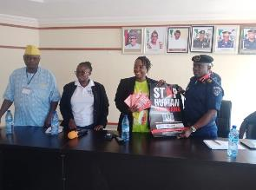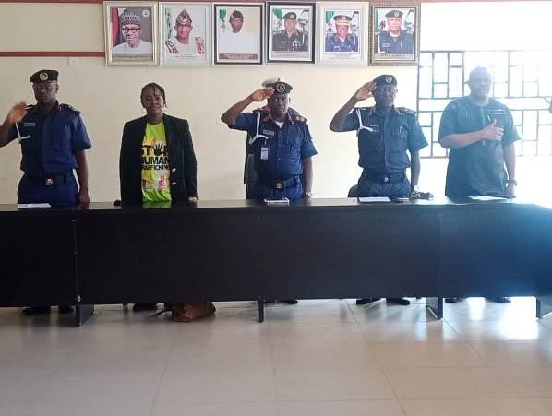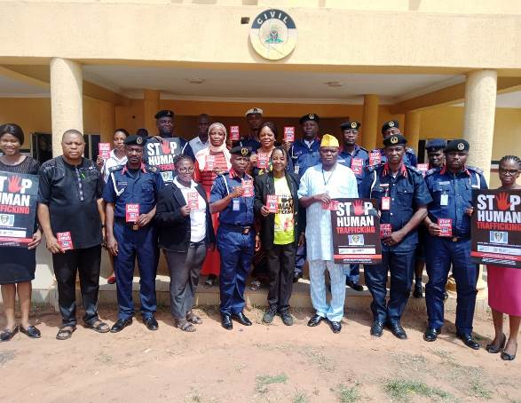
Pictures 1-3: WICCI Team on Advocacy visit to Nigeria Civil Defence Corps (NSCDC), Ogun Command. Photo credit: Ogbonnaya Dyke (NSCDC PRO)

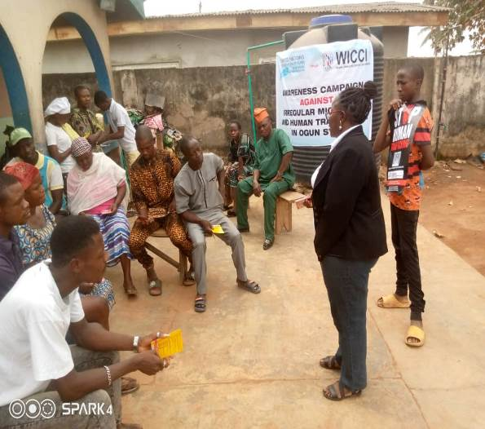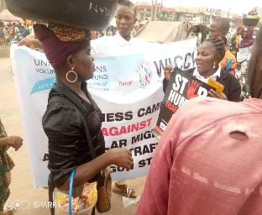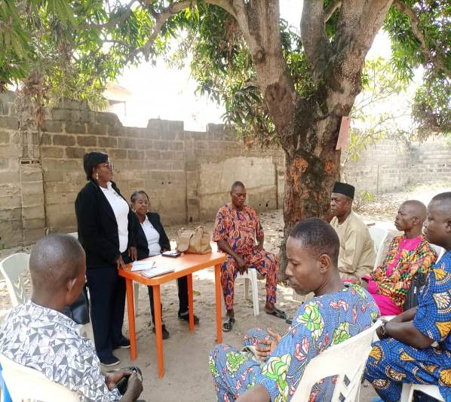
Pictures 4-6: WICCI Team conducts Sensitization and Awareness Campaign against Irregular migration and Human Trafficking at Ifo communities,
Ogun State. Photo credit: Adeleke Margaret
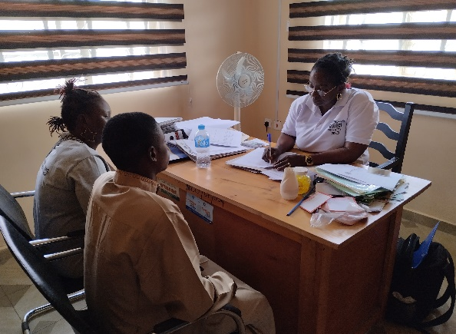
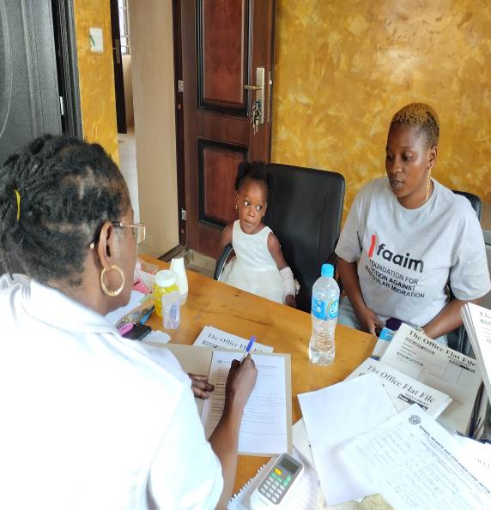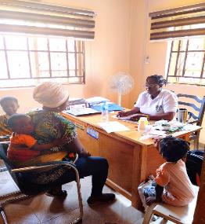
Pictures7-9: Conduct of VoT screening exercise for reintegration assistance. Photo credit: Yemisi Ademola

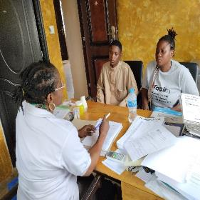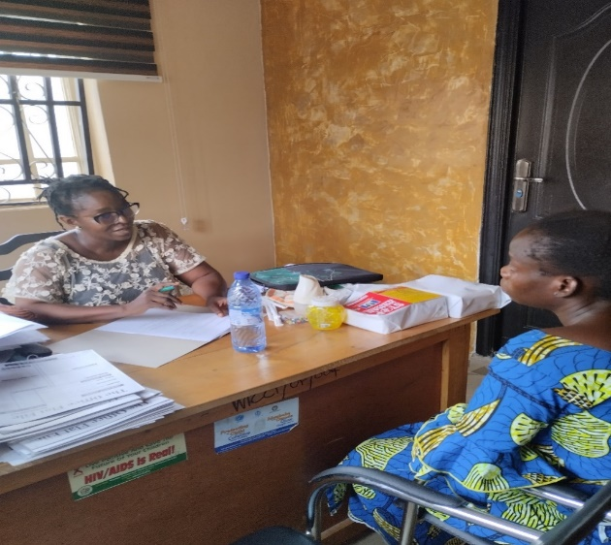
Pictures 10 &11: Conduct of VoT screening exercise for reintegration assistance. Photo credit: Yemisi Ademola
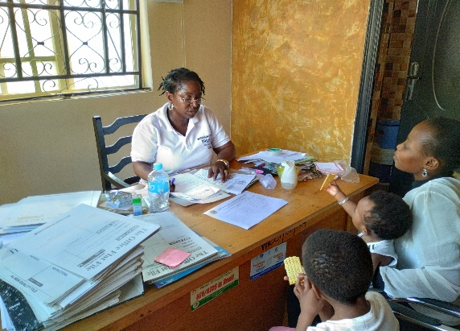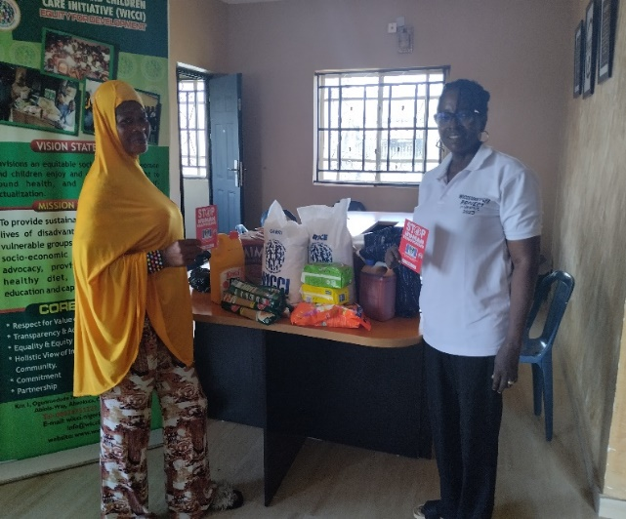
Picture 12: Screening of VoT Picture 13: Presentation of food items to VoT

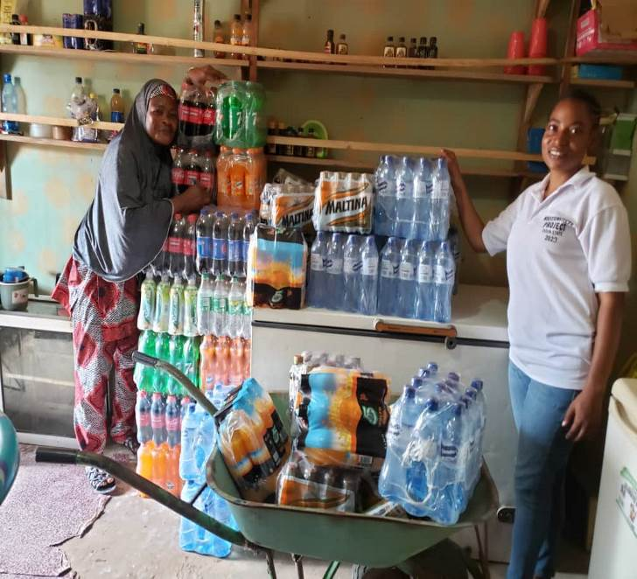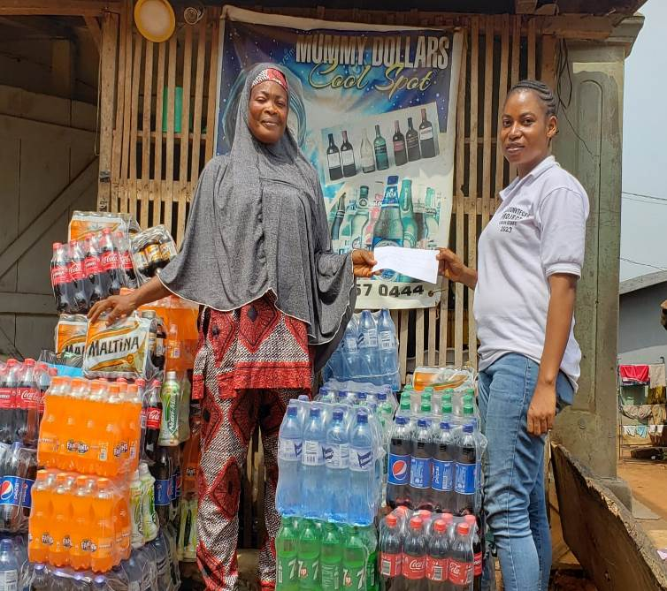

Pictures 14&15: Micro-enterprise business support to a Libya Returnee. Photo Credit: Ademola Yemisi

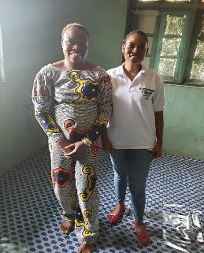 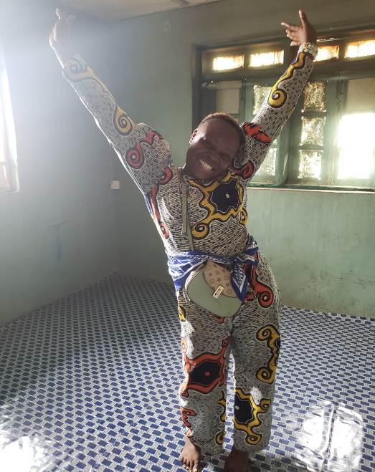 Photo Credit: Neighbour
Pictures 16-17: Pictures of a Caseworker and a Libya Returnee who was homeless and provided an accommodation (payment of a year rent).

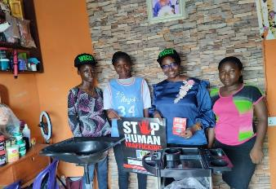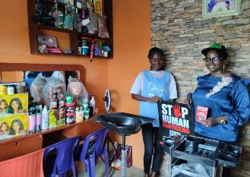

Pictures 18 &19: Establishment of micro-business for a Libya Returnee who has skill in hairdressing Photo credit: Oluwabusolami Mojisola

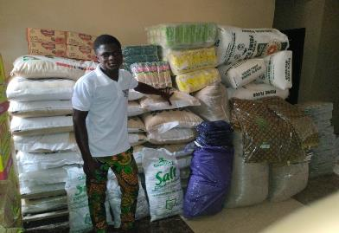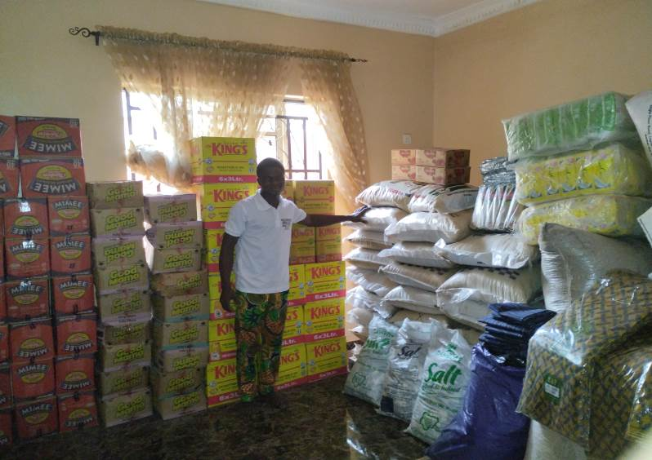
Picture 20 & 21: WICCI volunteer with the food commodities, clothing, sanitary towel and other materials
Photo Credit: Doyinsola Adebayo
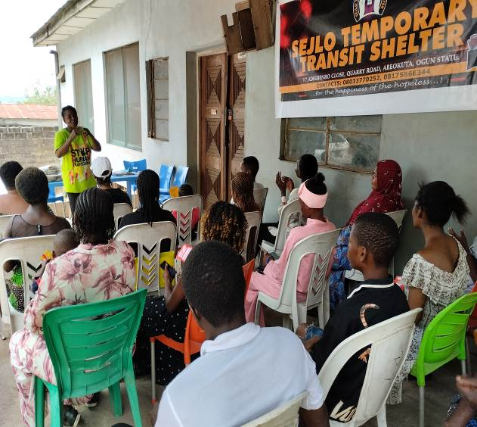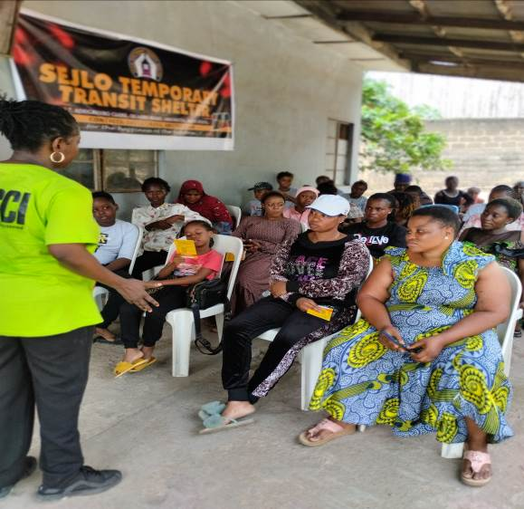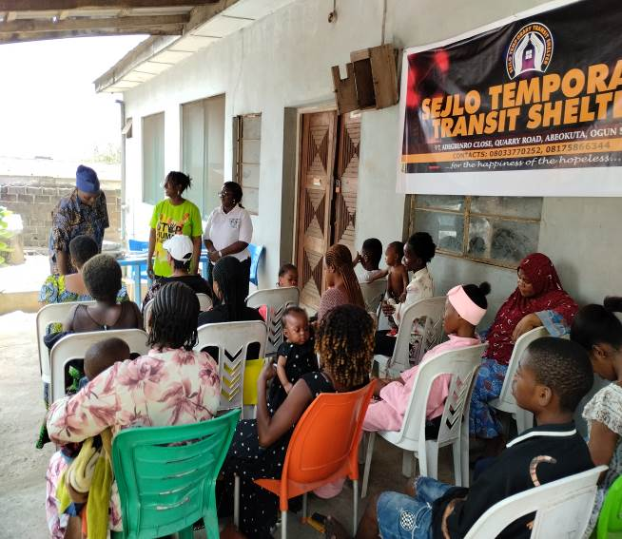
Pictures 22-24: Counselling session and sensitization against stigmatization and building their self-esteem. Photo Credit: Yemisi Ademola

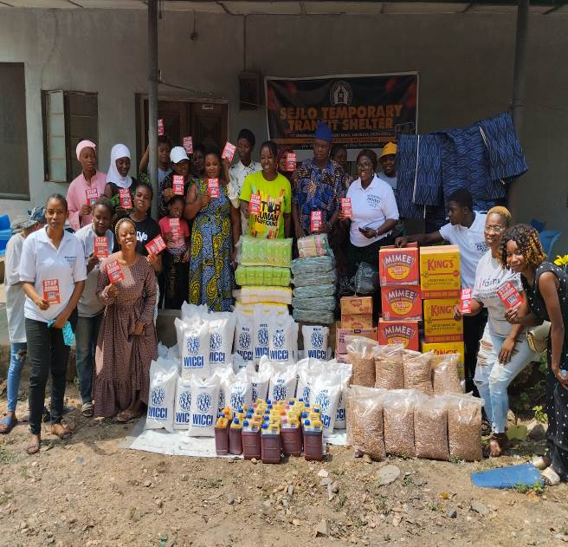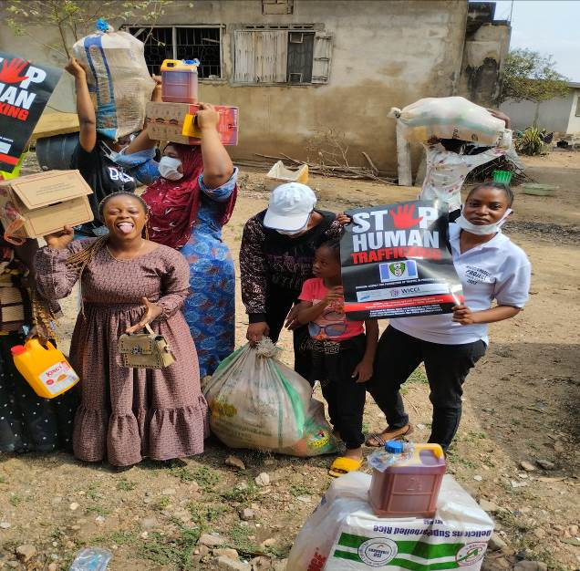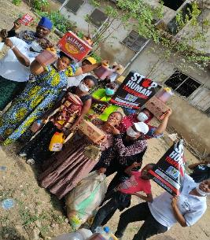
Pictures 25-27: Humanitarian support to VoT. Photo Credit: Adams
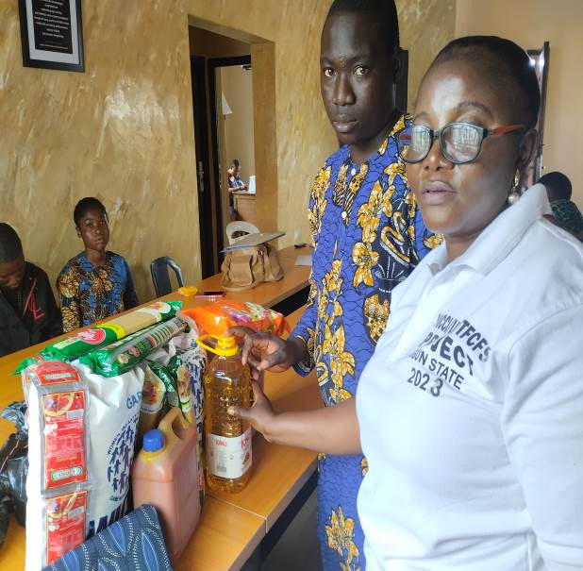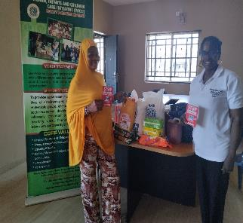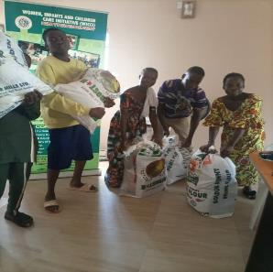
Pictures 28-30: Food support, clothing and other material assistance to VoT. Photo credit: Yemisi Ademola

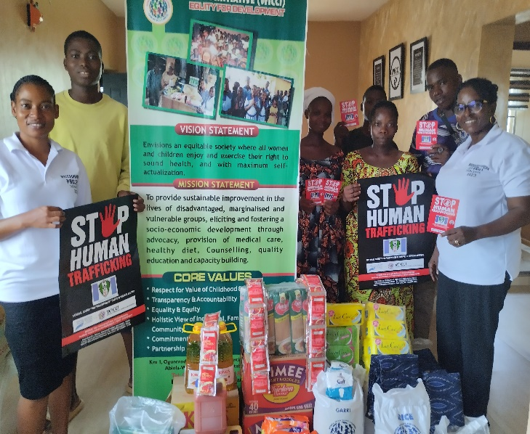 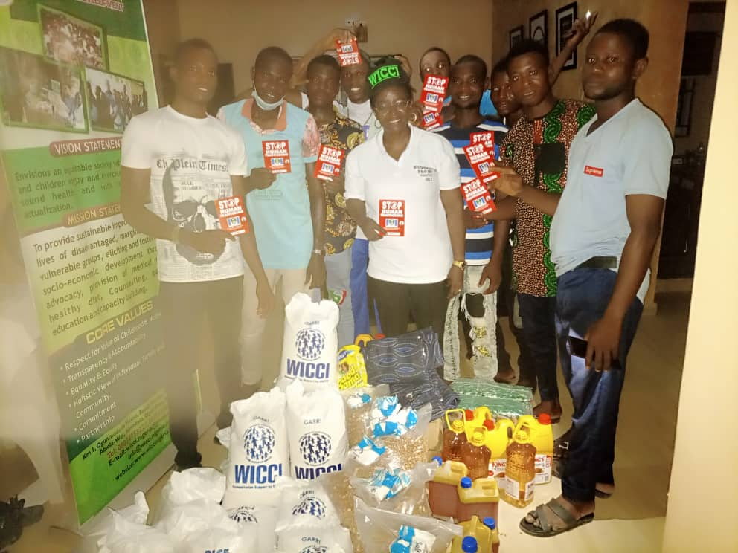 Picture 31: Provision of Humanitarian aid to VoT Picture 32: Returnees from Ivory Coast receiving humanitarian assistance
Photo credit: Margaret Adeleke

Pictures 33-36: below WICCI Team conducting Sensitization Campaigns against Irregular migration and Human Trafficking at Ipokia community,
Ogun State. Photo credit: Adeleke Margaret

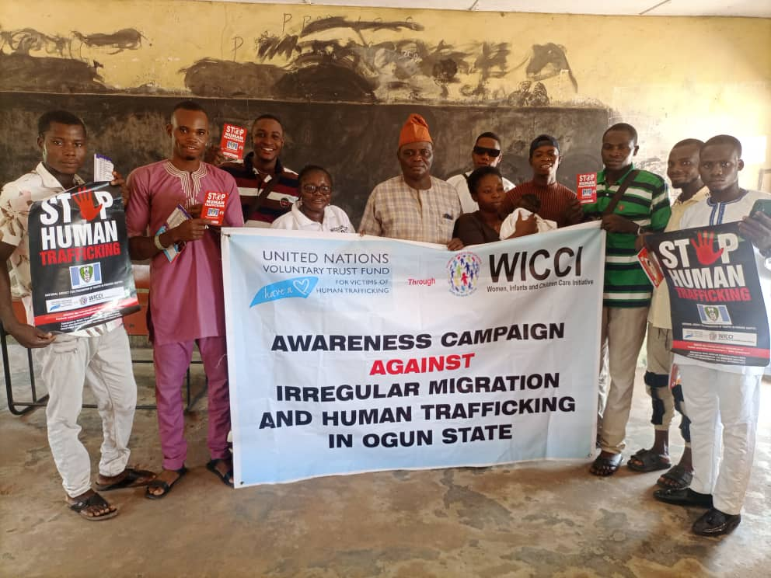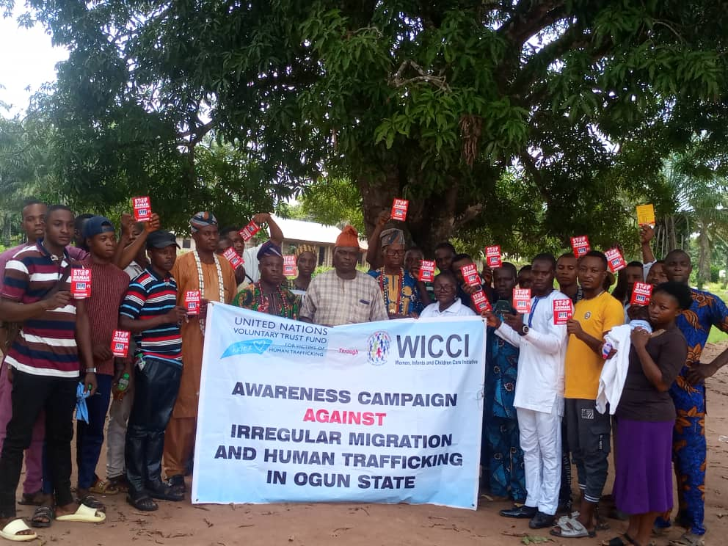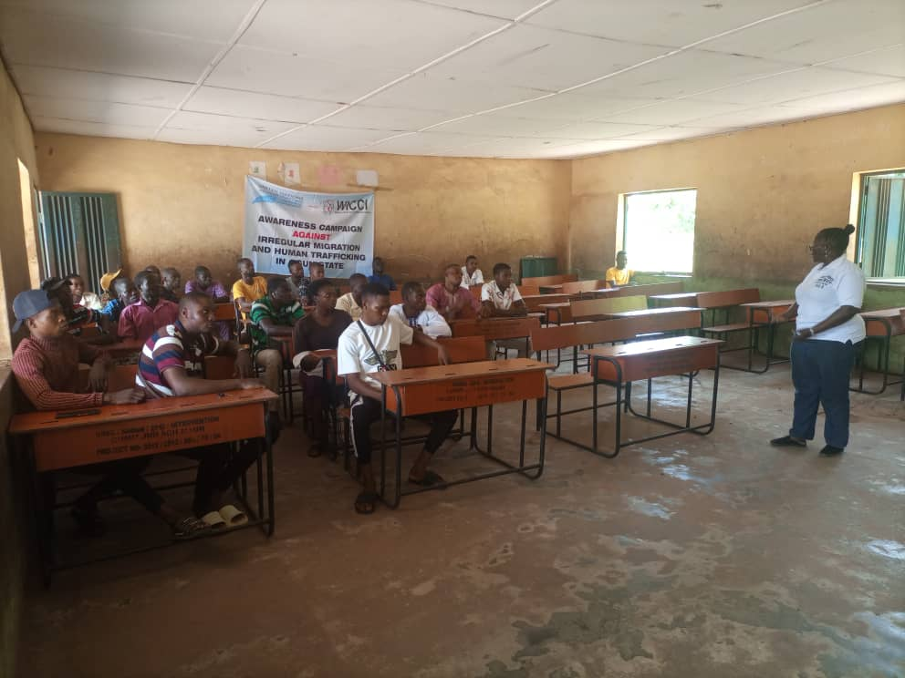
Pictures 33: Picture 34 Picture 35

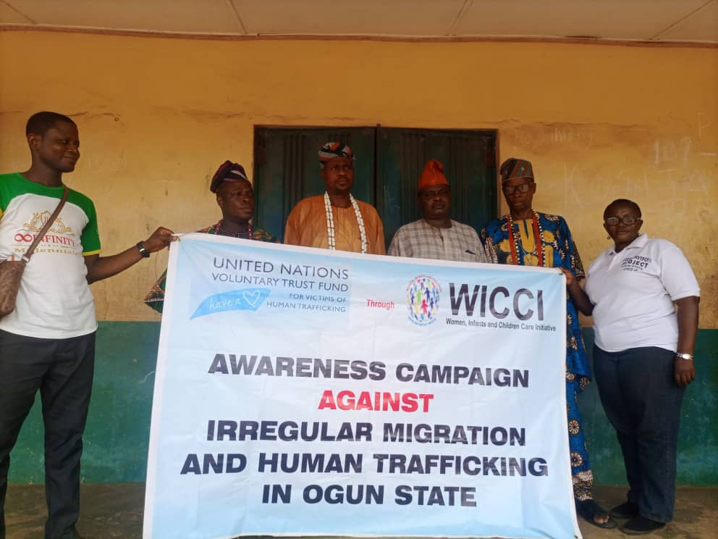 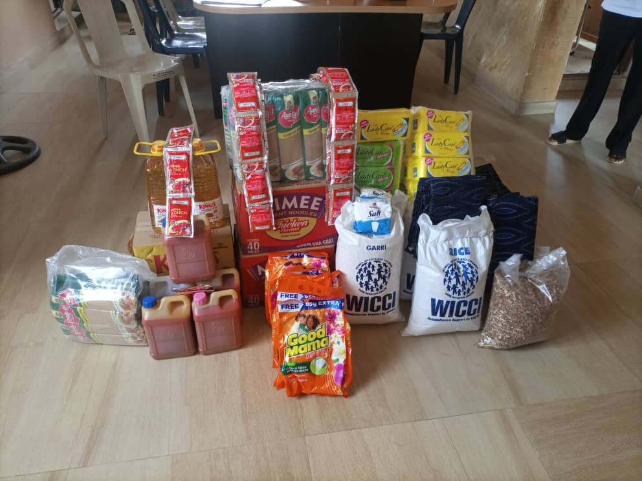 Picture: 36 Picture 37: Sample Food assistance given to the beneficiary. Photo Credit: by Oluwapelumi

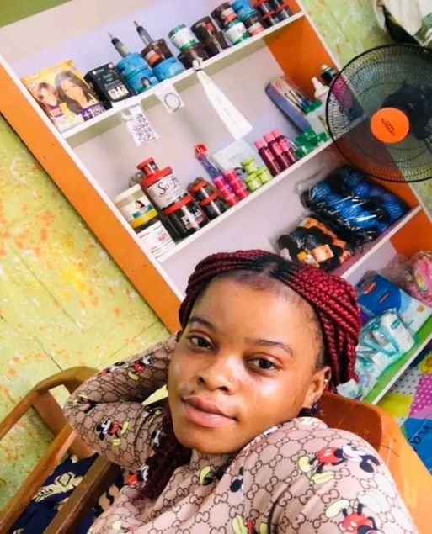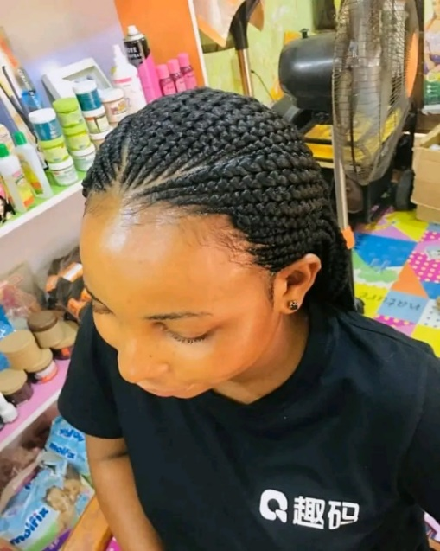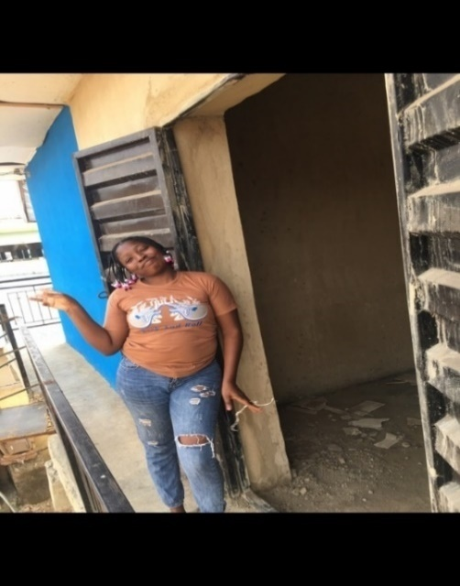
Picture 38: VoT in her new shop Picture 39: A customer with a new hairdo Pic.40&41: Showing a beneficiary in her new shop ready for setting up with
Photo Credit by: Ademola Oluwayemisi Start-up tools

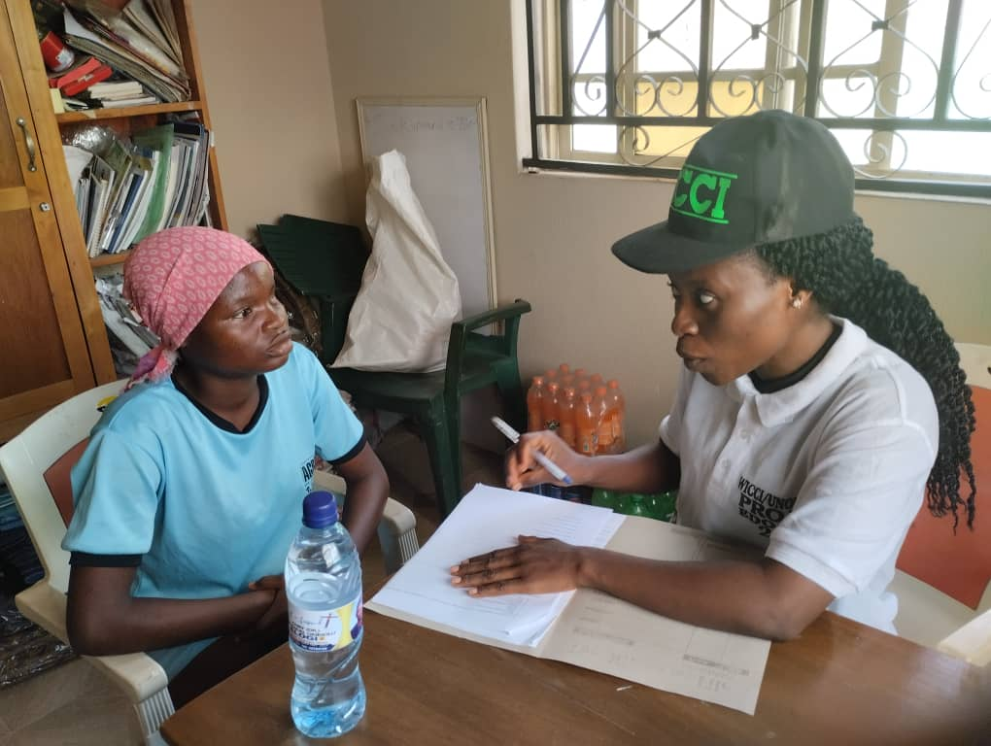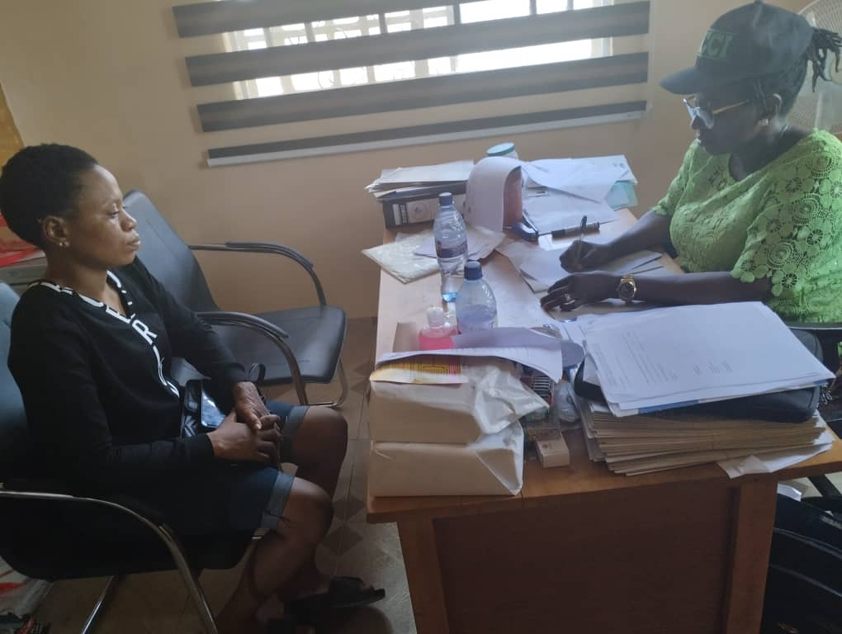
Pic. 42-43: Screening of survivors at WICCI’s office by caseworkers – Photocredit by: Tobiloba Emmanuel
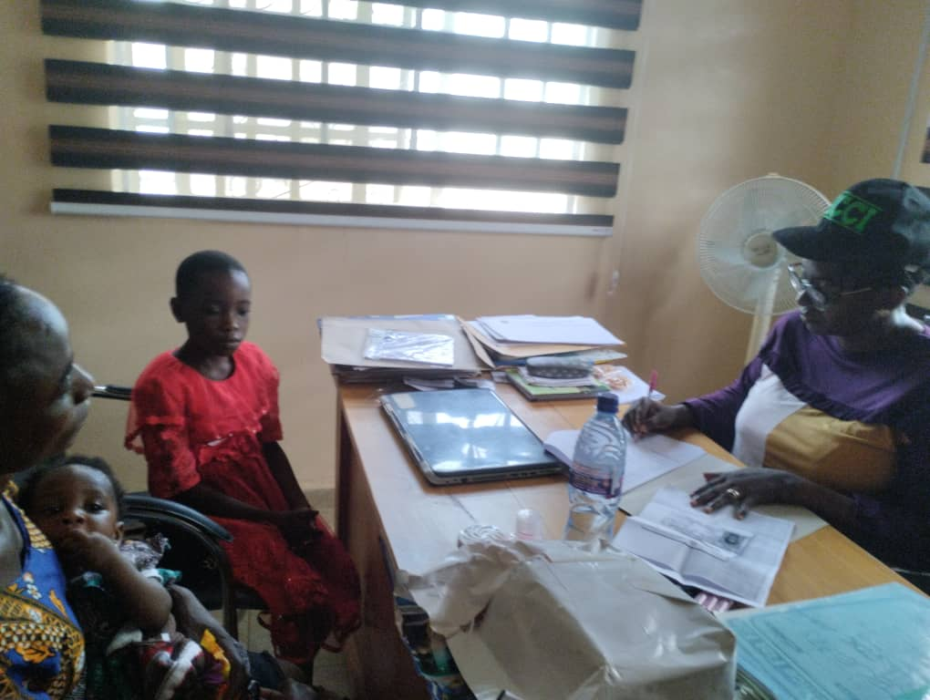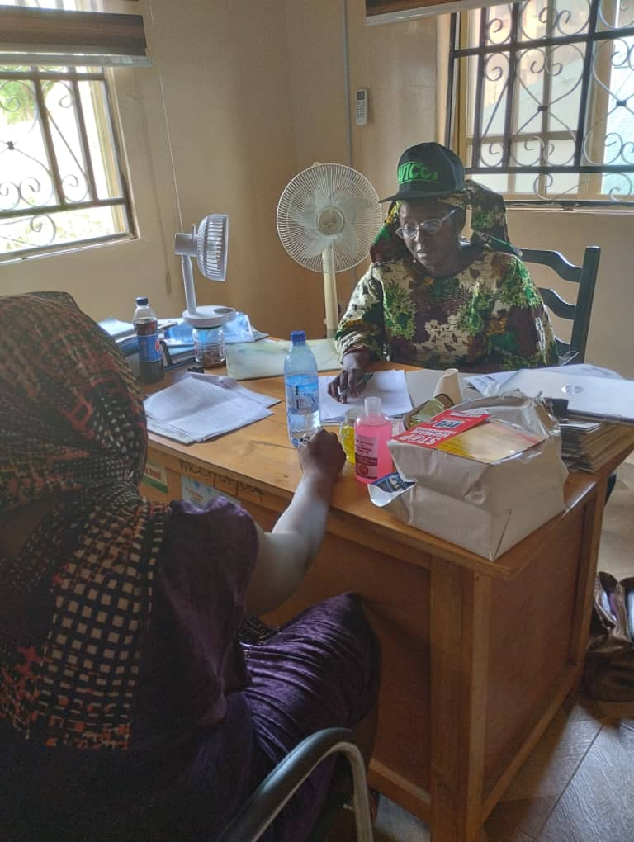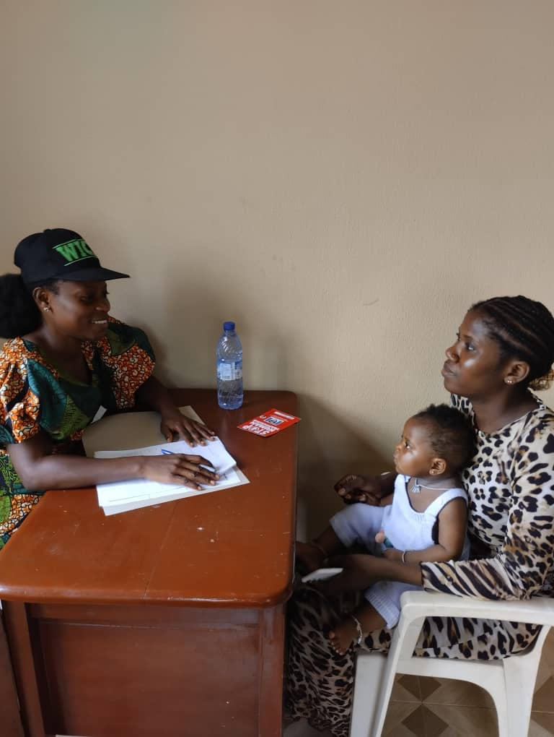
Pic. 44-46: Screening of survivors at WICCI’s office by caseworkers – Photocredit by: Tobiloba Emmanuel

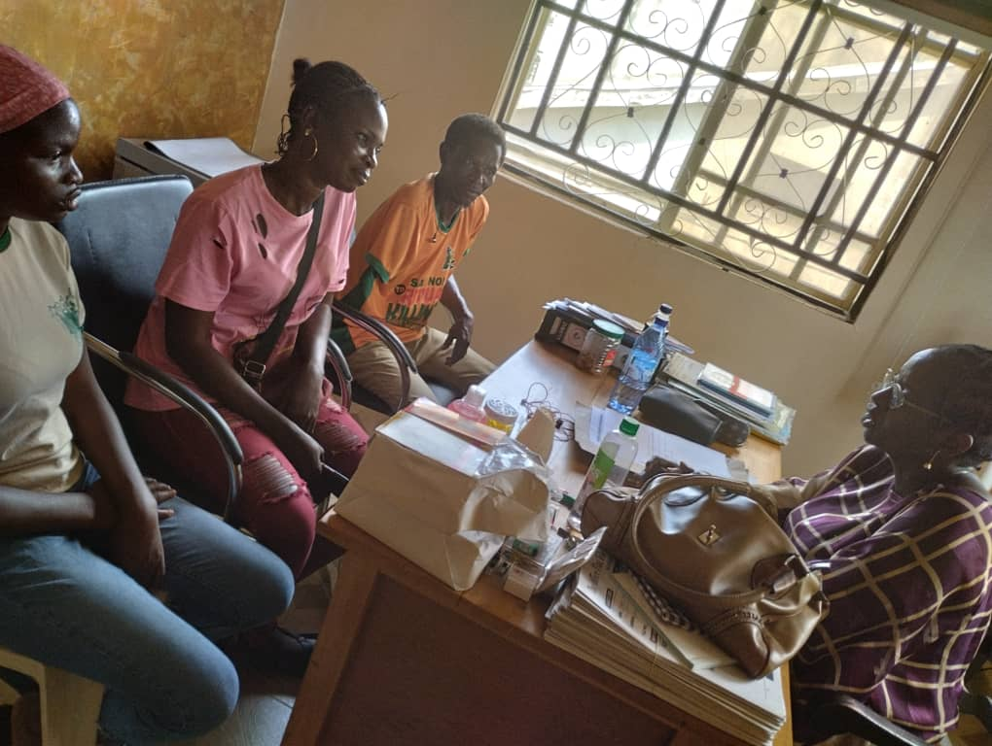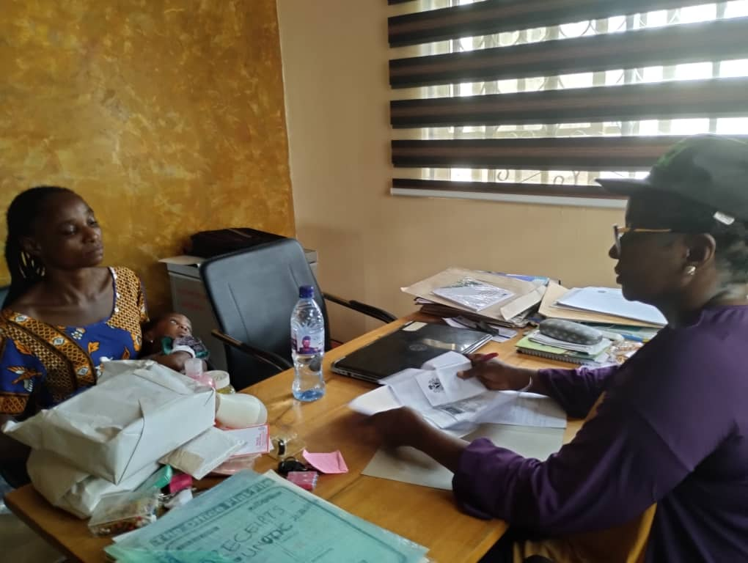
Pic.47-48: Counselling of victims on the reintegration process by Doyinsola Adebayo – Photocredit by: Tobiloba

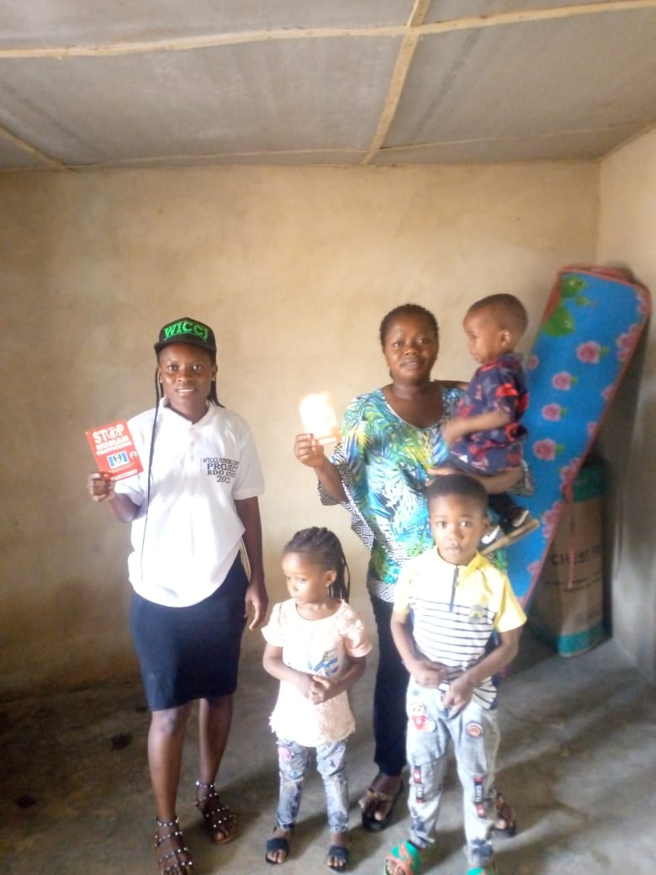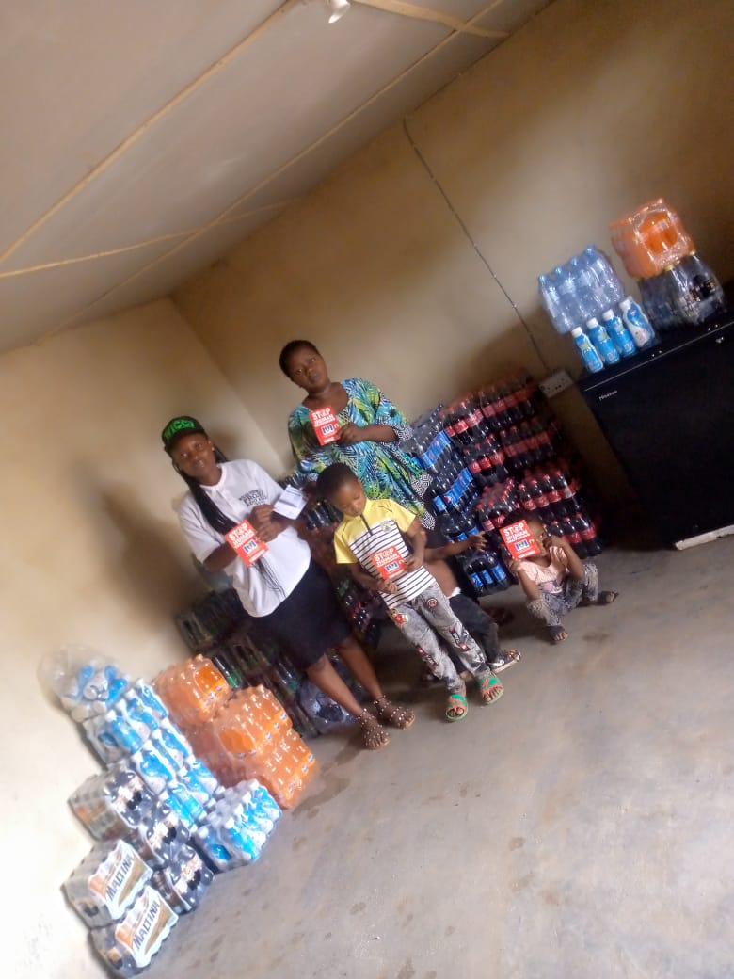
Pic.49-51: Empowerment of a beneficiary (widow) with soft drinks and juice (pictures of Before and After the empowerment)

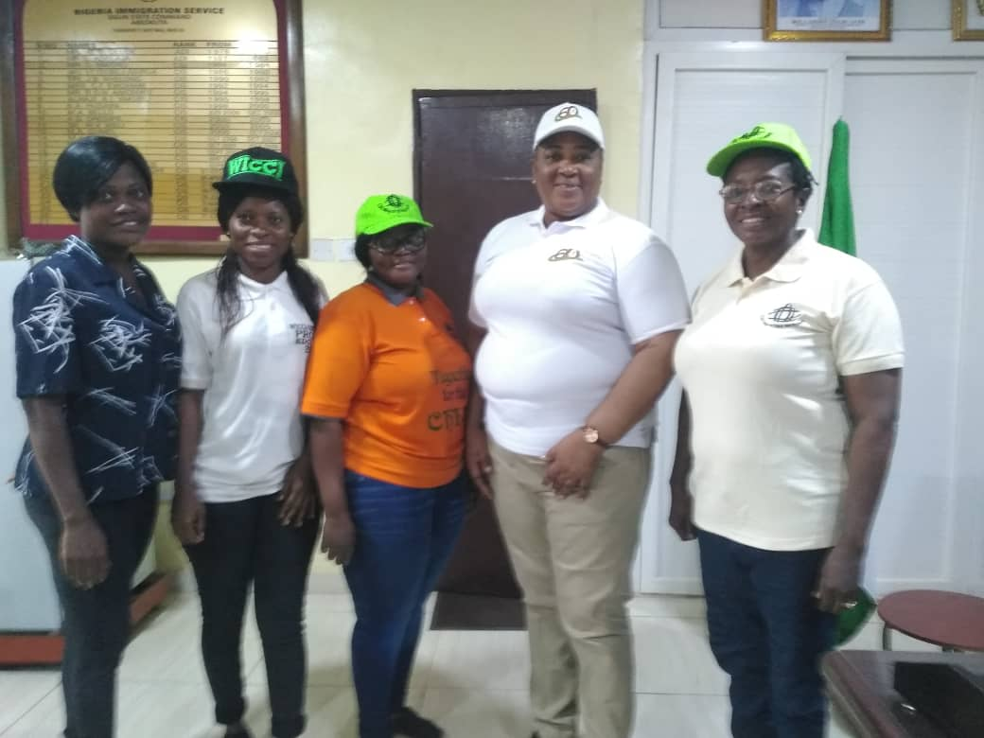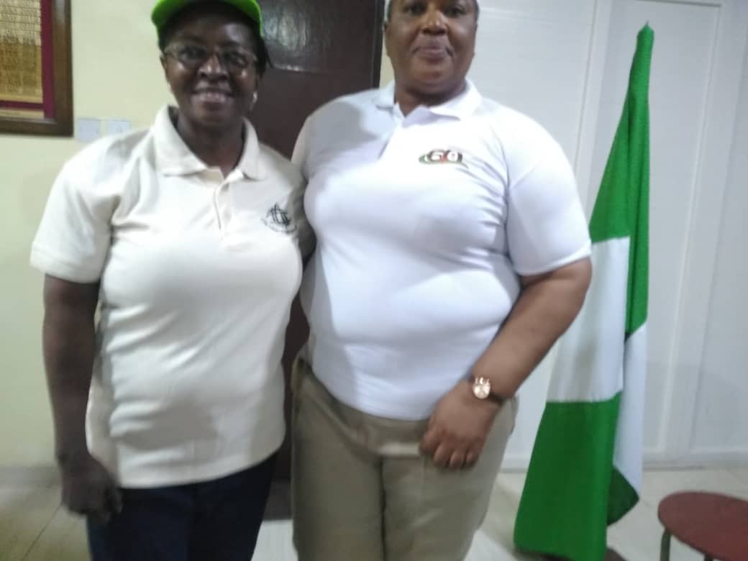
Pic. 52: WICCI Team on an Advocacy visit to Ogun State Commandant Nigeria Immigration Service on 2/8/2023. Photo Credit by: NIS PRO

Pictures 53-56 below: WICCI collaborates with Nigeria Immigration Service to celebrate World Trafficking against TiP

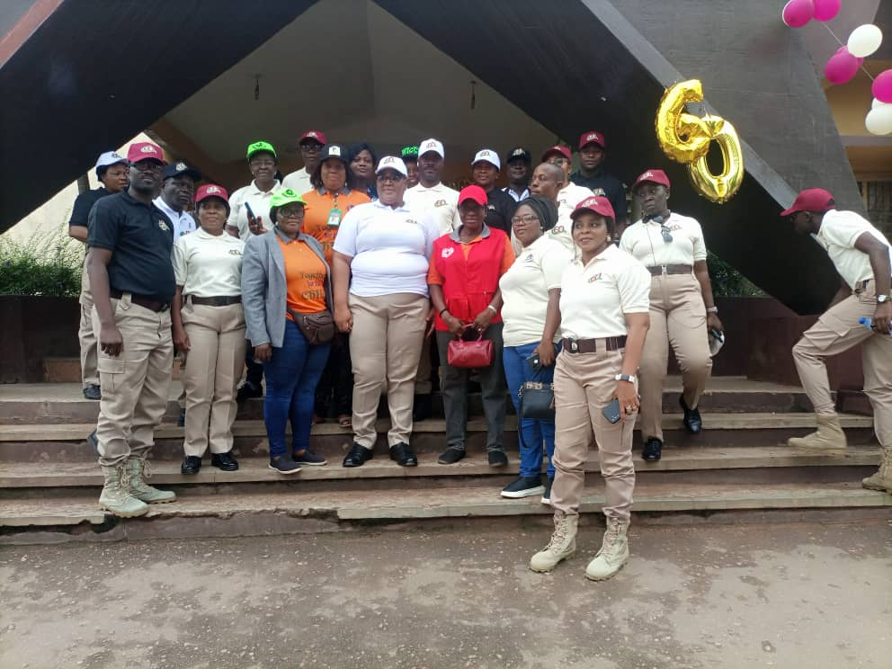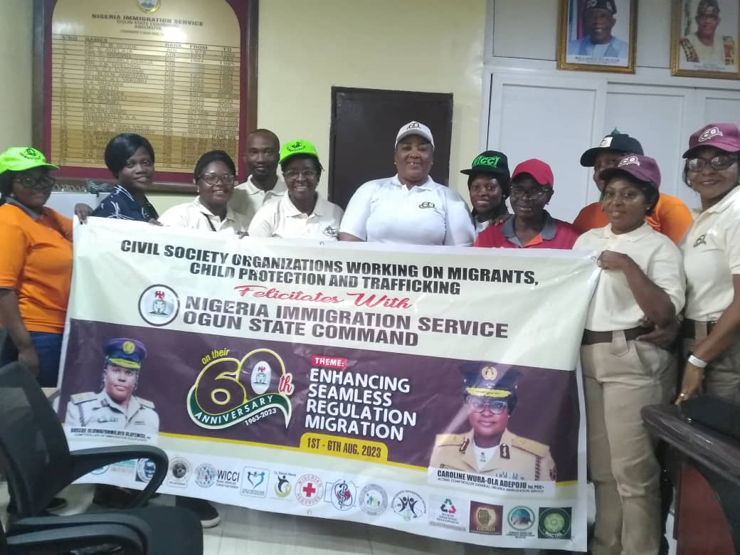

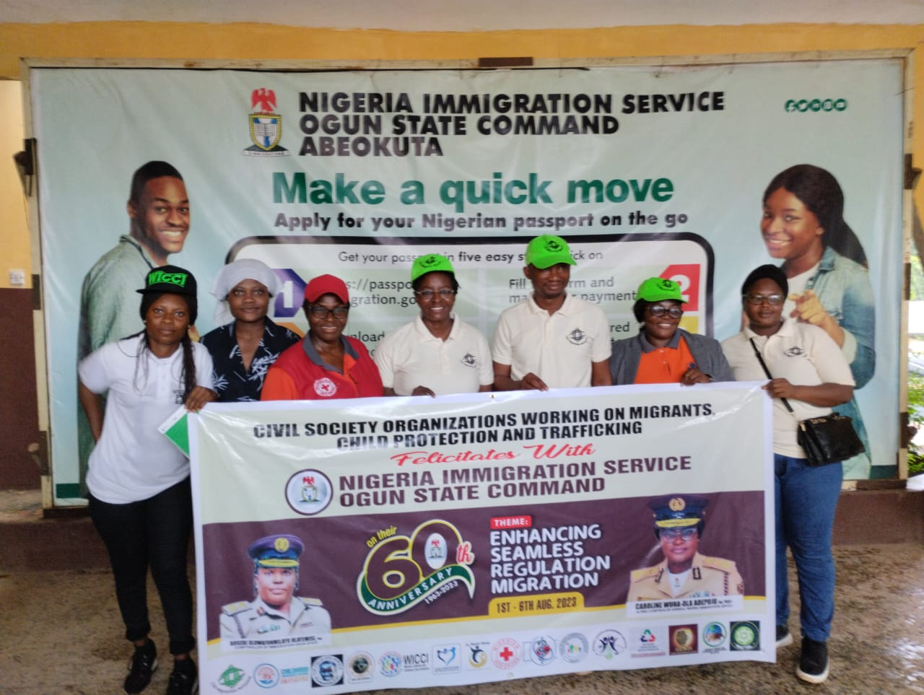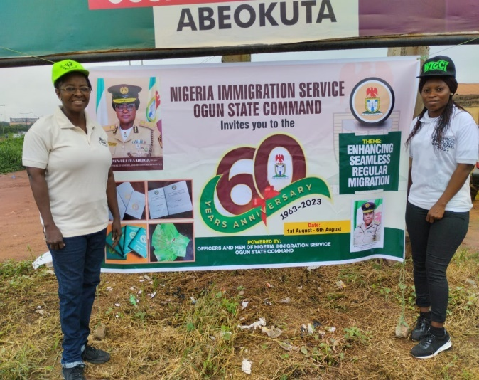

Pictures 57-64 below: Training of VoT in Business Management Skills Training Workshop held on 6th July 2023. Photocredit: Deborah

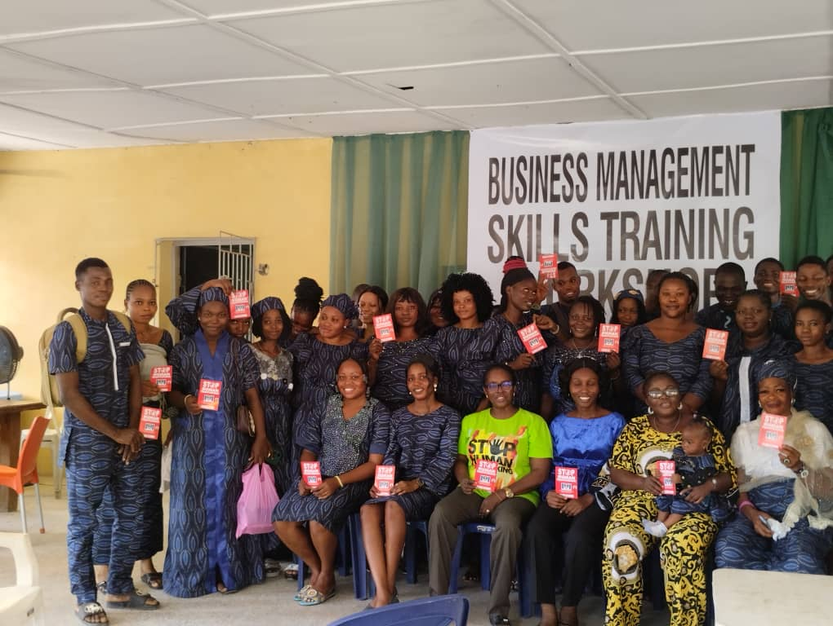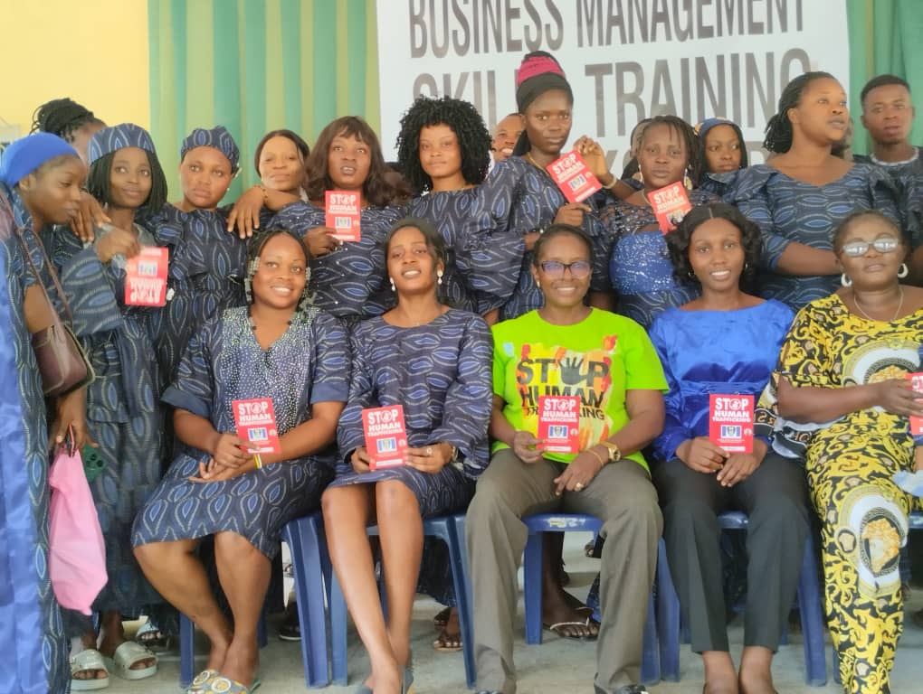

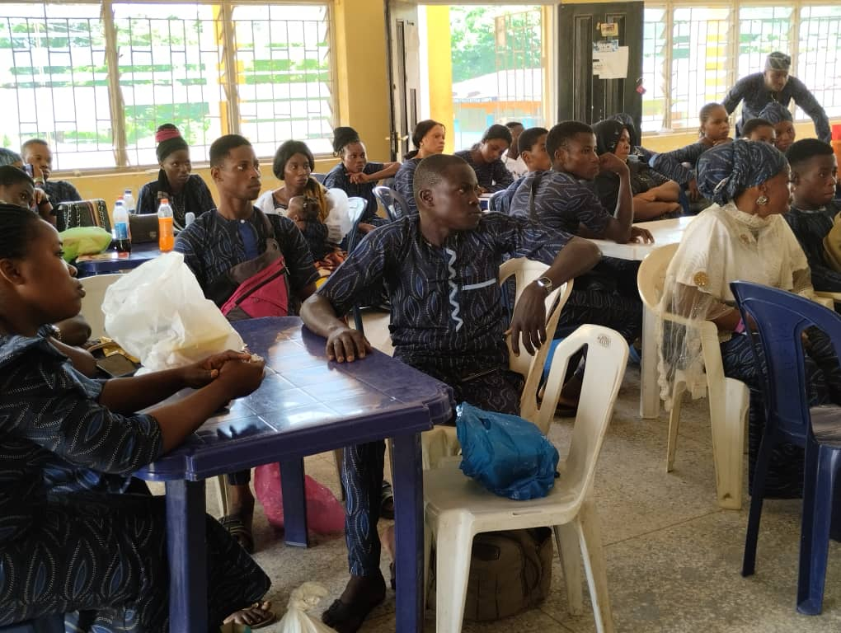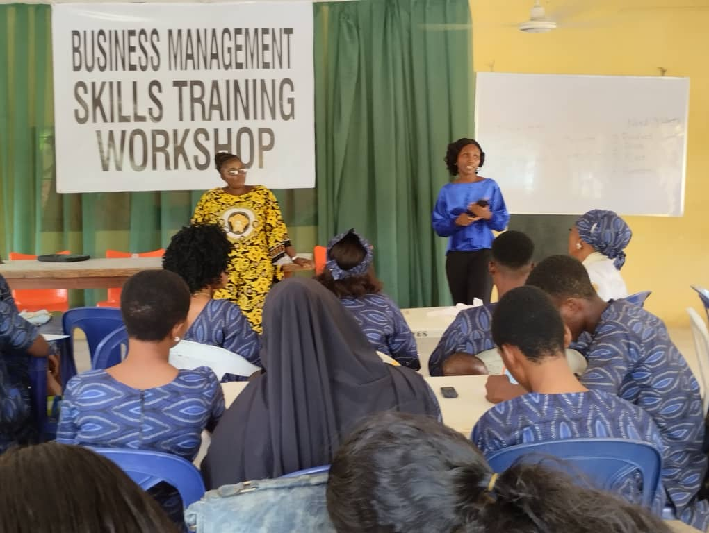
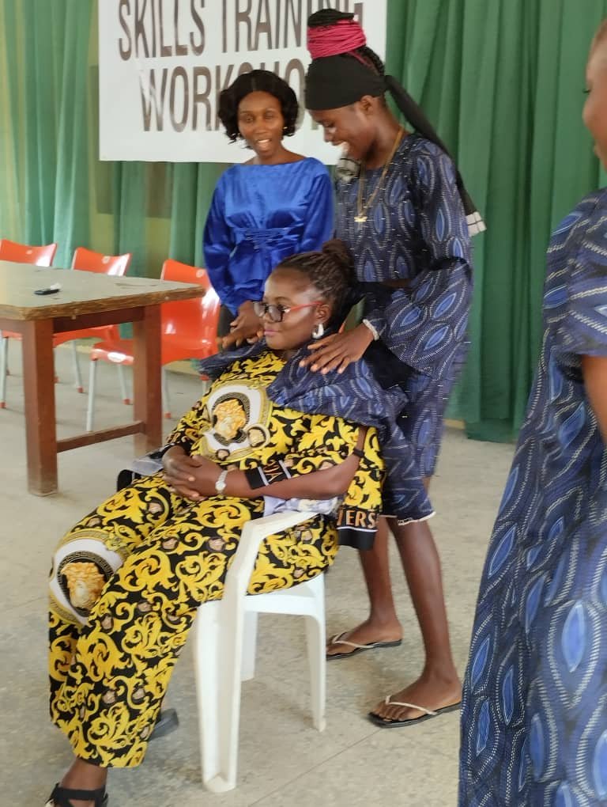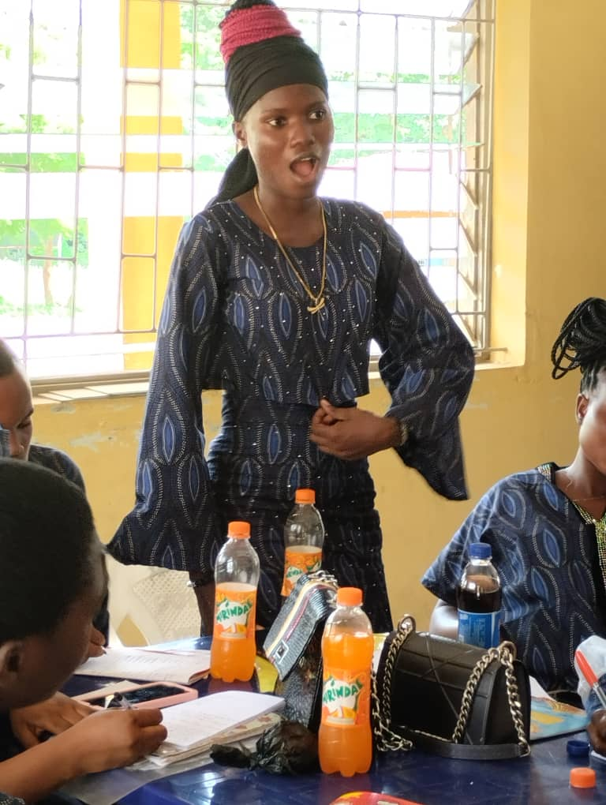
Practical: VoT showing how to attend to a customer One of the beneficiaries answering a question during the workshop
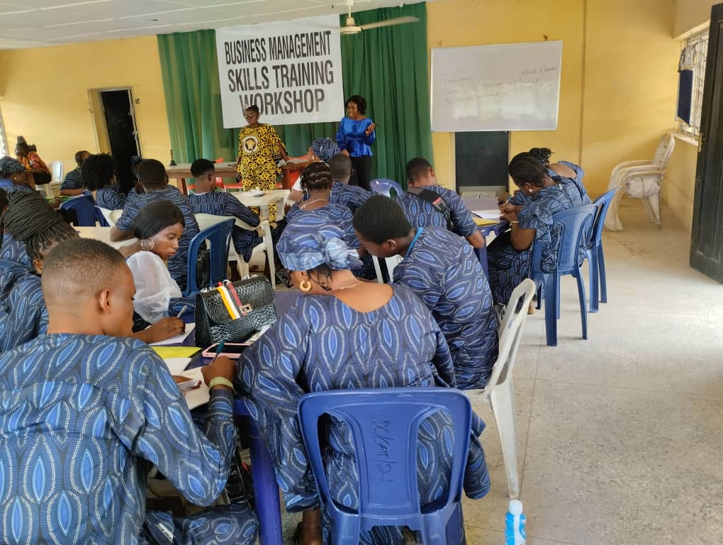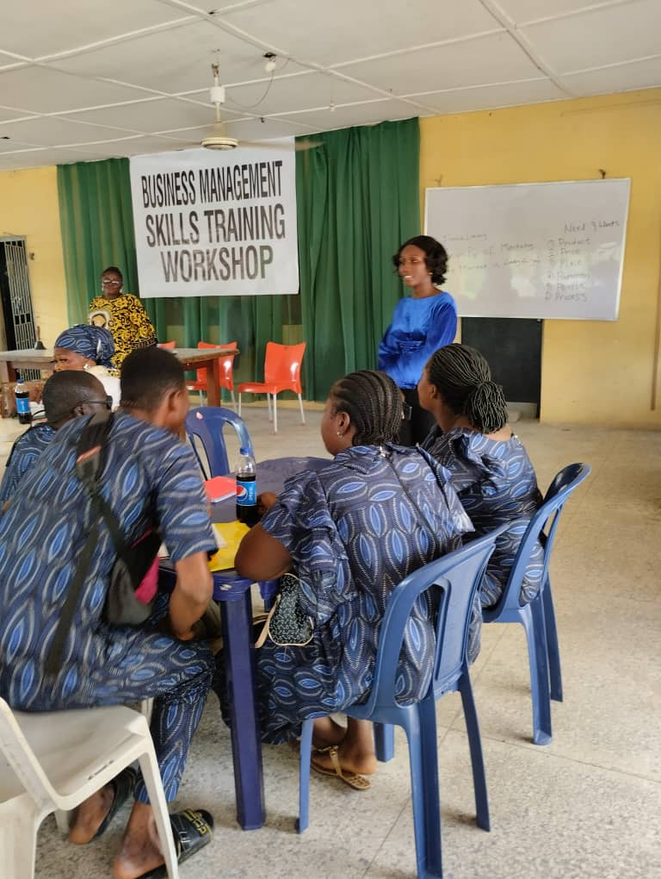
Cross-section of the participants during the workshop
Pictures 65-71: donation of food items and mattresses to Internally Displaced Persons community at Ijebu-Ode, Ogun State
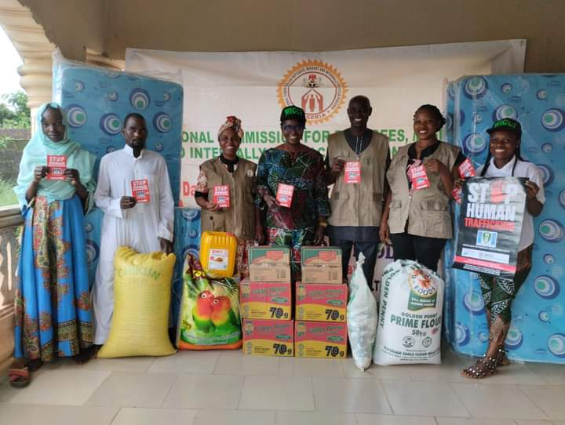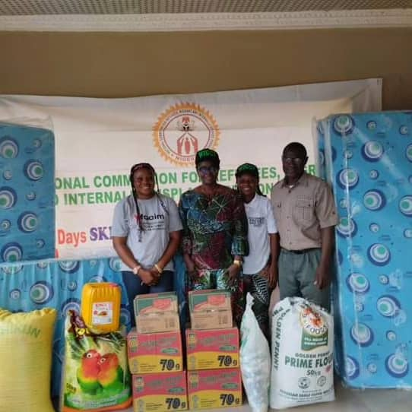

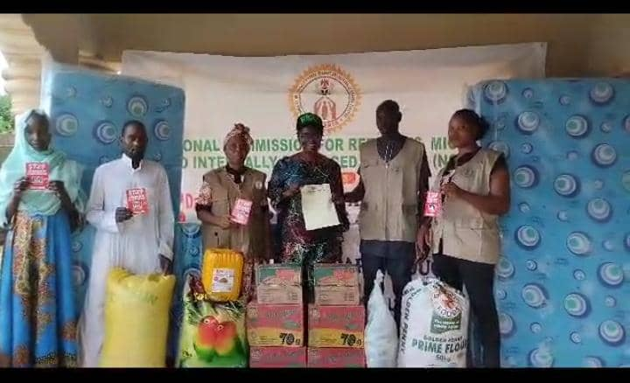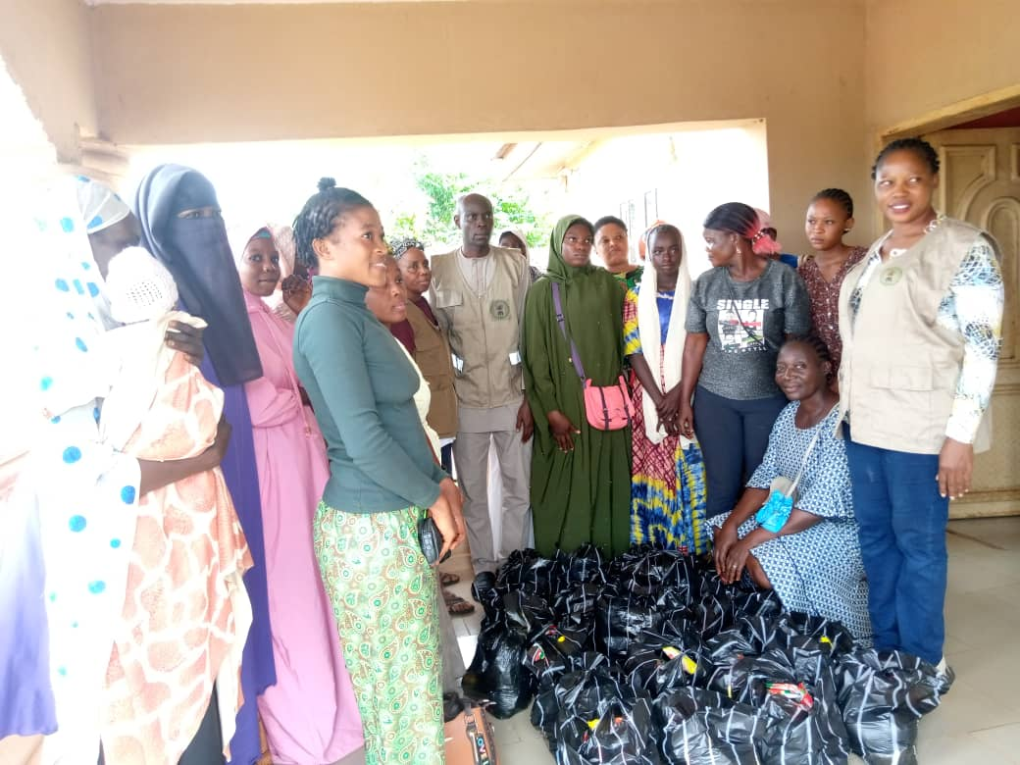
Presentation of an Appreciation Letter, on behalf of the Hon. Federal Commissioner of National Commission of Refegees, Migrants and
Internally Displaced Persons (NCFRMI) to WICCI ED by the Program Head of NCFRMI Office at Ijebu-Ode

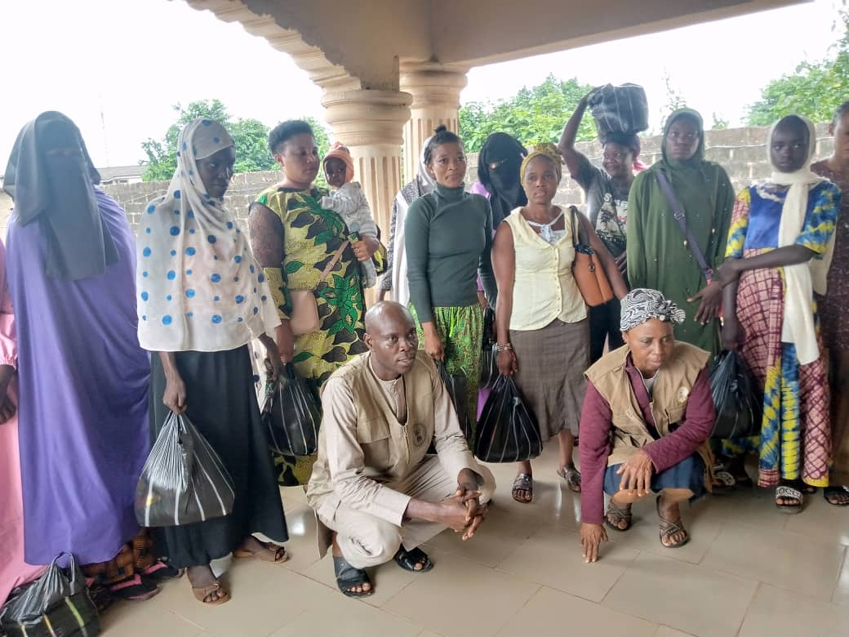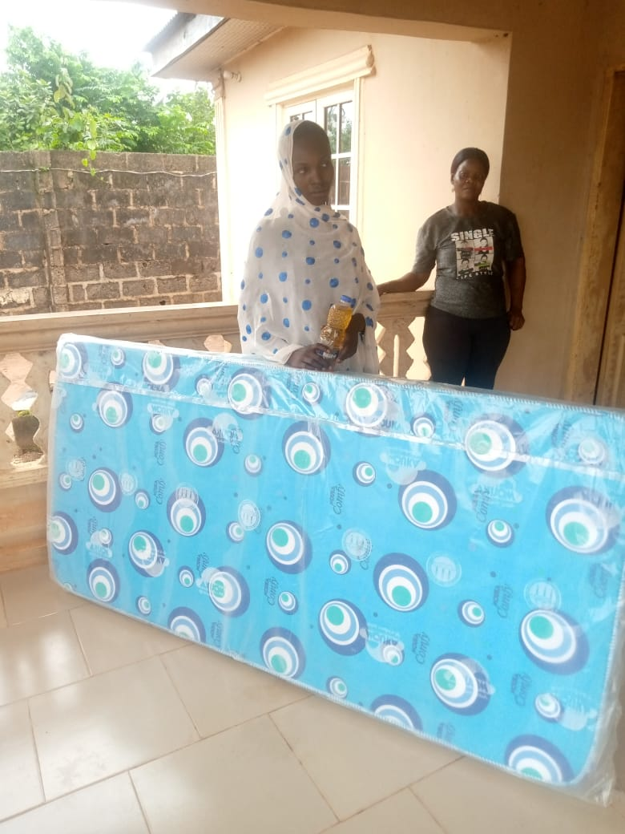

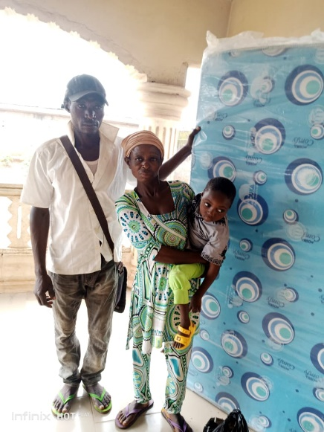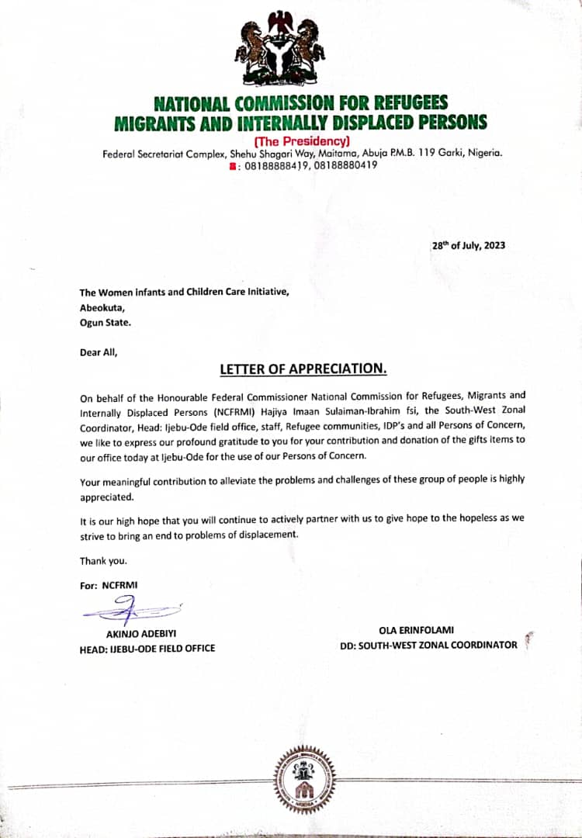
Beneficiaries of the food stuff and mattresses.
Photo Credit: NCFRMI Social Worker Pic. 72: LETTER OF APPRECIATION FROM NCFRMI

FOURTH QUARTER PICTURES – SEPTEMBER TO NOVEMBER 2023
- Pictures 73-81 showing the VoT during screening exercise
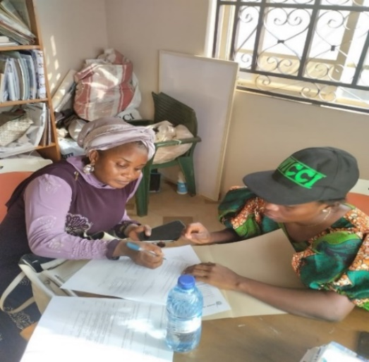 `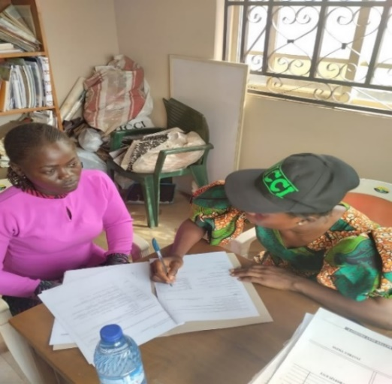 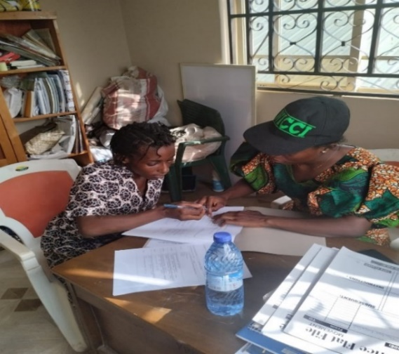

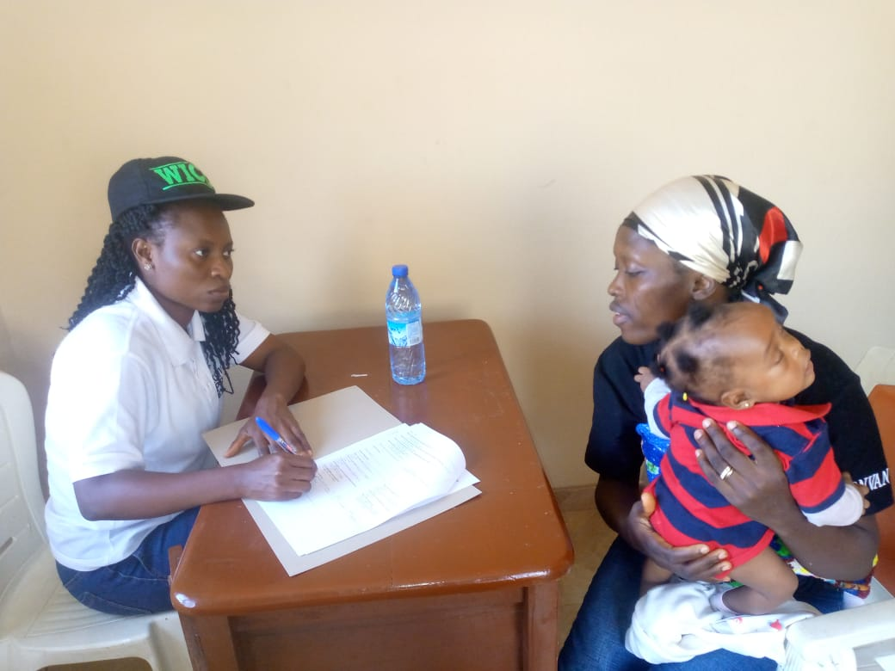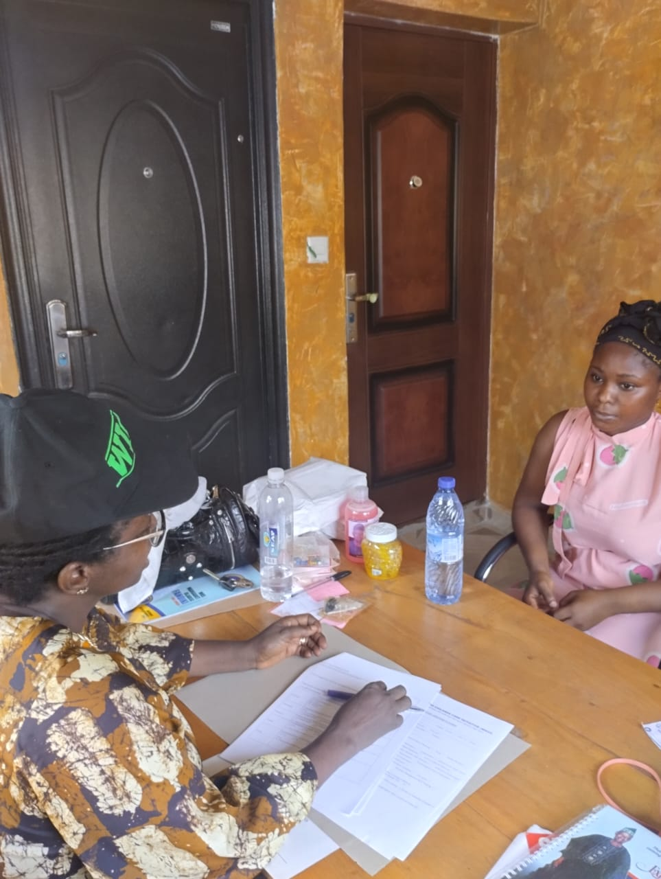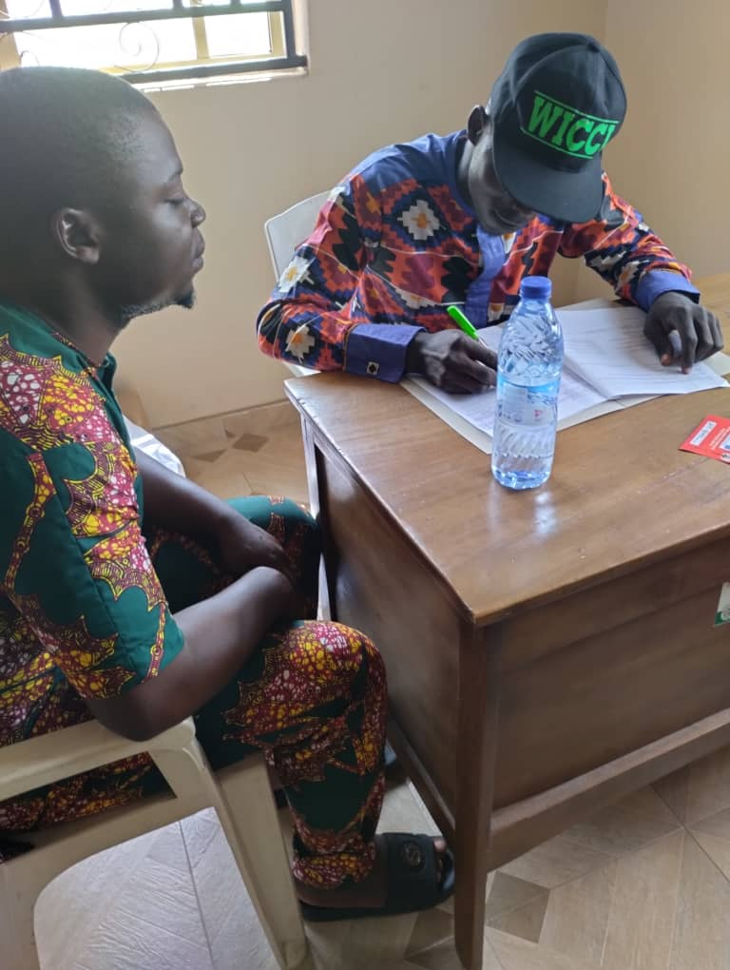
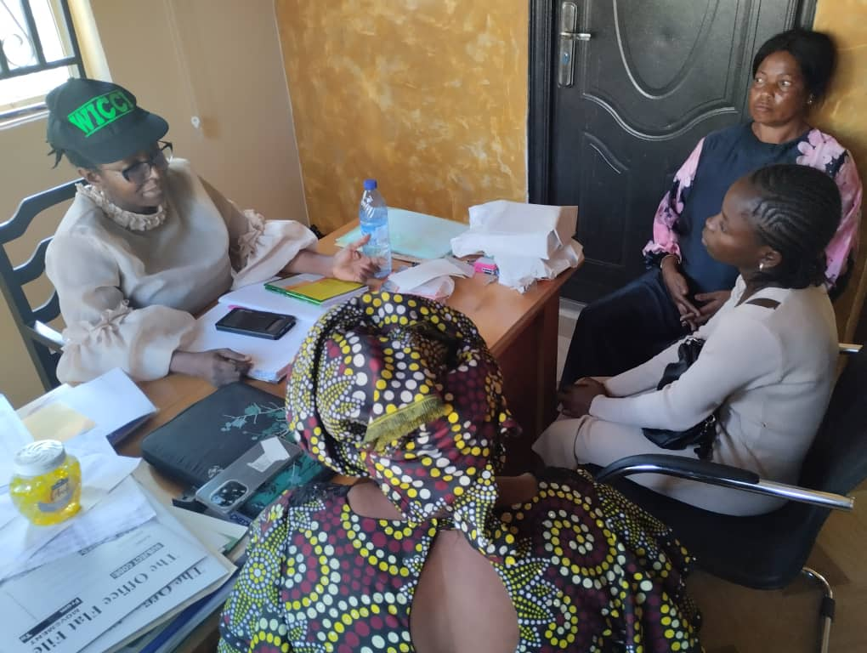
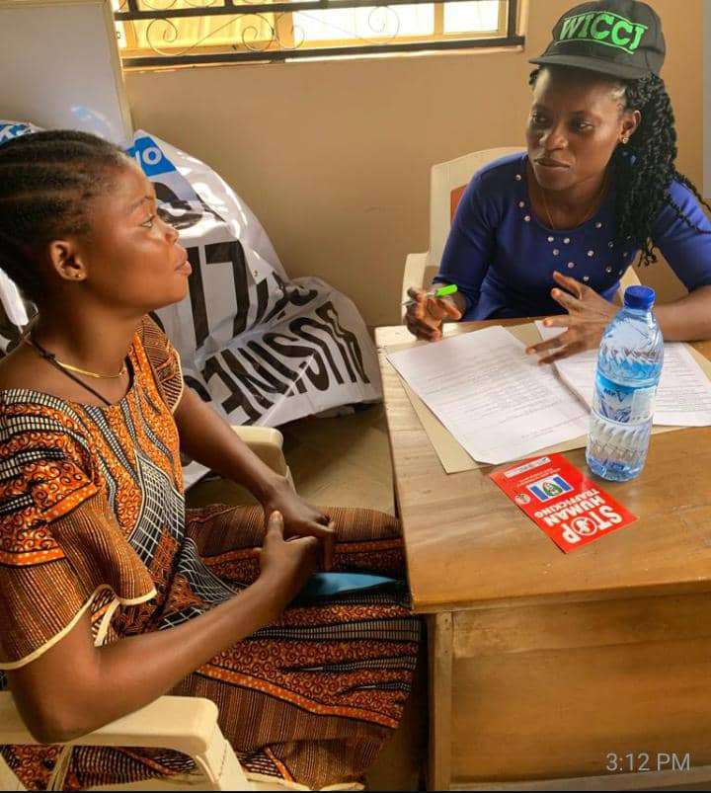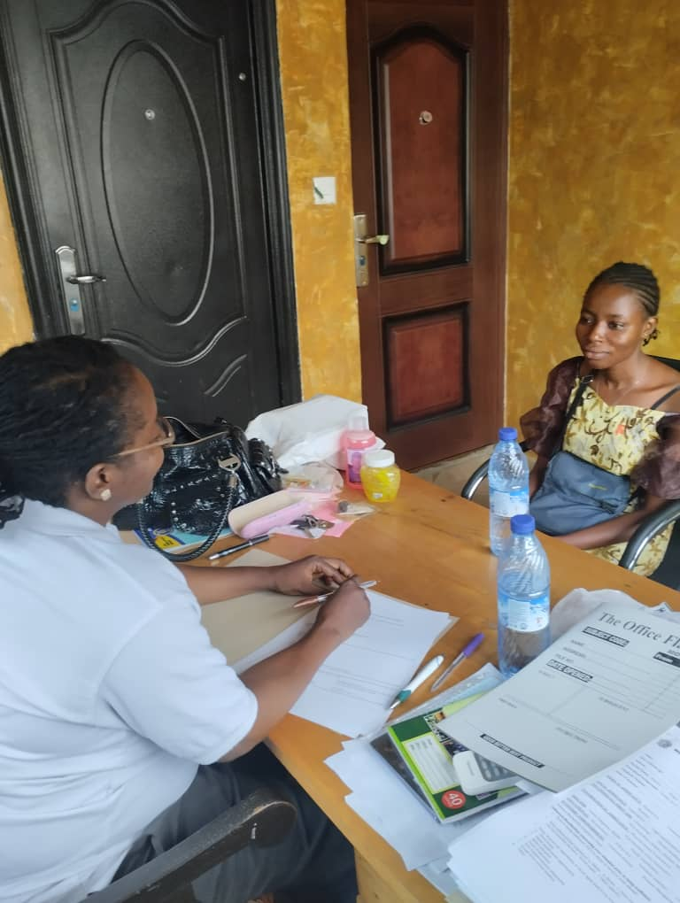

- Humanitarian Assistance – Pictures 82- 86
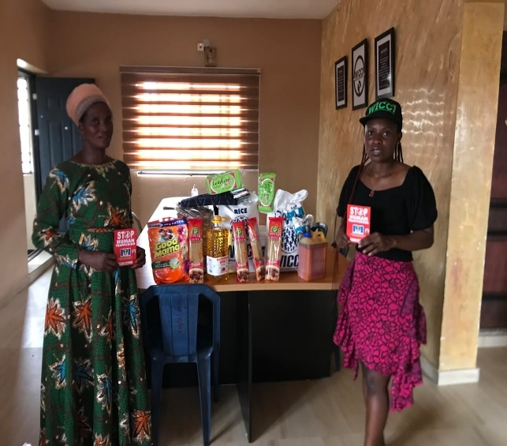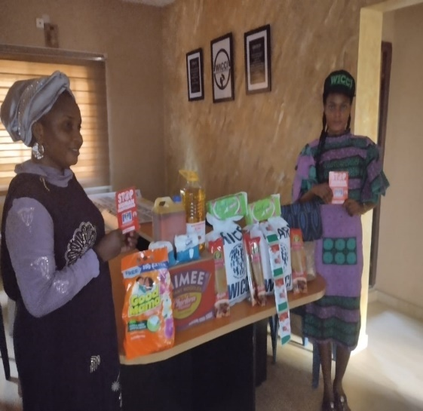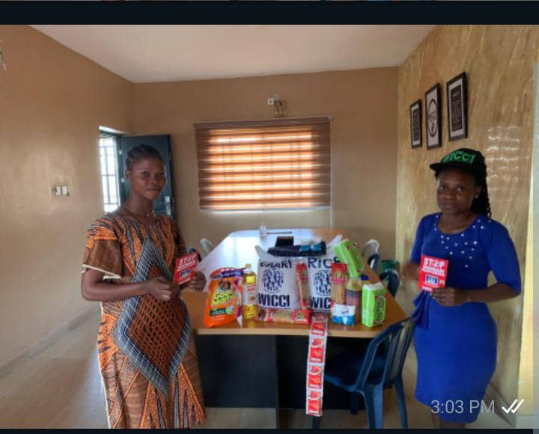

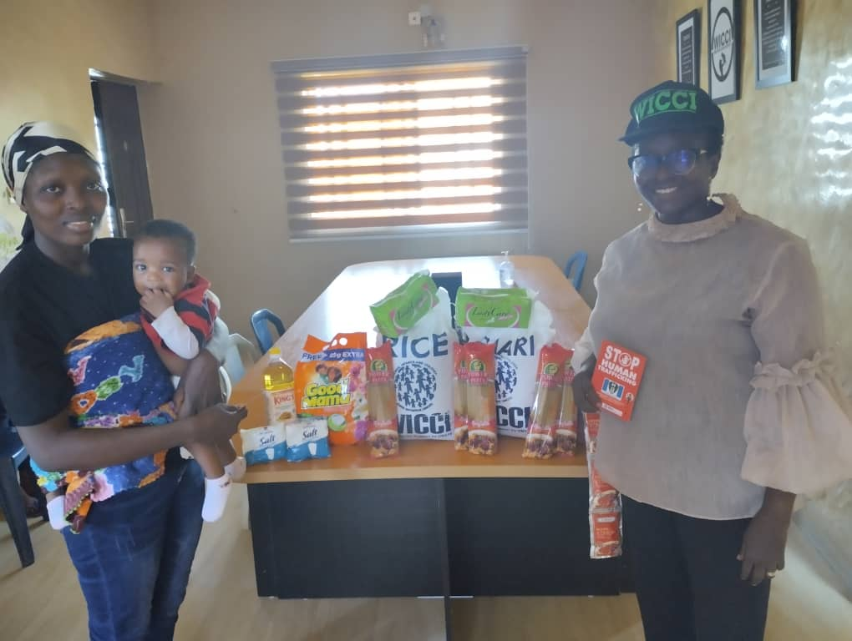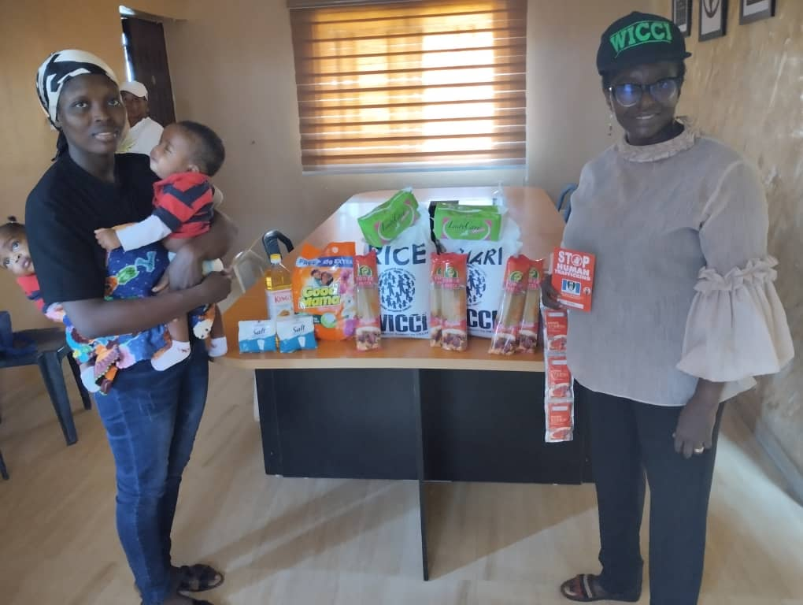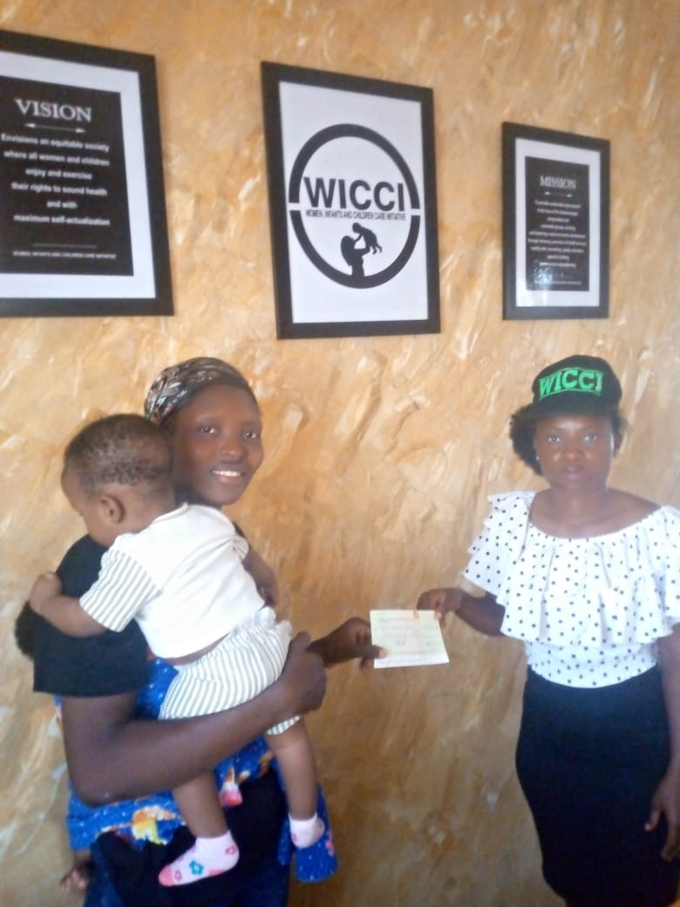

Pic.87: Payment for an accommodation
3. A gift of a flex banner in appreciation of WICCI by members of People with Disabilities network (Pictures 88 & 89)

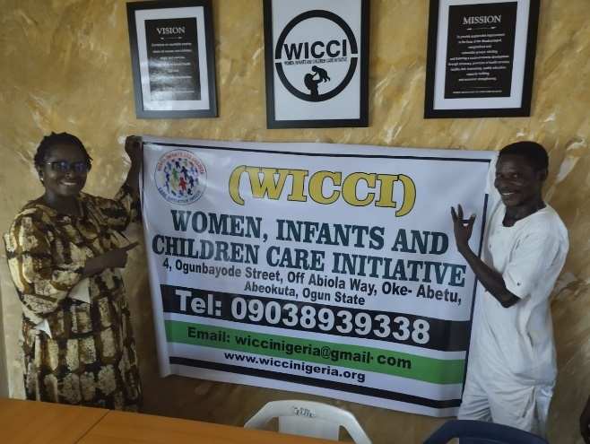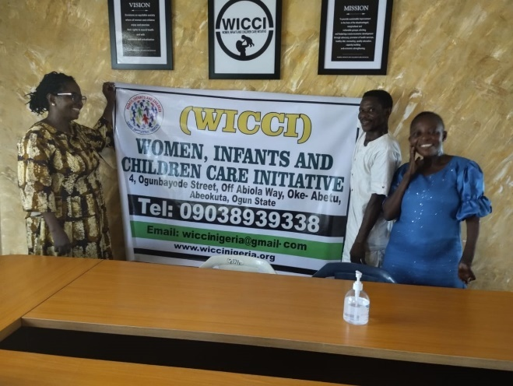

- Presentation of start-up tools to the beneficiaries held on the 14th September, 2023 – (Pictures 90 – 100)

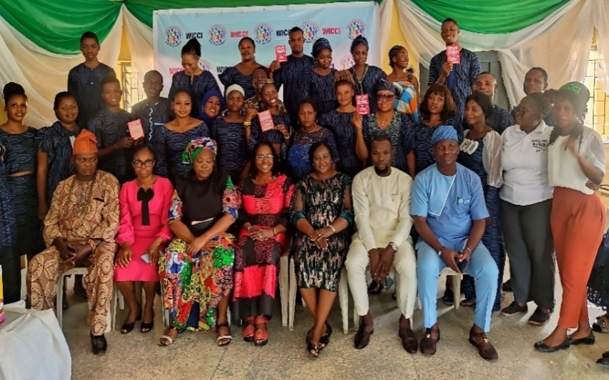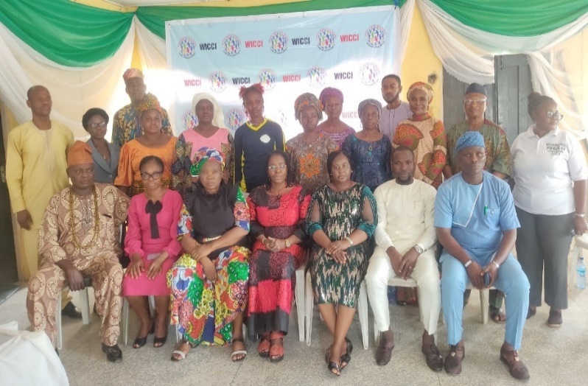
Pic. 89: WICCI Project staff, Stakeholders and the beneficiaries Pic. 90: WICCI Project staff, Stakeholders and Guardians
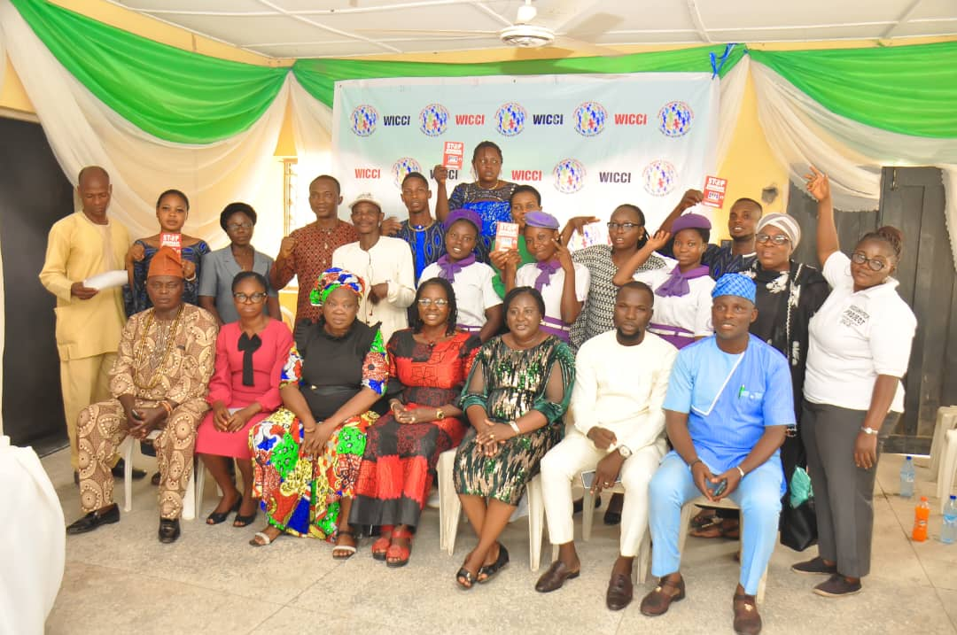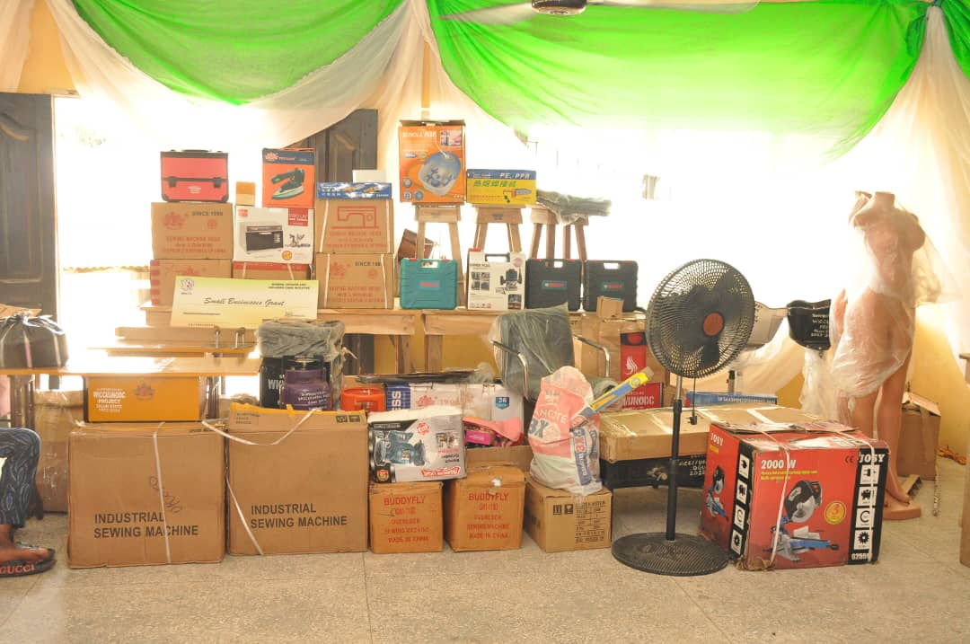
Pic.91: WICCI Project staff, Statkeholders and CSOs Pic.92: Disbursed start-up tools for the beneficiaries
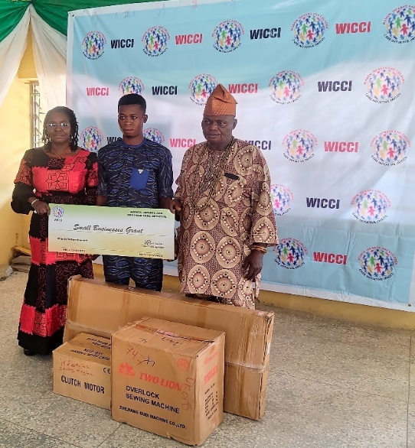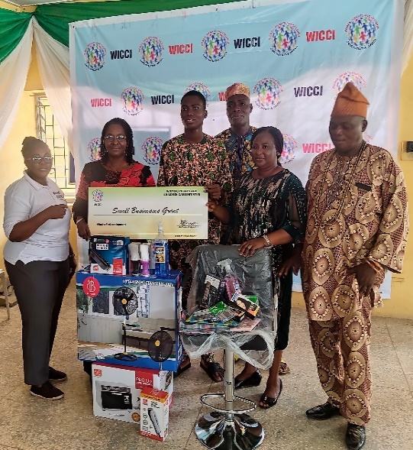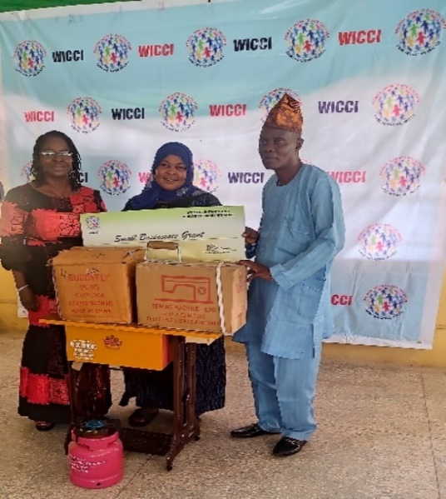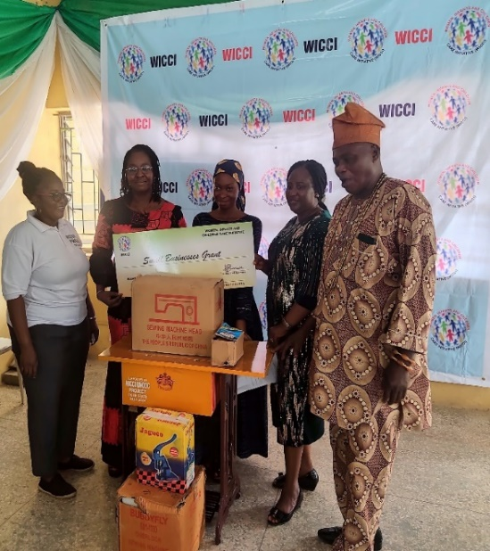
Beneficiary assisted with industrial machines …barbing equipment …tailoring equipment …tailoring tools

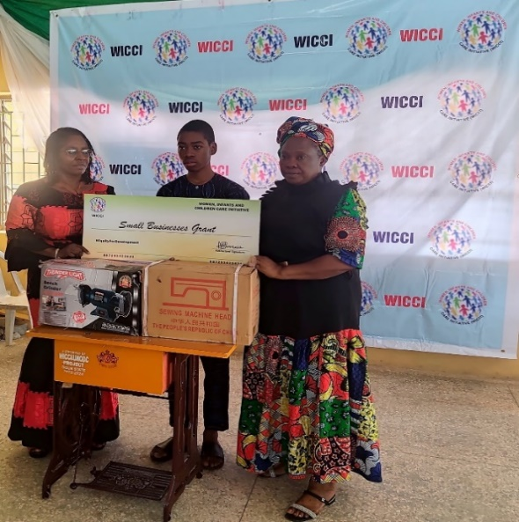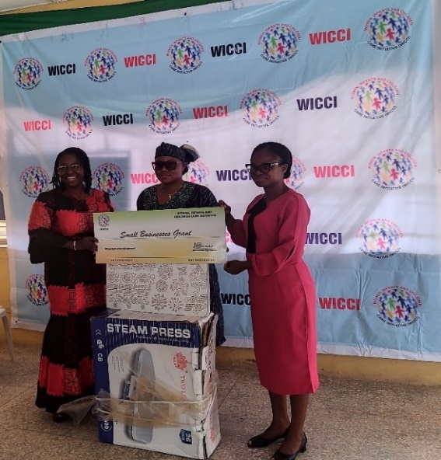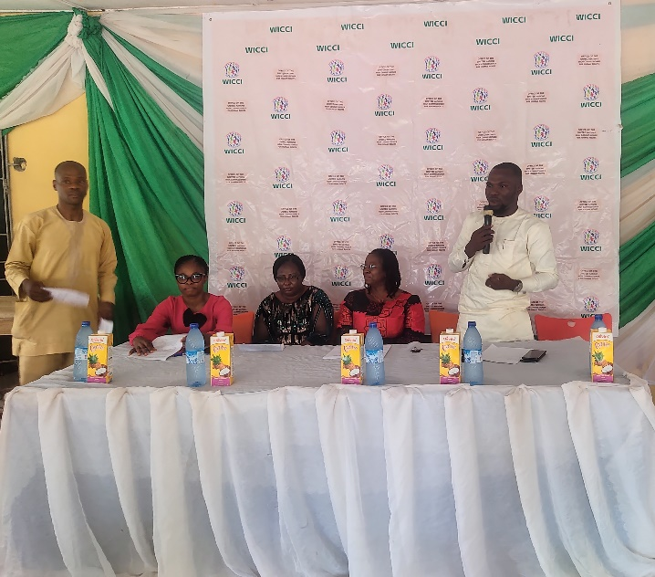
…Shoe-making machines …Fabric stoning equipment …Coordinator, Task Force on TiP deliverig a goodwill message

- Fabric Stoning training for young community women by a beneficiary of WICCI/UNODC 2022-2024 Project – Miss Nike Olaonipekun

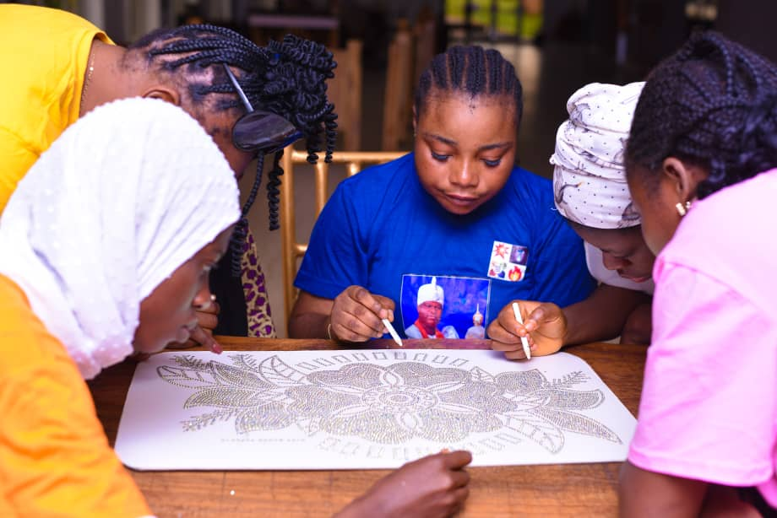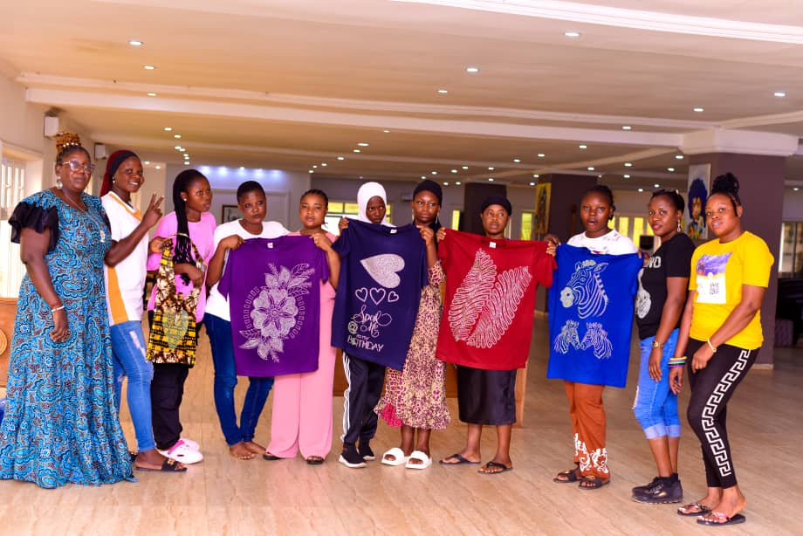
Pic. 101: training in session Pic.102: Participants showcasing their work. Trainer - Nike Olaonipekun (R)

- Monitoring of some of the beneficiaries at their business places held in December 2023 – February 2024
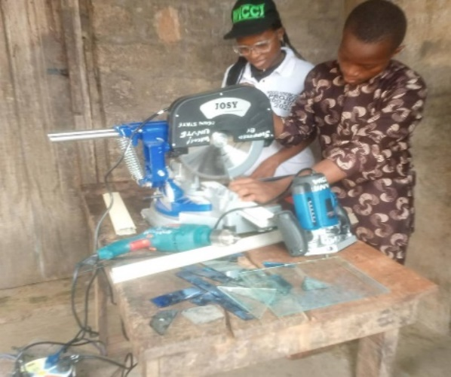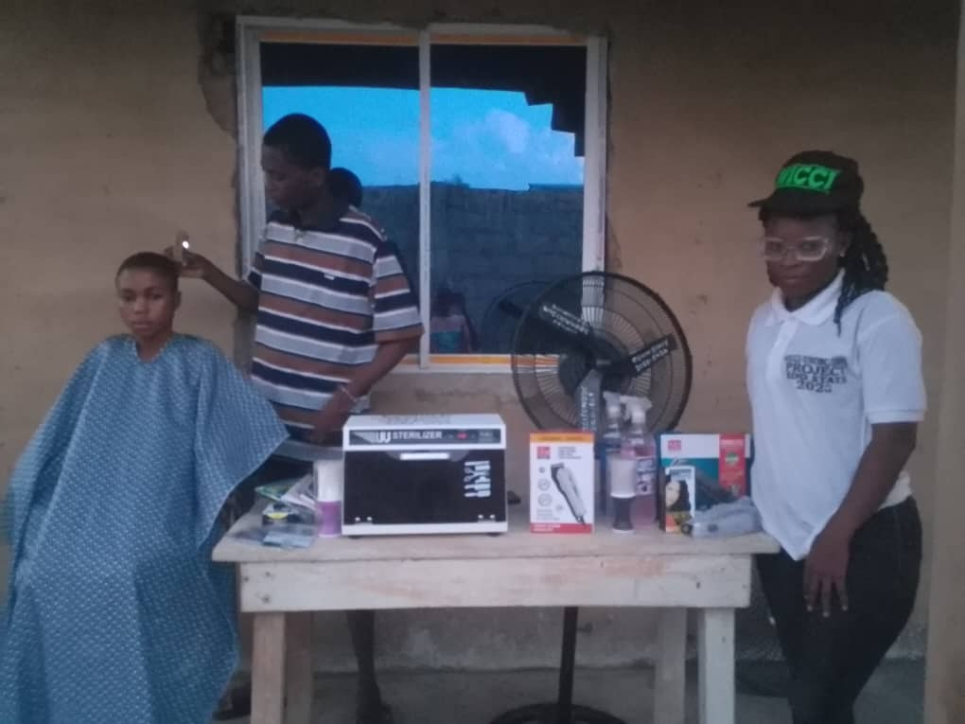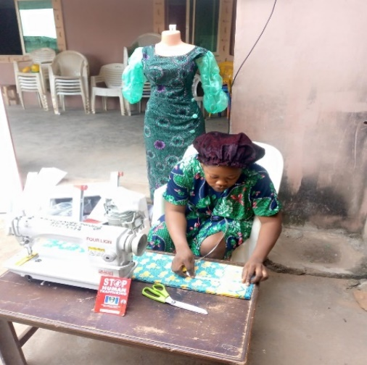
Pic. 103: VoT cutting Aluminium window frame Pic.104: VoT Barber beneficiary… Pic105: VoT Fashion designer working from home
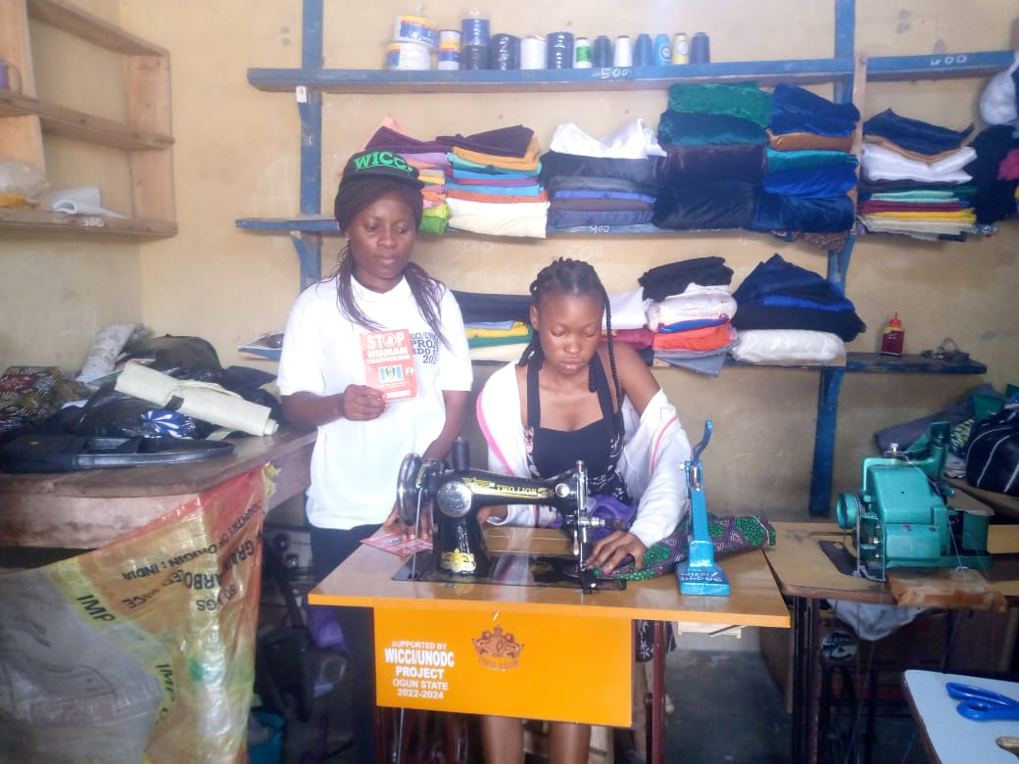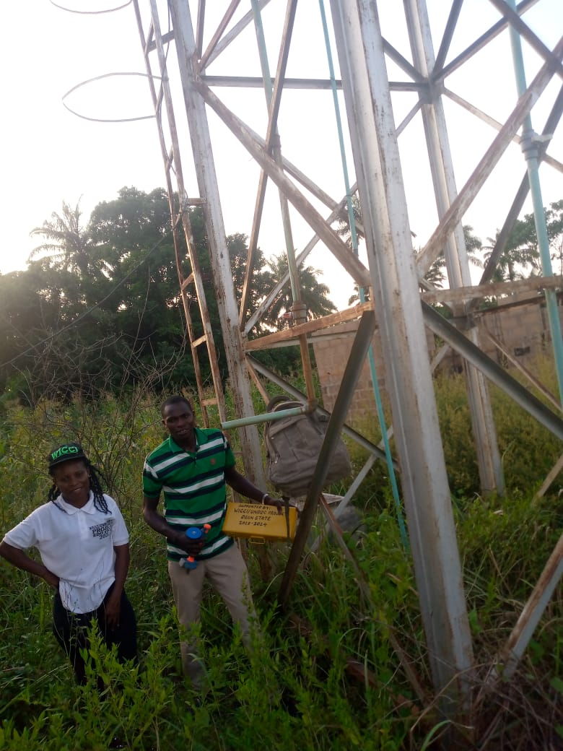
Pic.106: Ruth has gotten a shop for herself after the empowerment Pic.107: Beneficiary (Plumber) took part in the construction of the water project
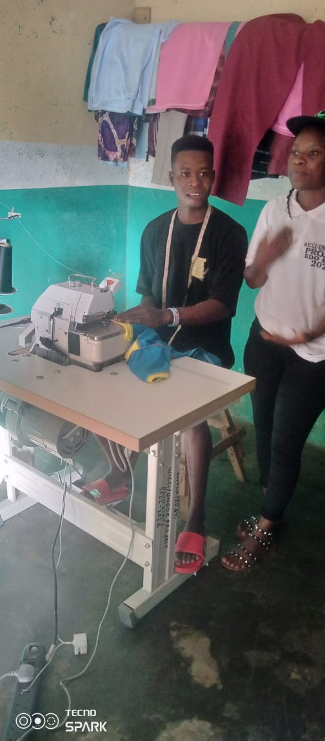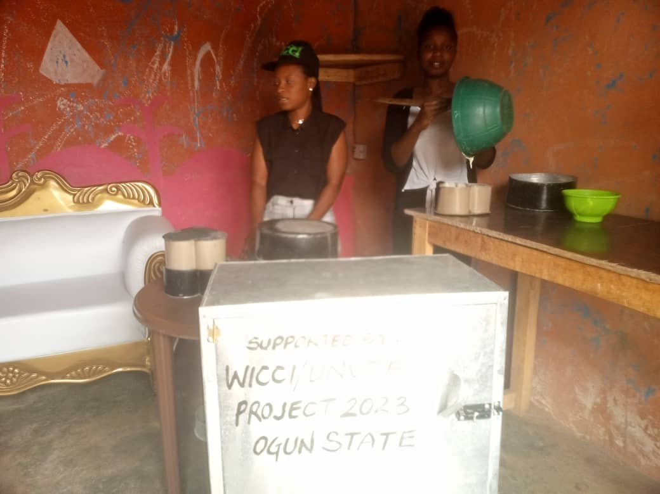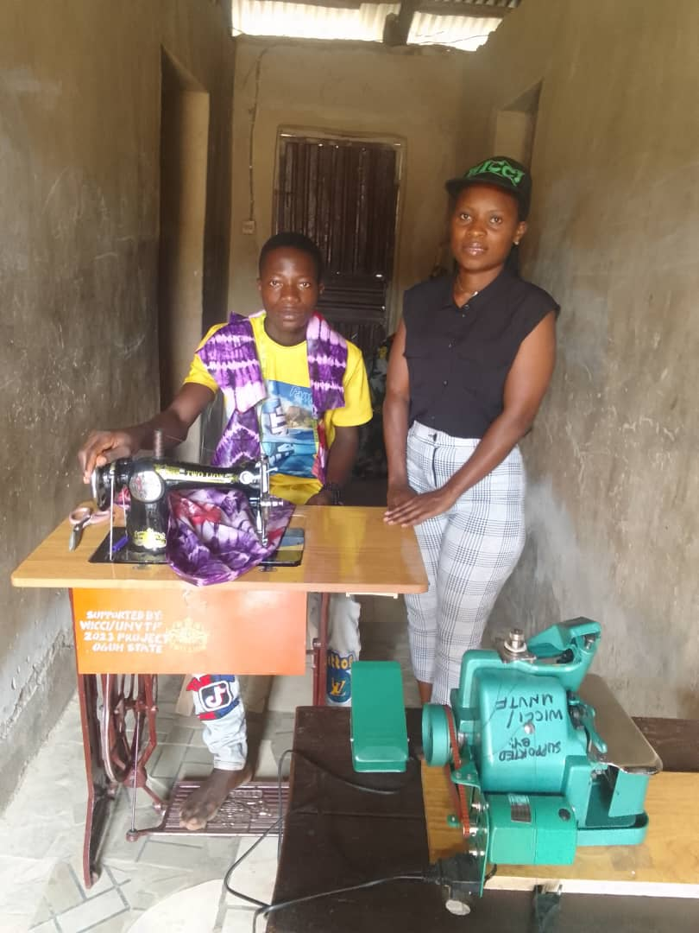
Pic.108: Fashion designer… Pic. 109: VoT empowered in catering vocation Pic.110: VoT empowered with sewing equiment
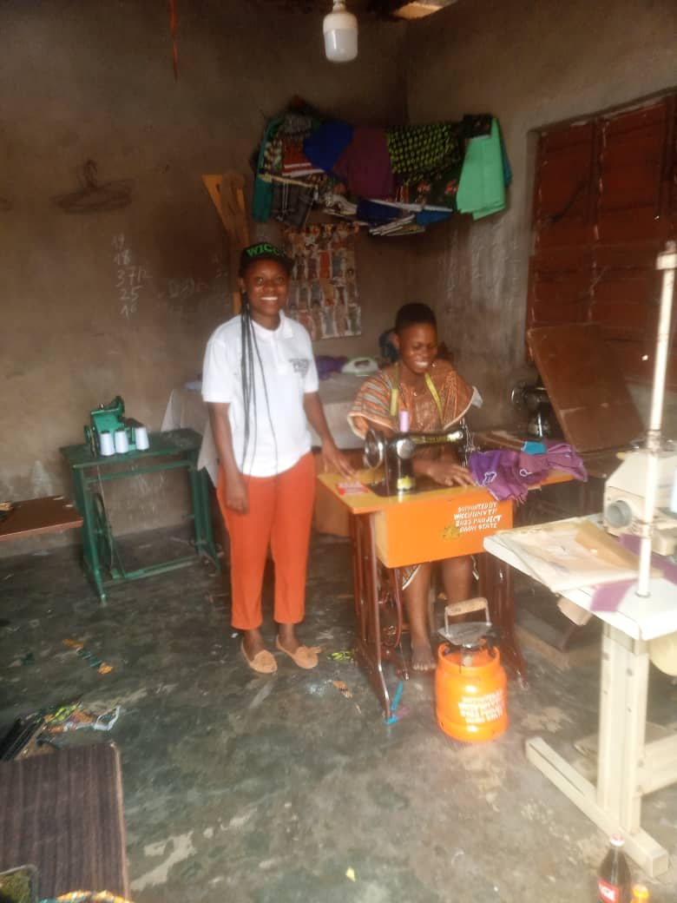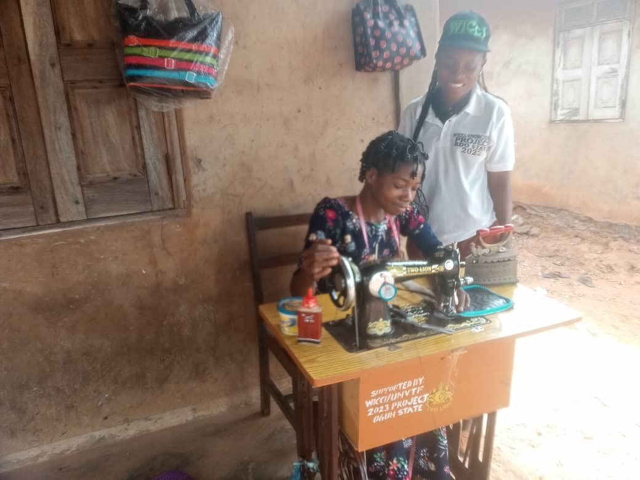
Pic.111: The beneficiary and the caseworker during monitoring visit Pic.112: Bag-making vocation by one of the beneficiaries
9. Activity pictures in Quarter 6 - Counselling/screening session with some of the survivors of human trafficking: Pictures 113 -118
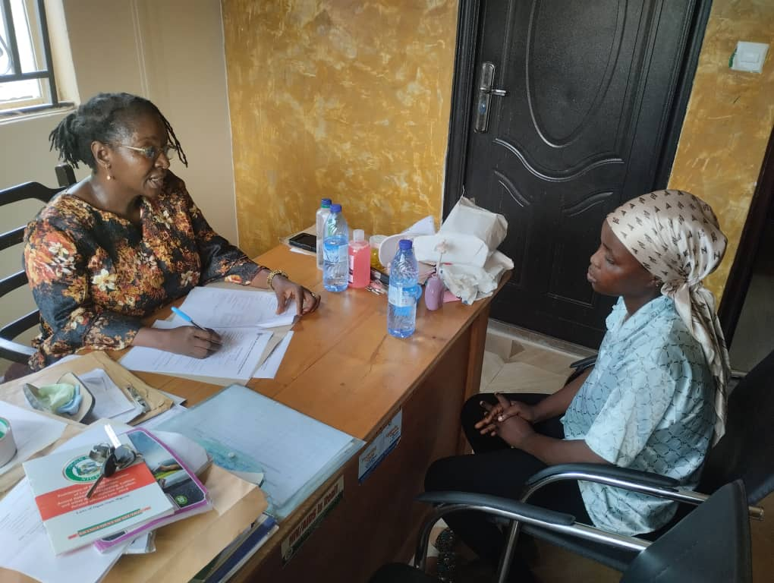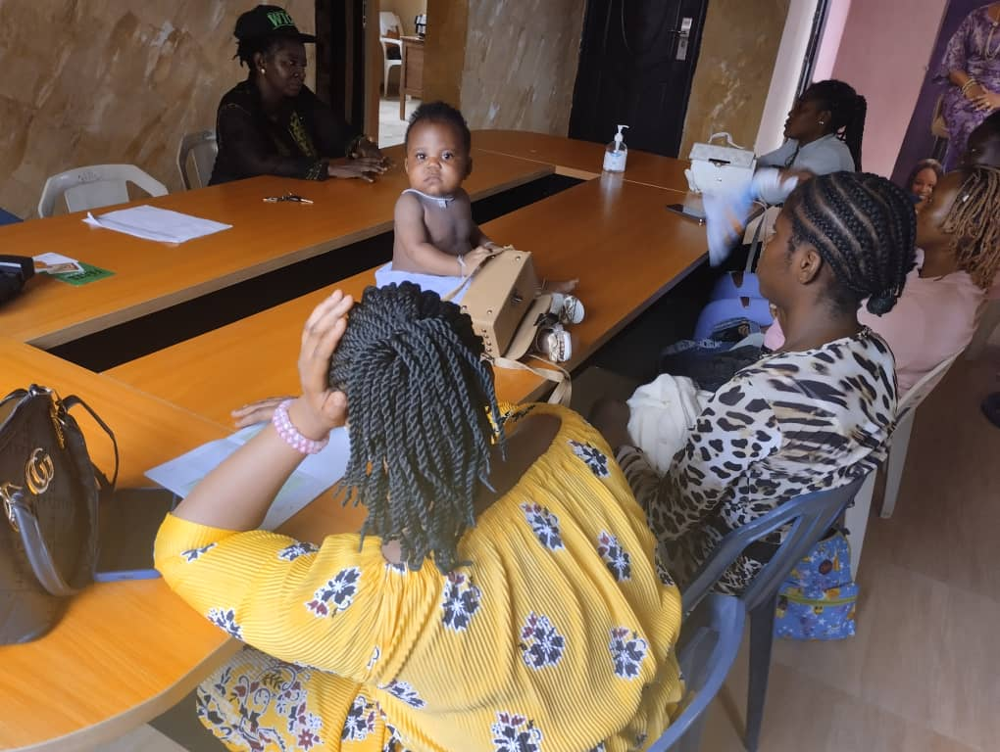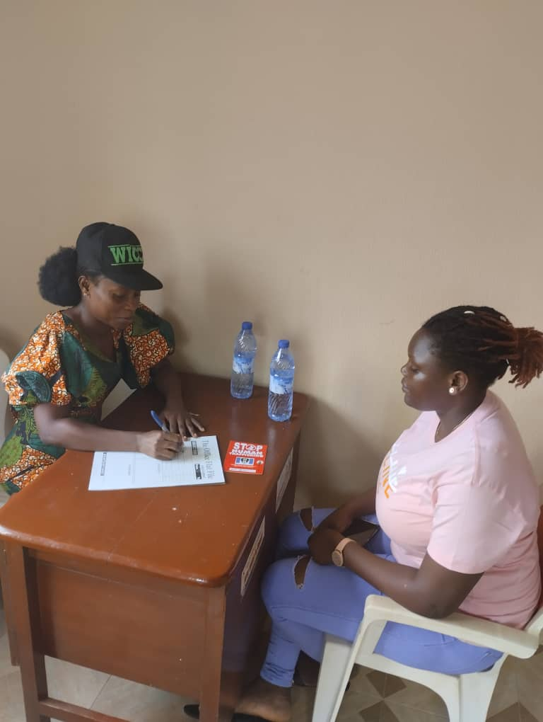

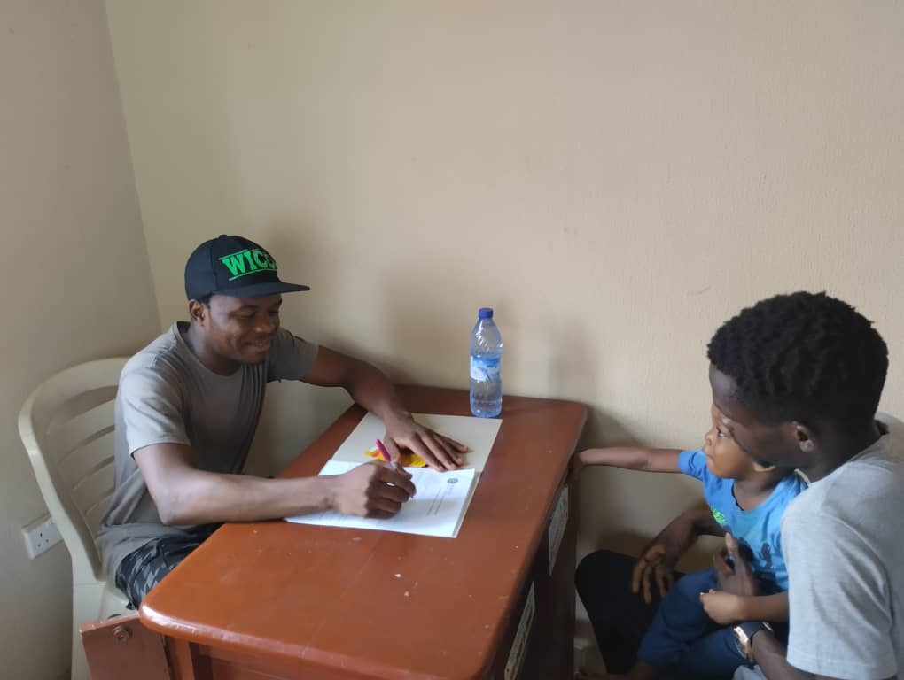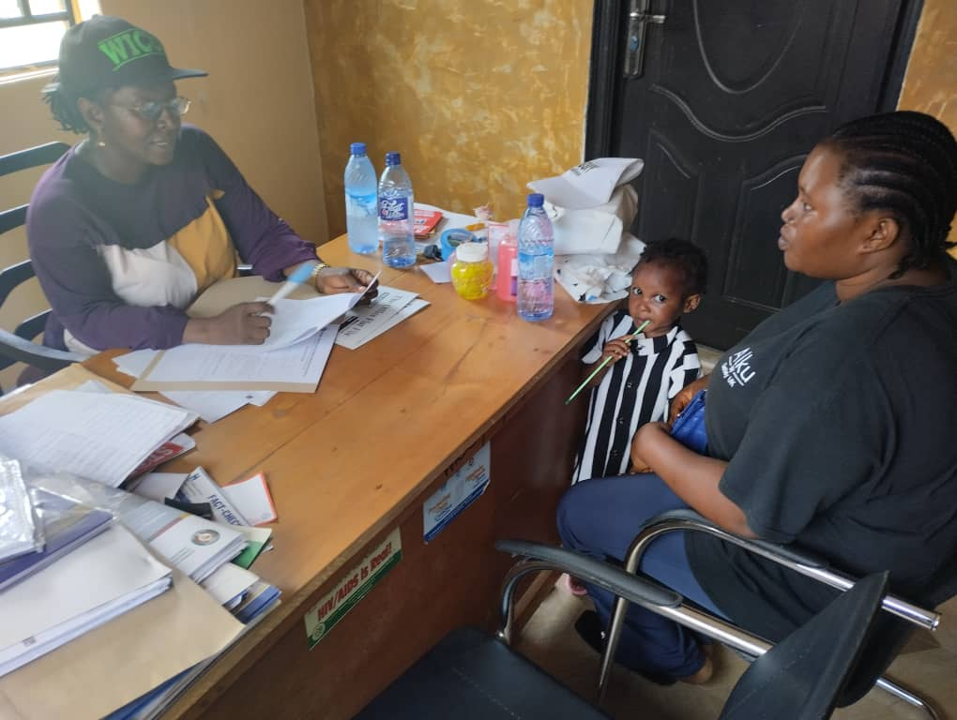
Emergency Relief Assisstance for survivors of human trafficking: Pictures 119 - 122
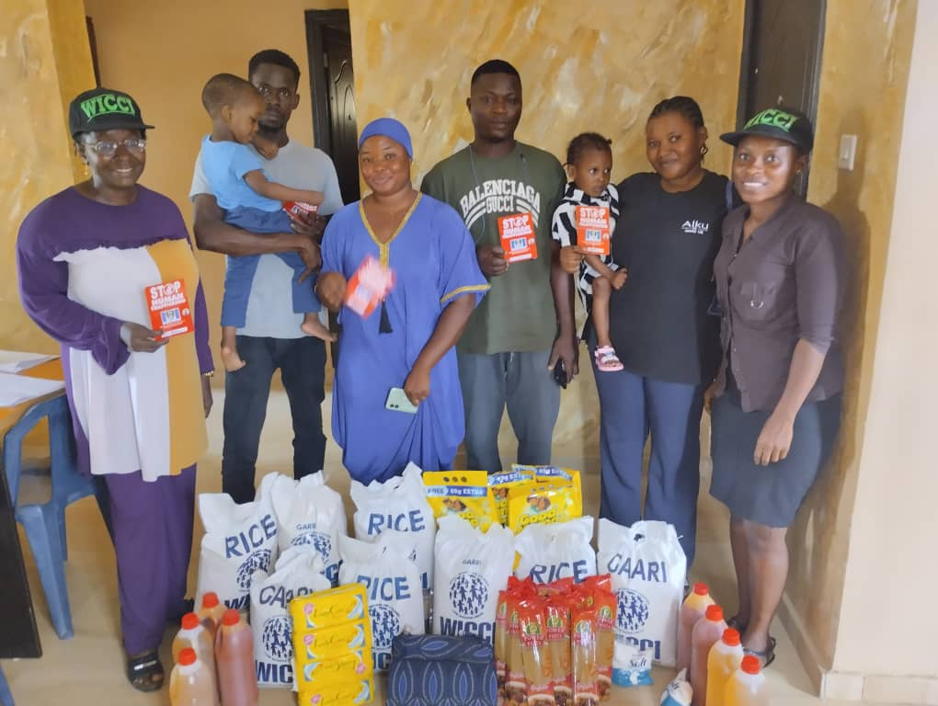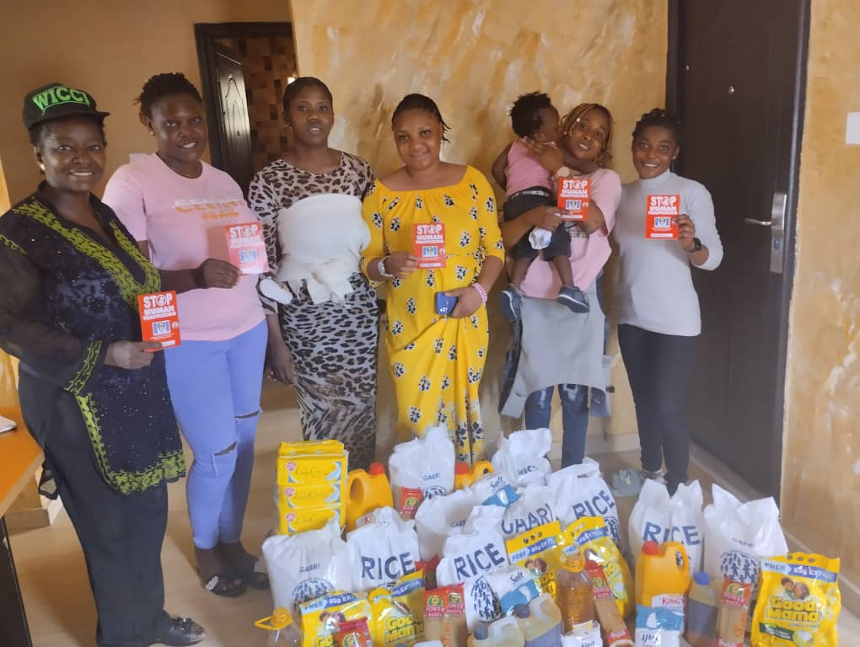
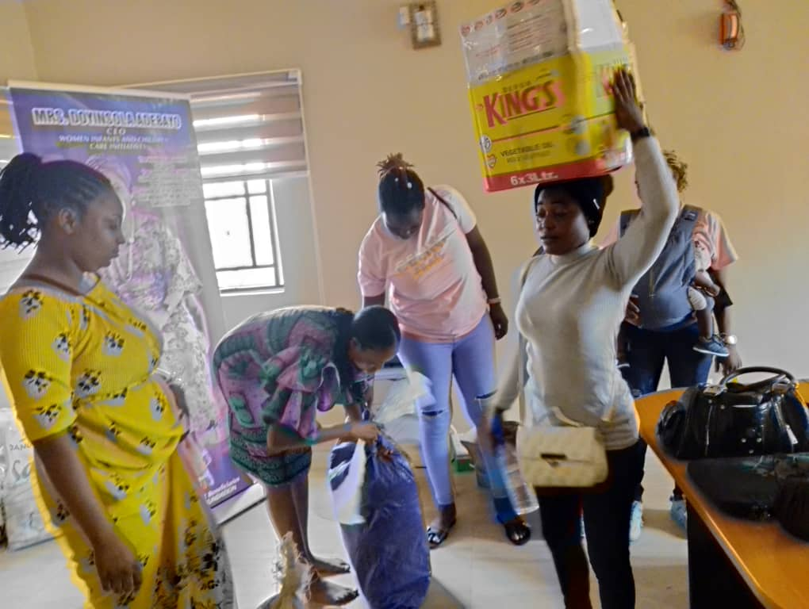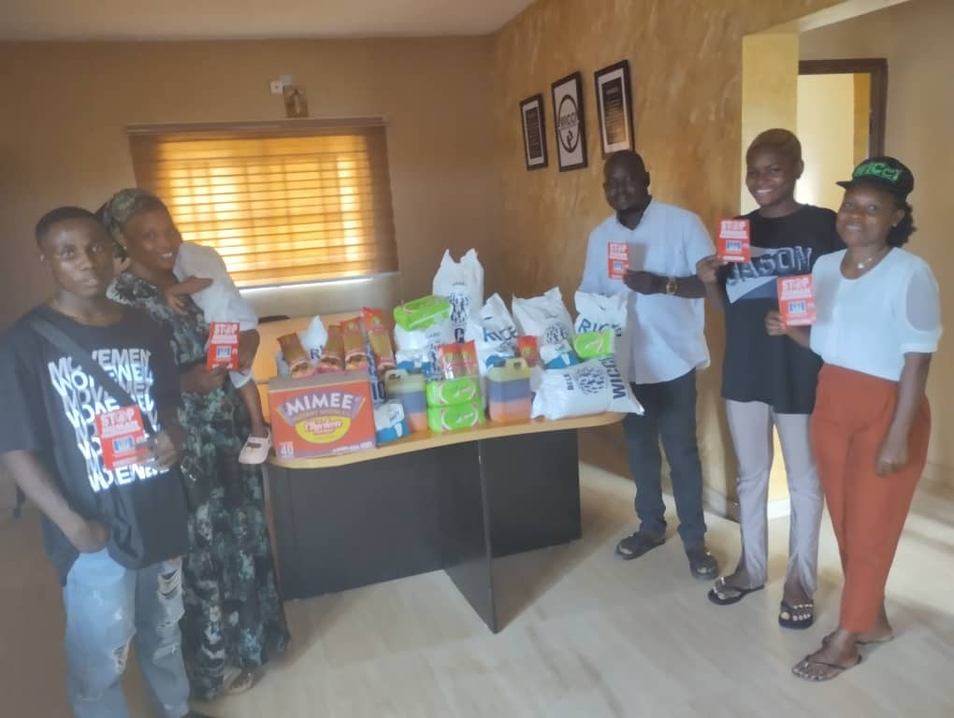

Activity report for quarter 7 Photo Credit: Deborah Oni
- WICCI Team on Advocacy visit to the Commander, National Agency for the Prohibition of Trafficking in Persons (NAPTIP): Pics. 123 & 124
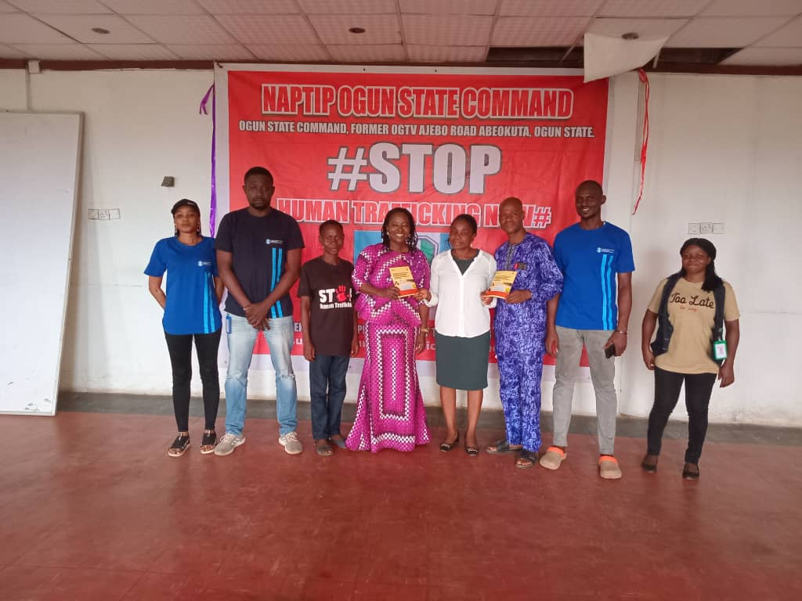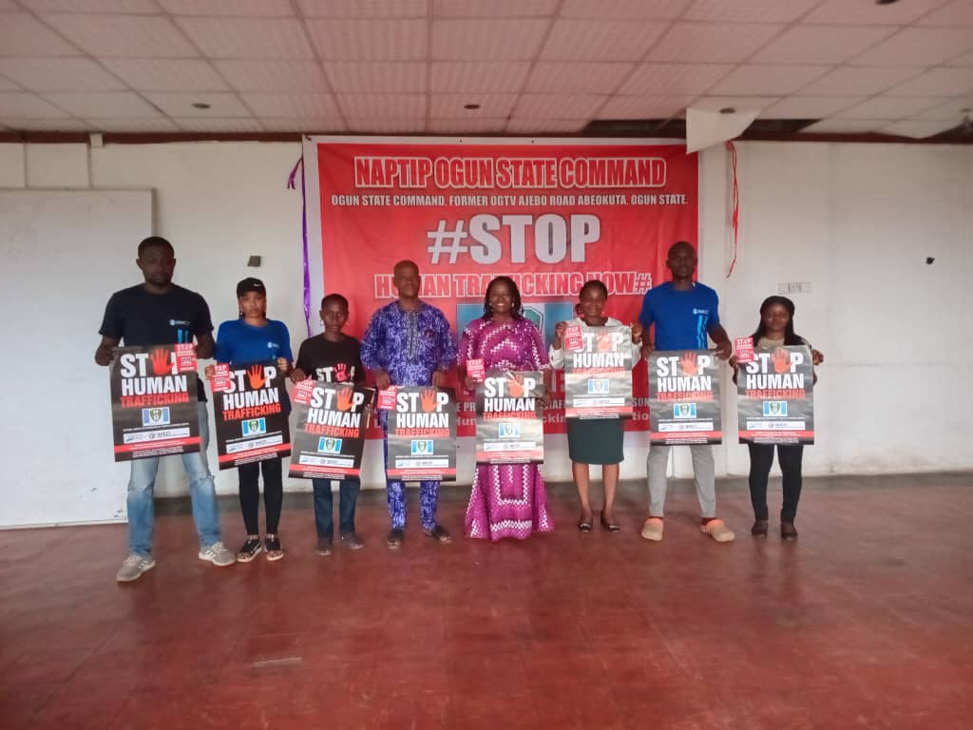
ii. Counselling/screening session with some of the survivors of human trafficking: Pictures 125 - 136
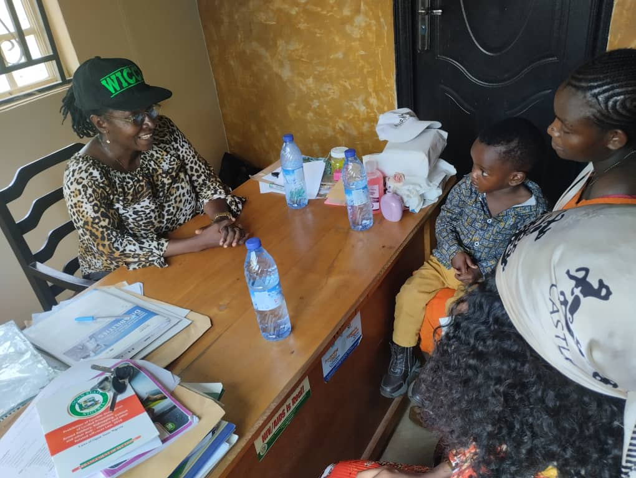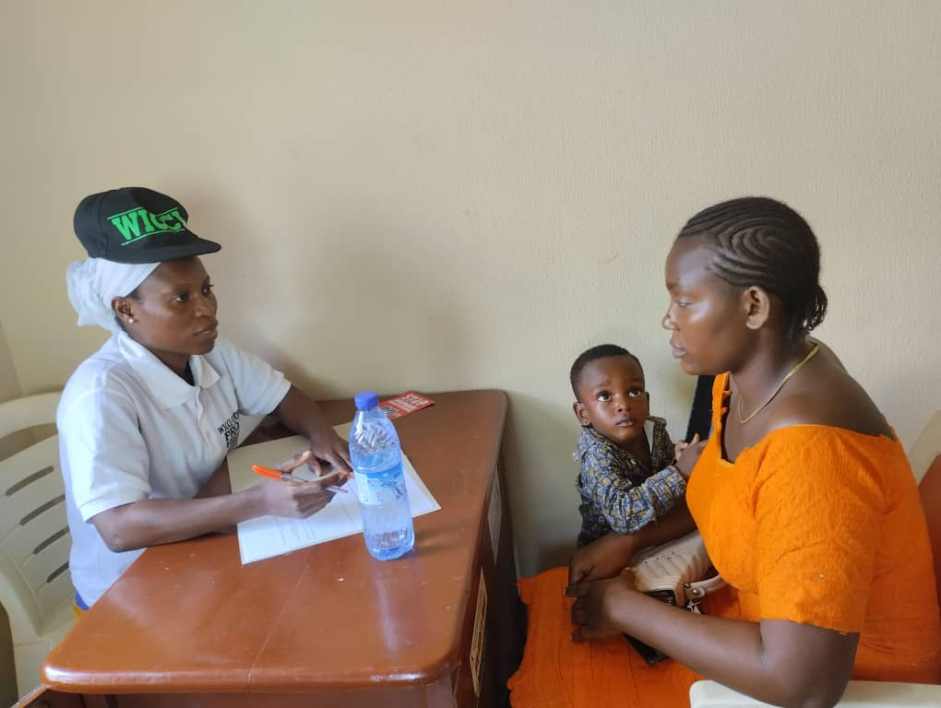
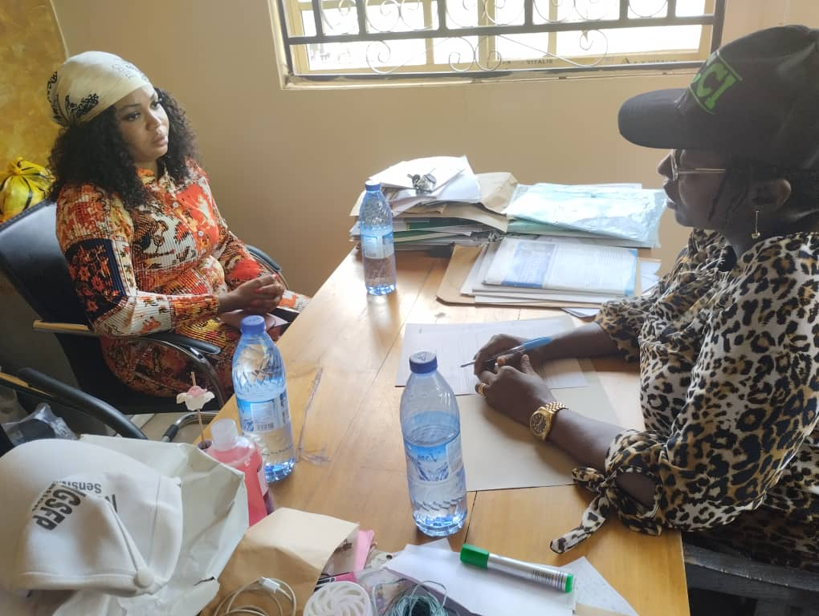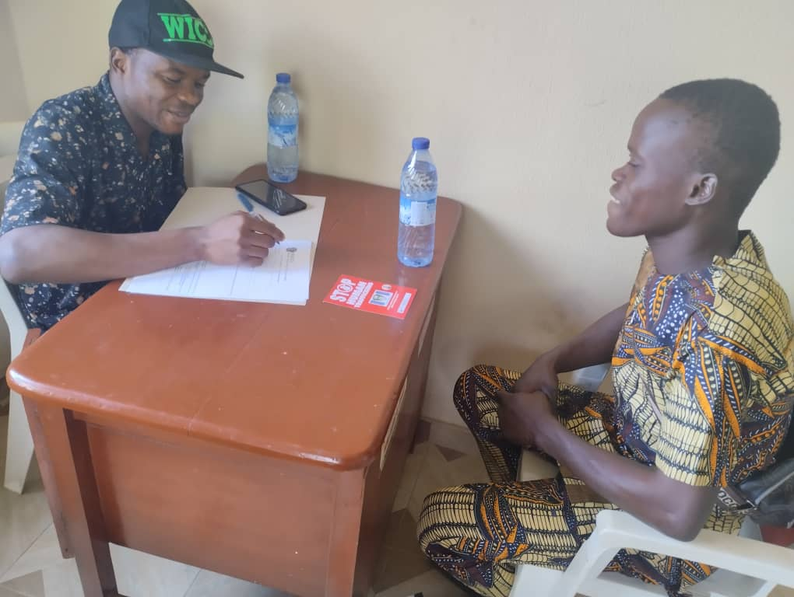
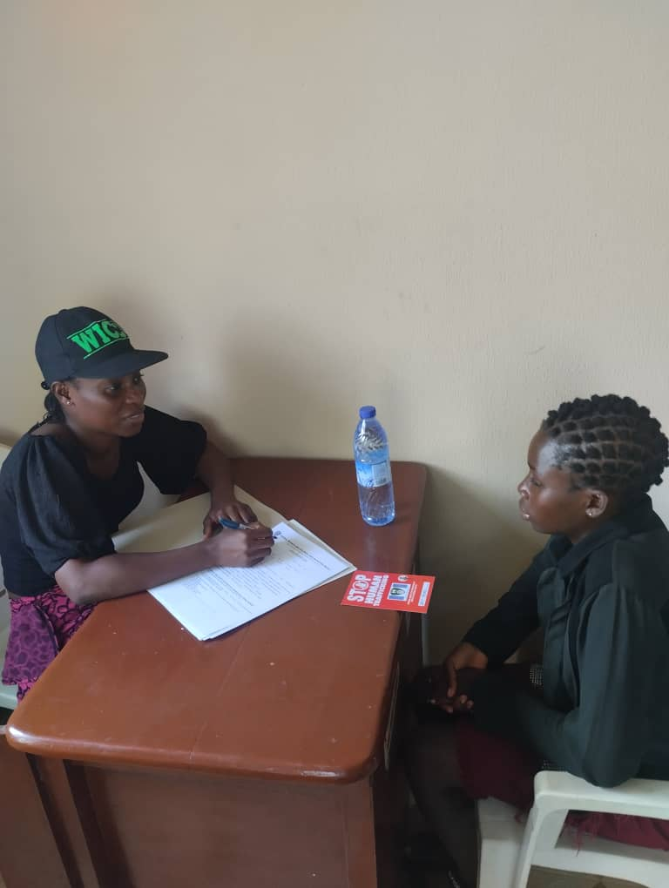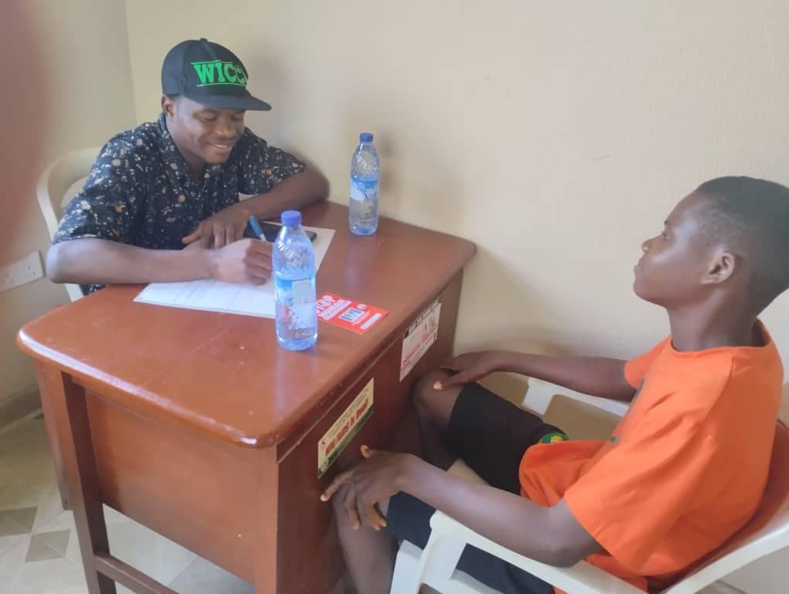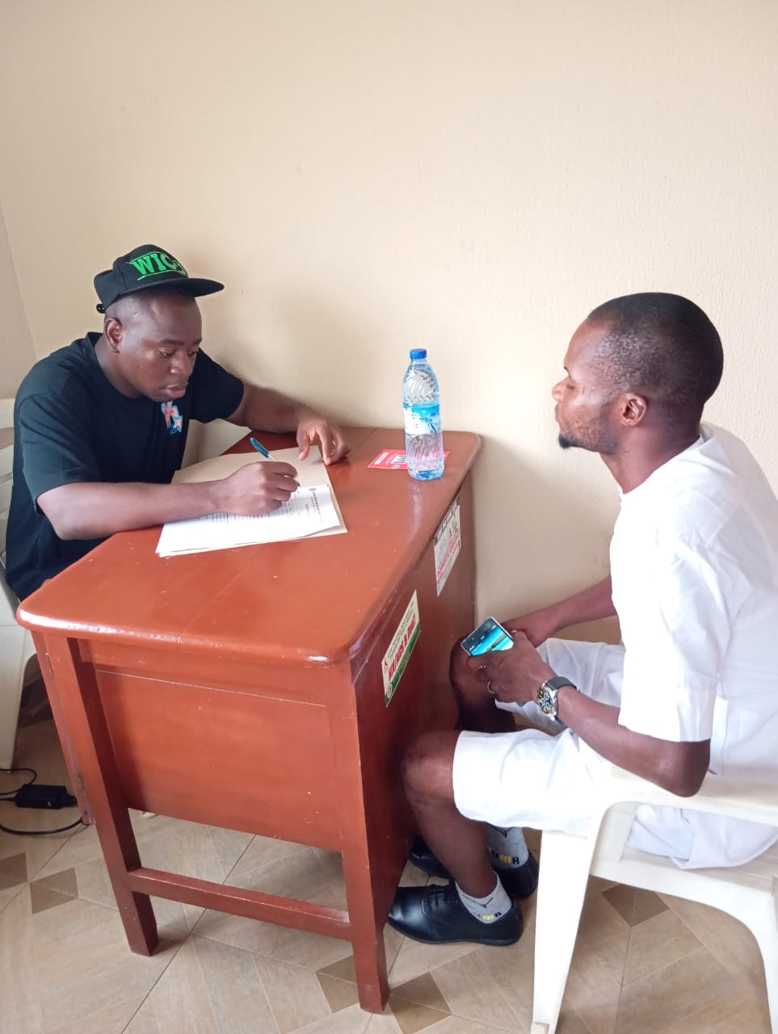

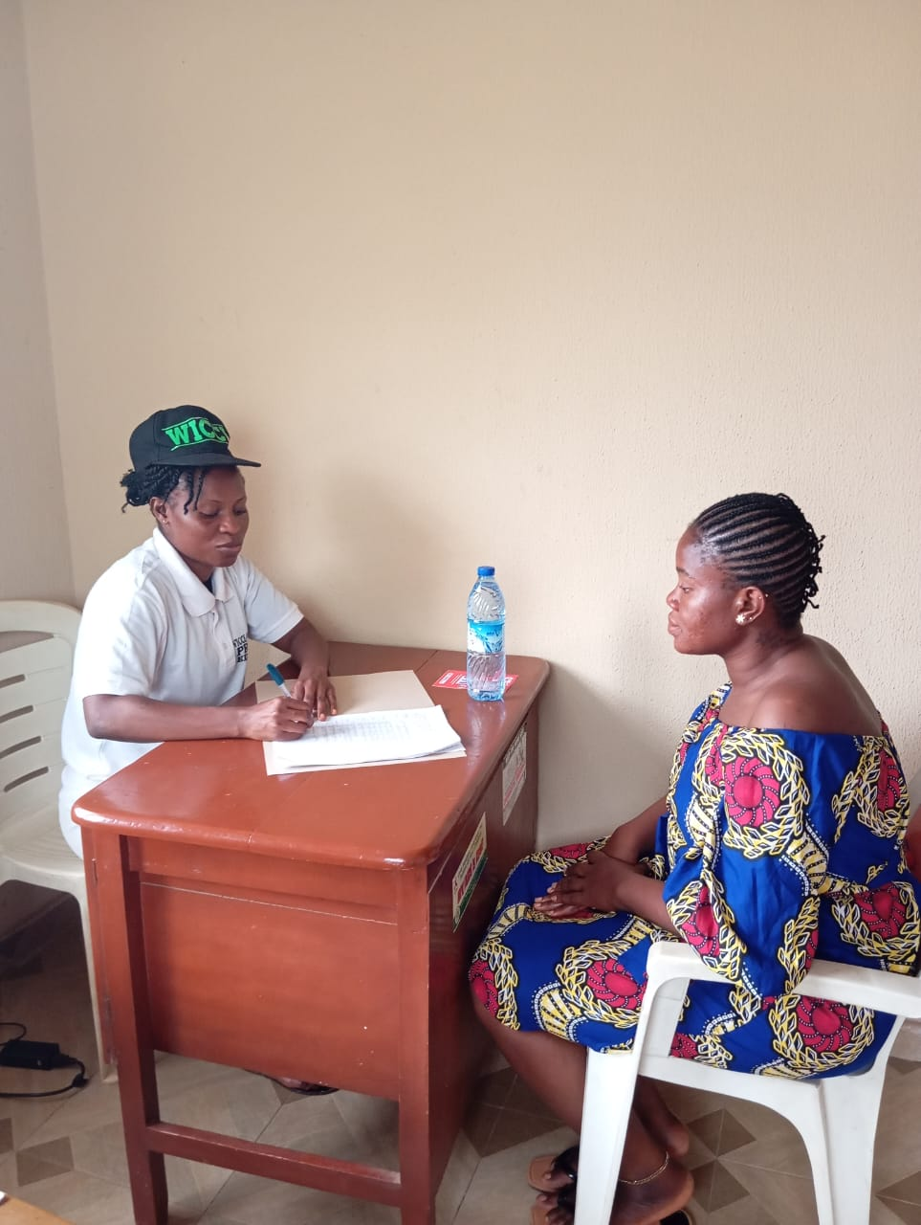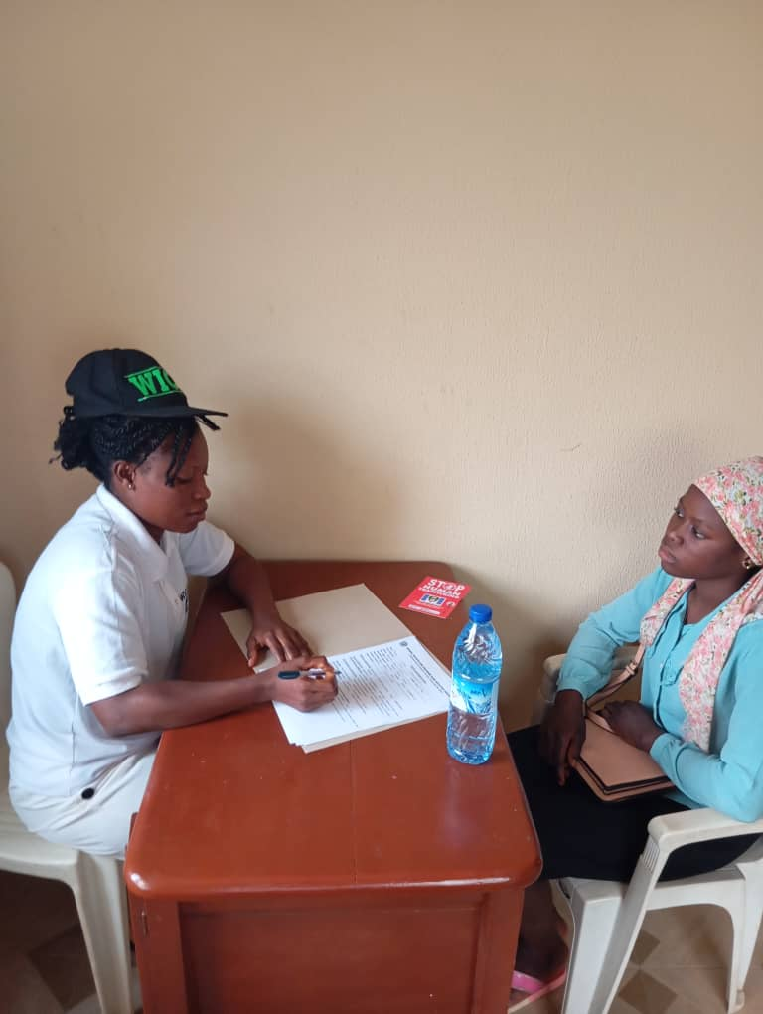
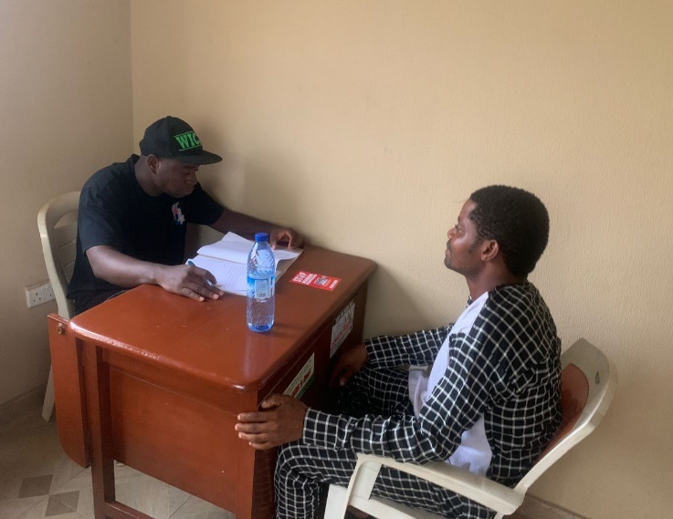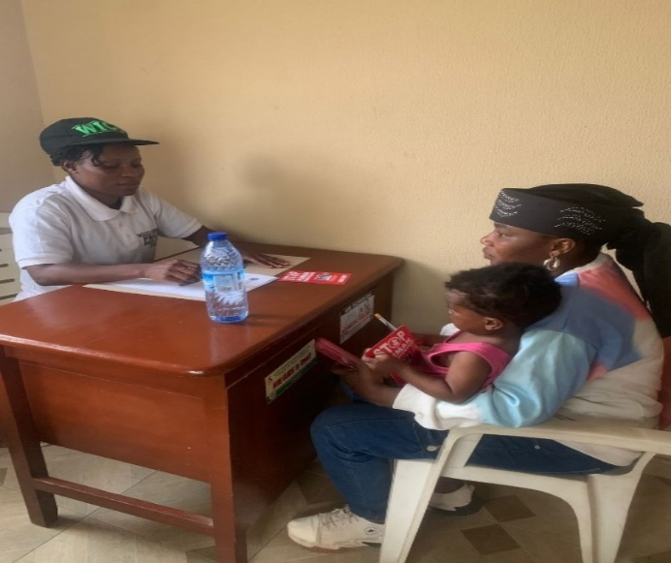

- Emergency Relief Assisstance for survivors of human trafficking/Internally Displaced Persons: Pictures 137 - 142
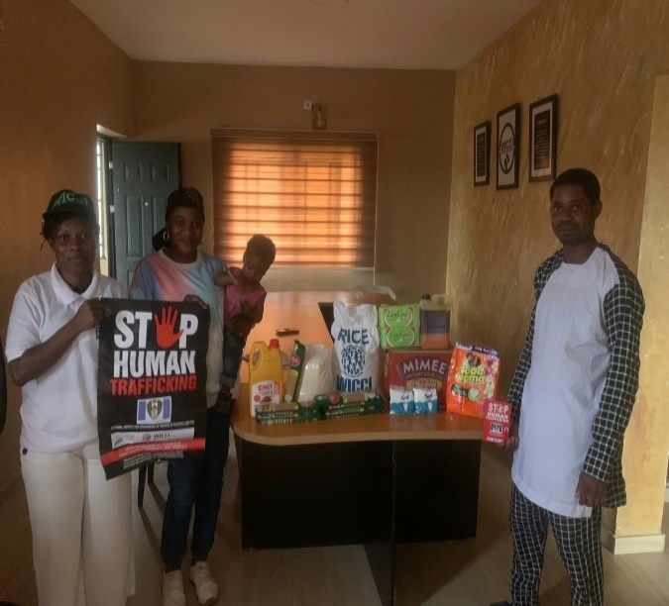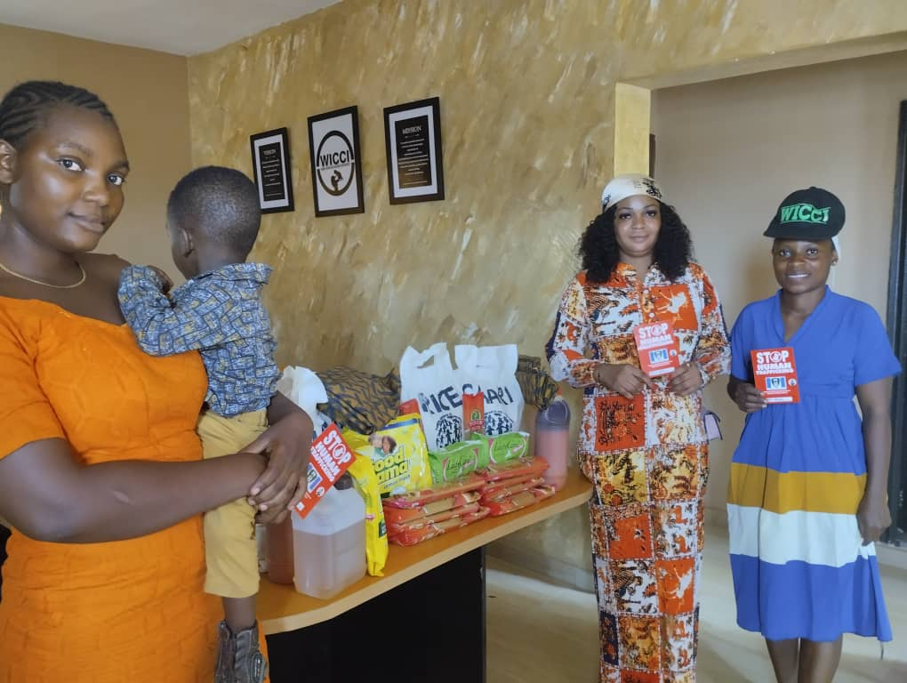
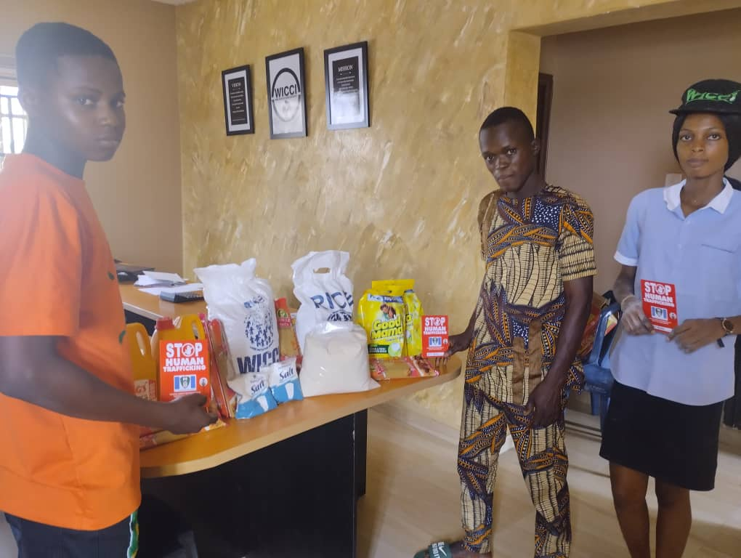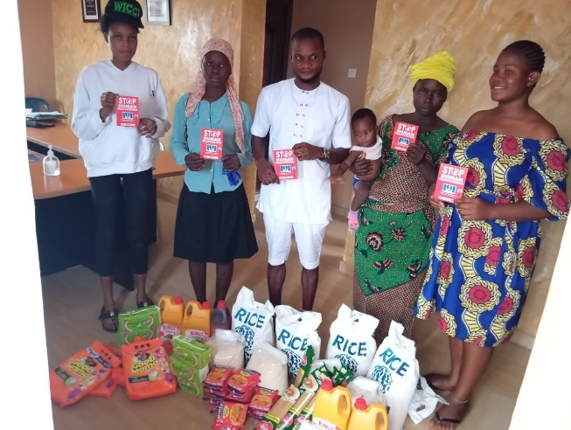

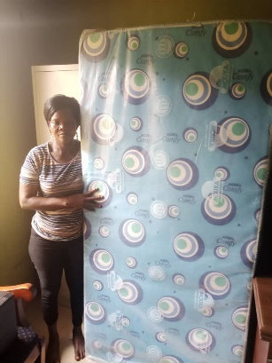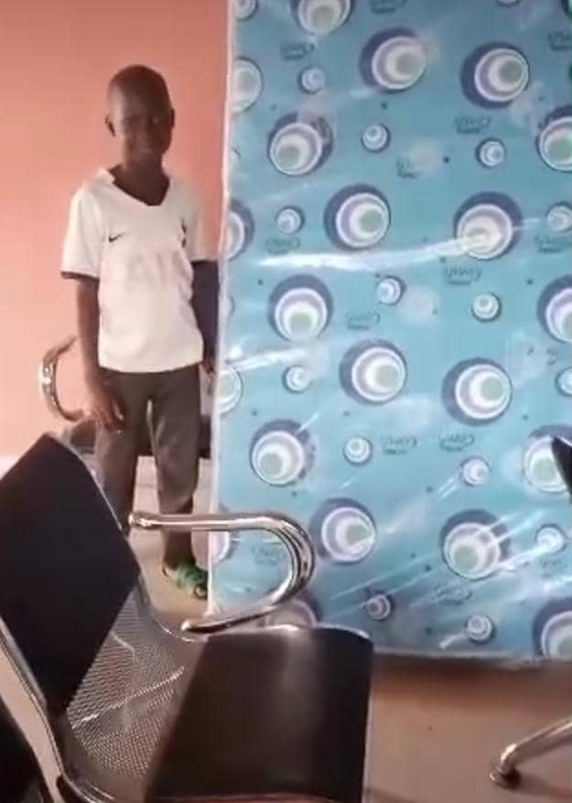

- Stakeholders’ Consultative Forum/Empowerment of VoT on the 25th July, 2024 in Abeokuta.
Pictures 143- 154. Photo Credit: Festus Omileye

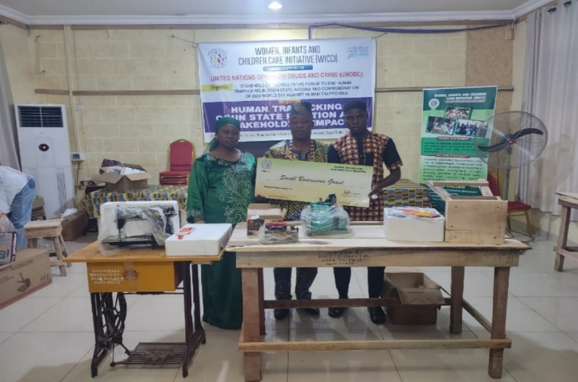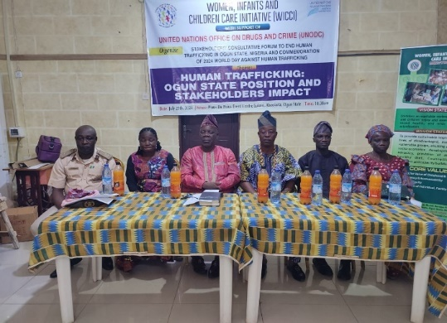
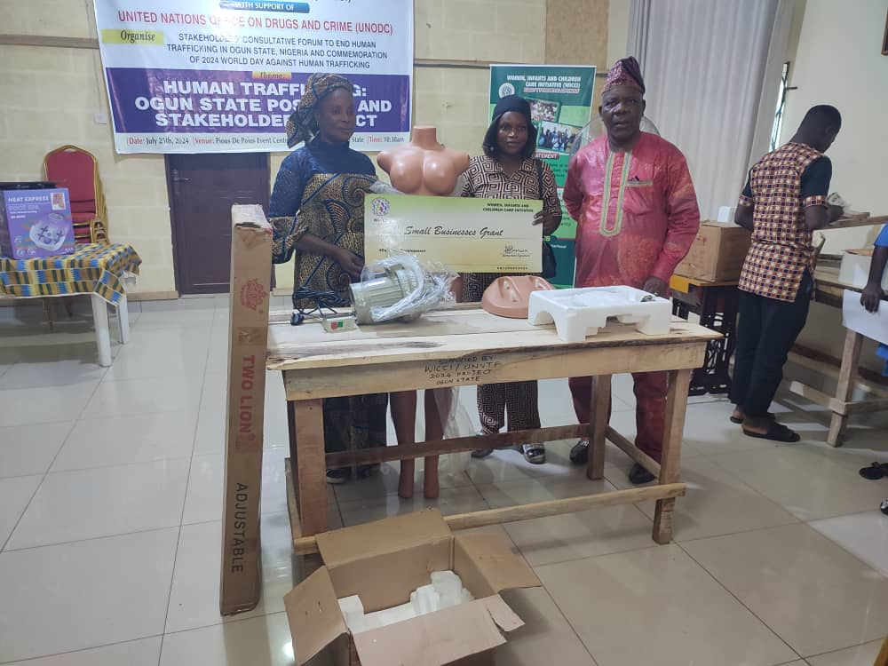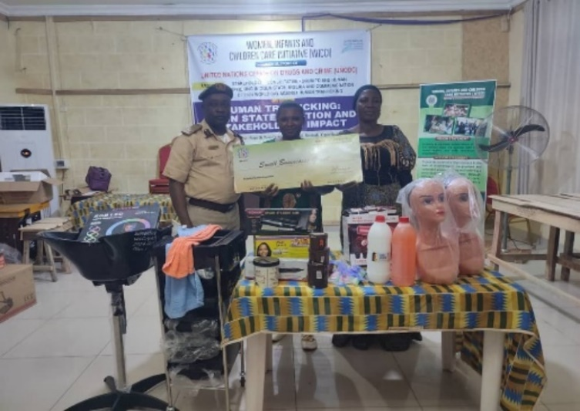
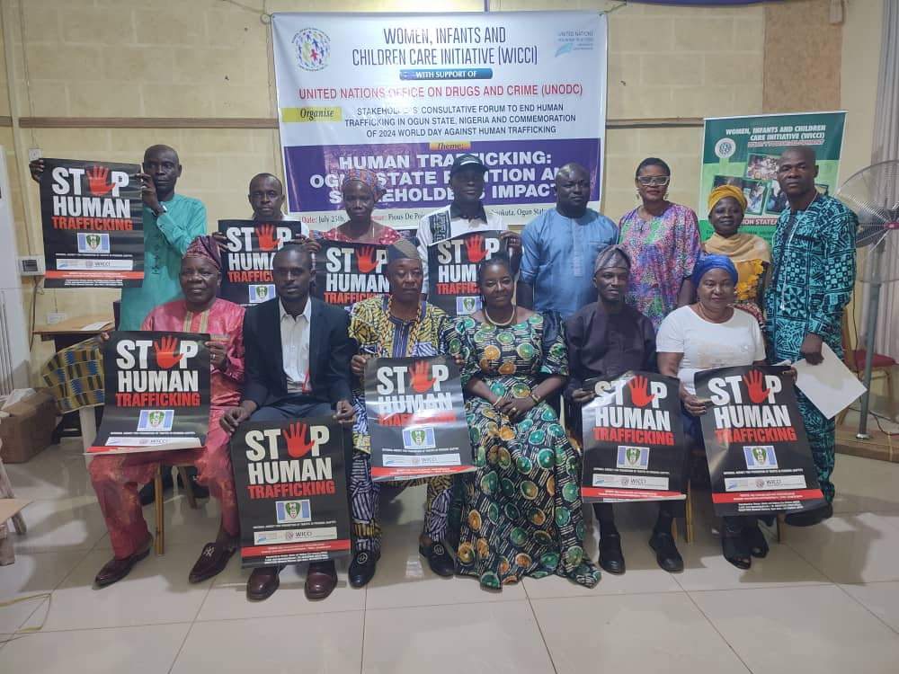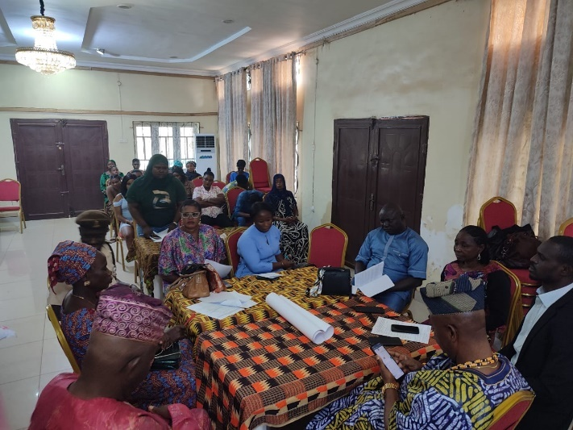
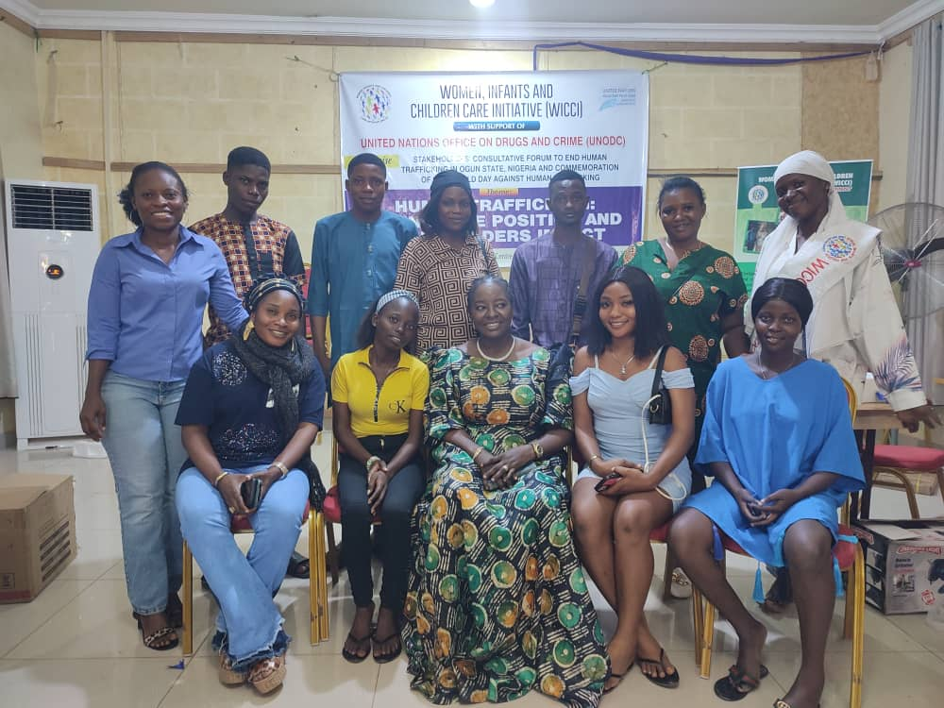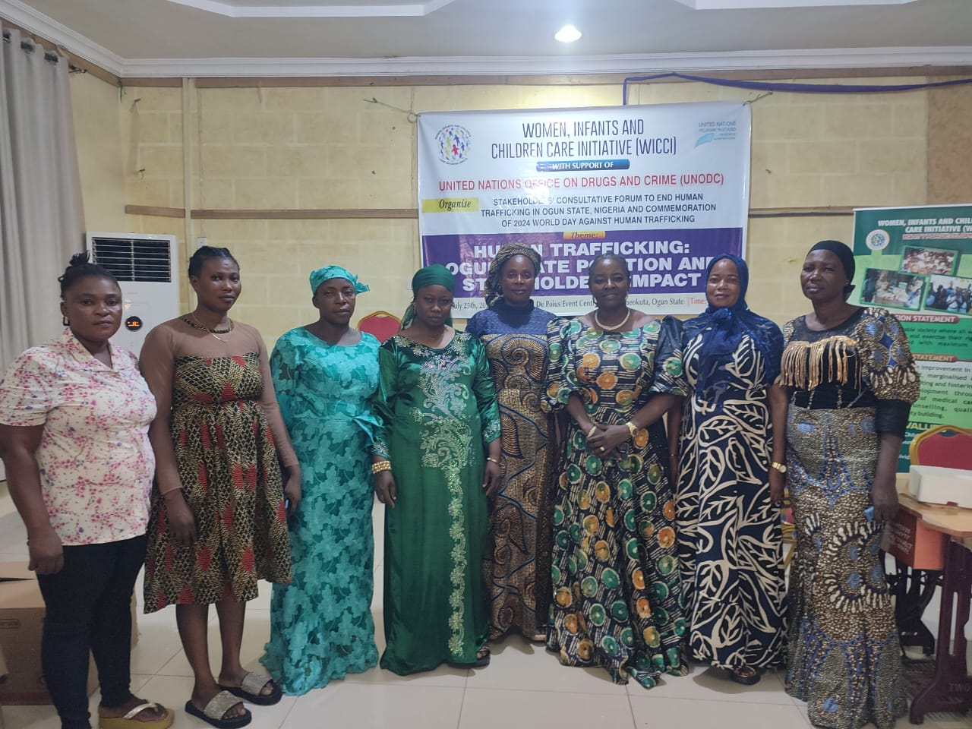

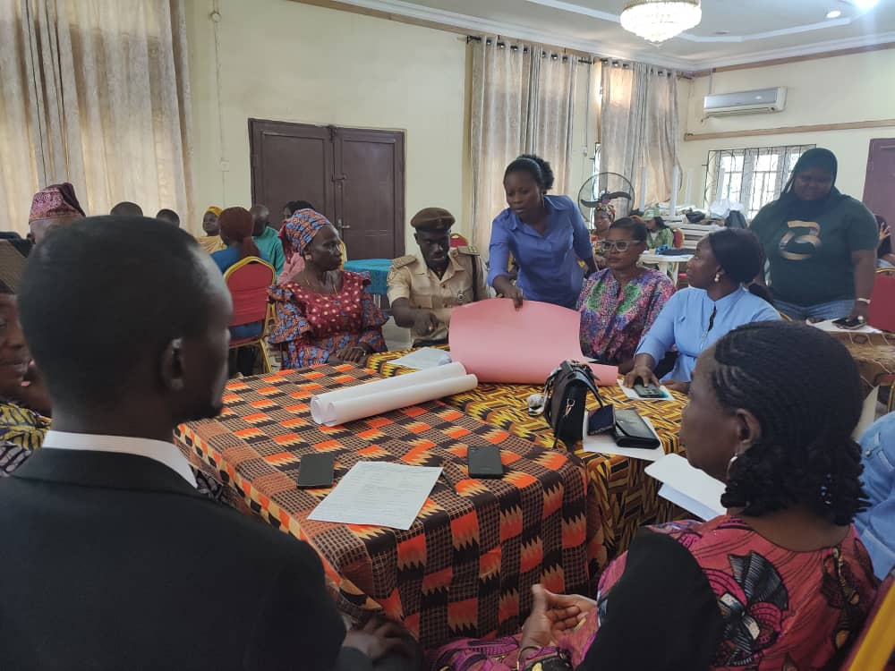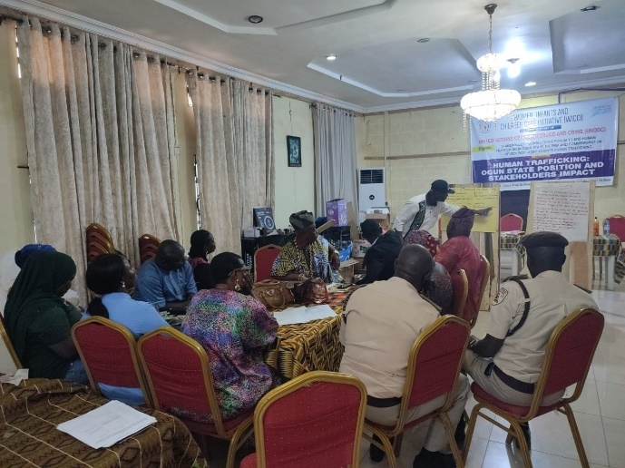
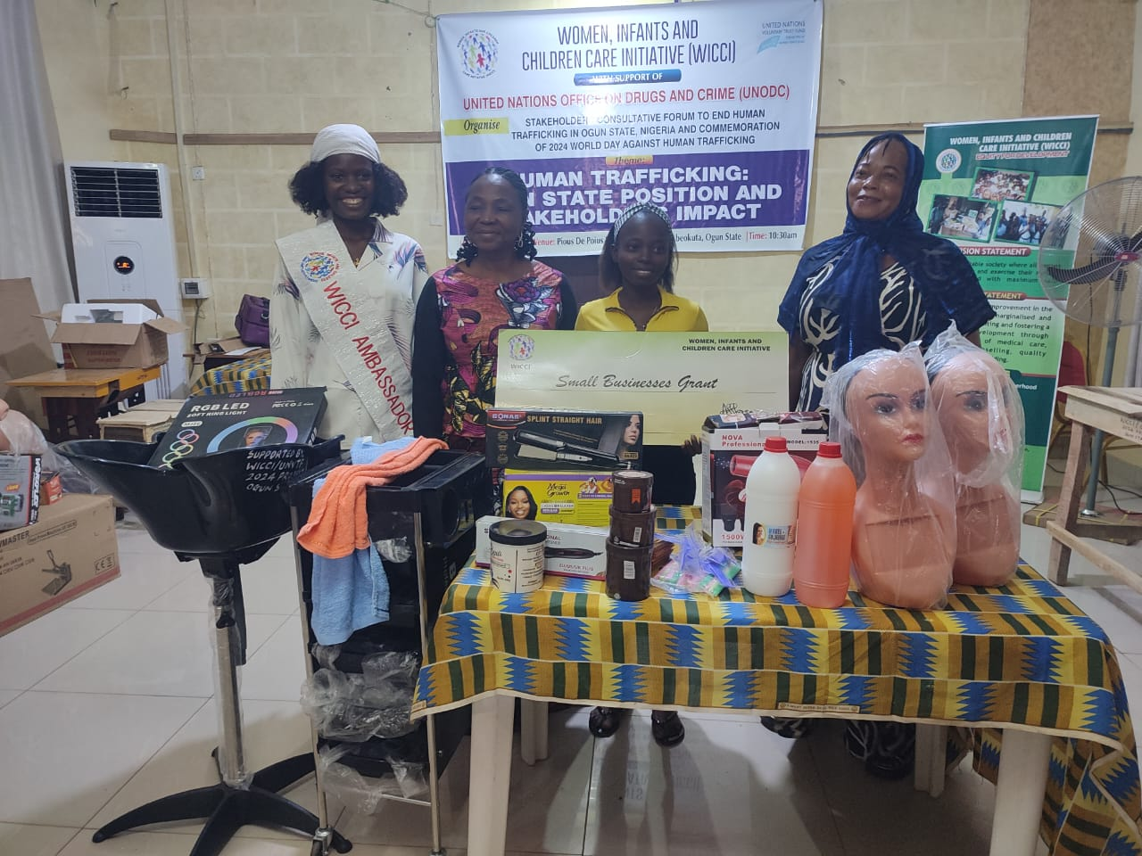

- 2024 World Day Against Human Trafficking Pic. 155-156 Photo Credit: Grace Oloruntoba
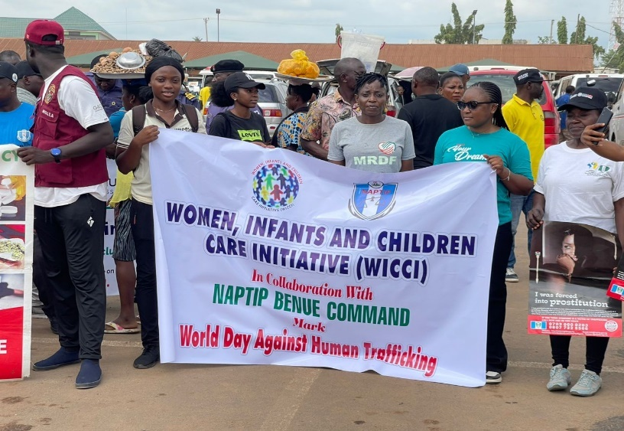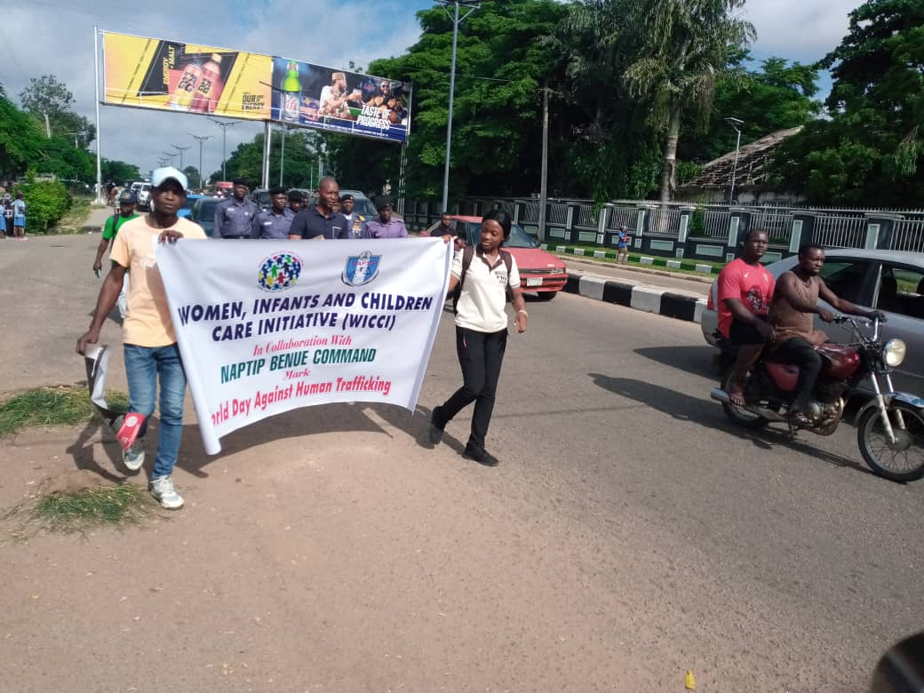
- Activity Report for Quarter 8 – Screening and Profiling of VoT Pic. 157-159 Credit: Doyinsola Adebayo

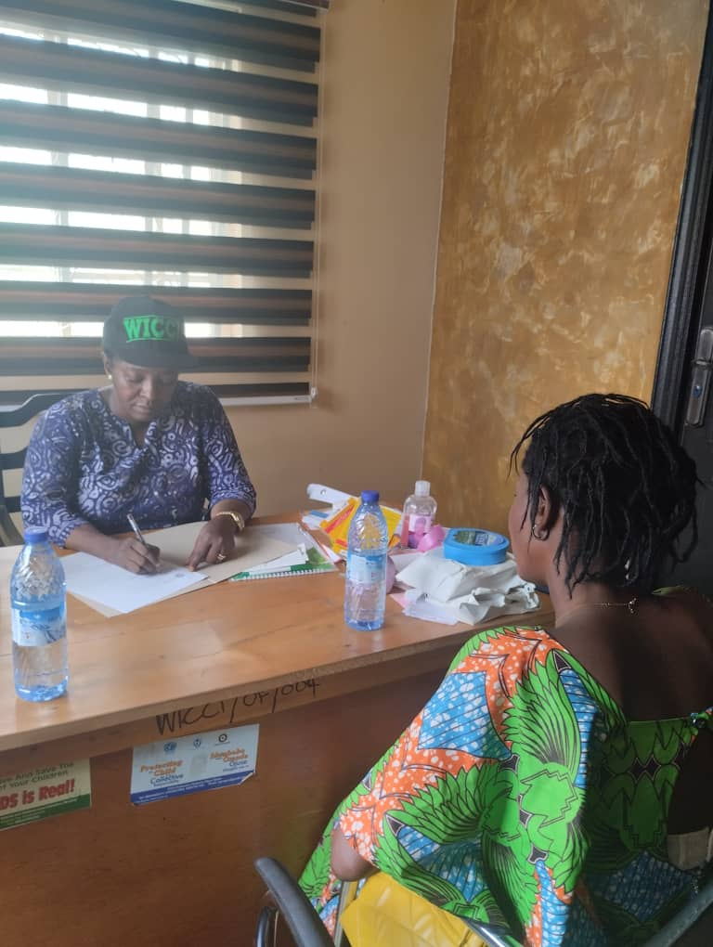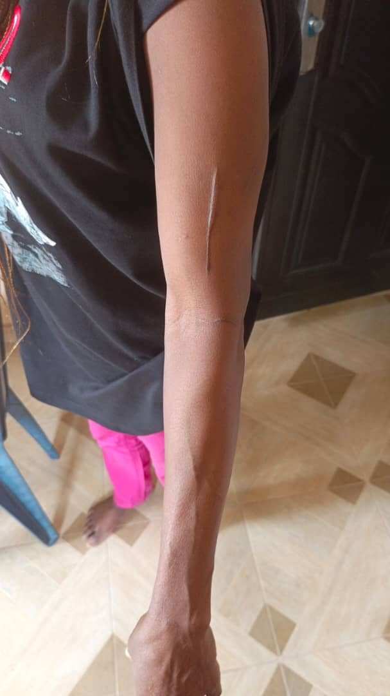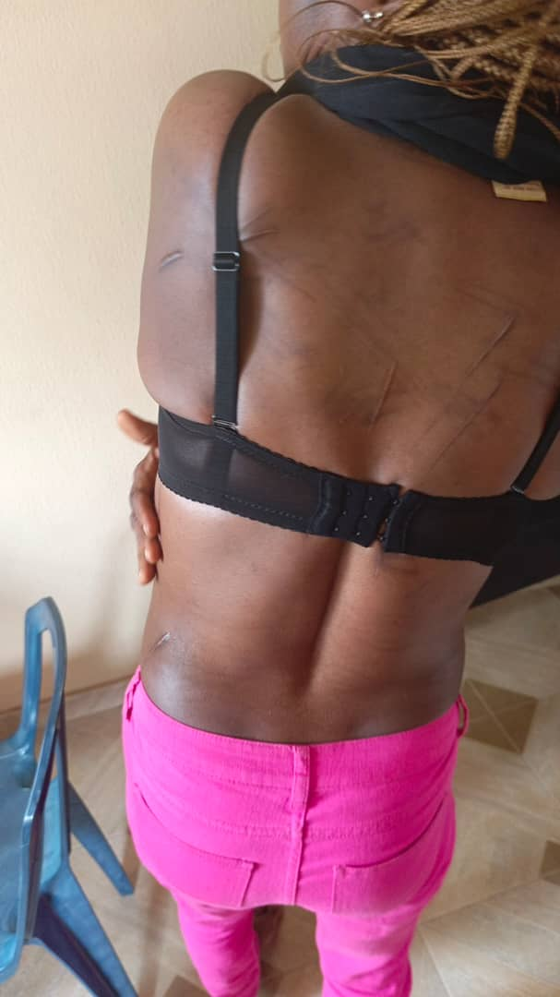

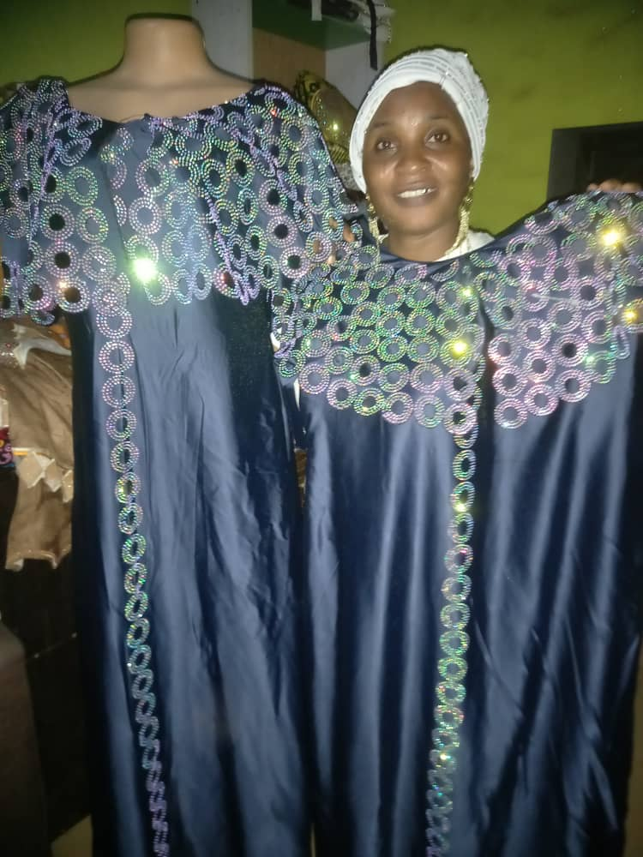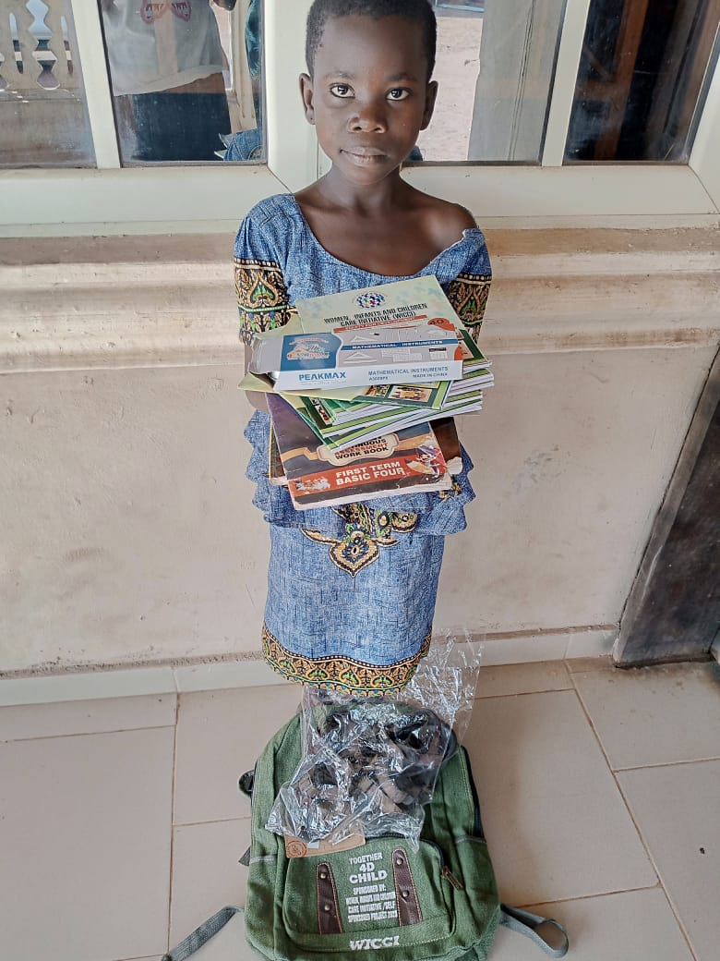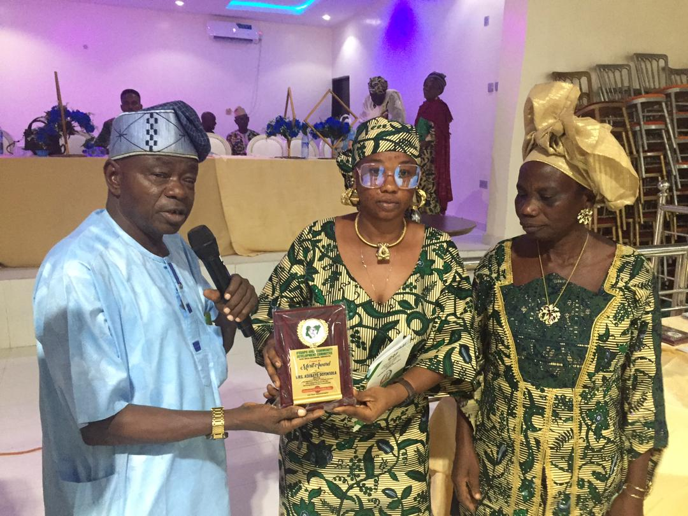

Pic.160: A returnee and beneficiary of vocational Pic.161: An Internally Displaced Person Pic. 162: Merit Award to WICCI for her Selfless service to
skill empowerment displaying her work in fabric stoning empowered with scholastic materials humanity by our Partner – Ifedapo Community Dev. Assoc.

The Trust Fund may wish to publish a summary of the preliminary results of the project. For this purpose, please kindly send any visual material you might have (photos, brochures, etc.). Should you have any objections to the Trust Fund publishing these materials, please state them here.

Name of authorized representative: Doyinsola A. Adebayo
Signature: 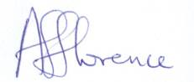
Location: Ogun State, Nigeria
Date report due: 30.11.2024
Date report sent: 29.11.2024
Stamp:

